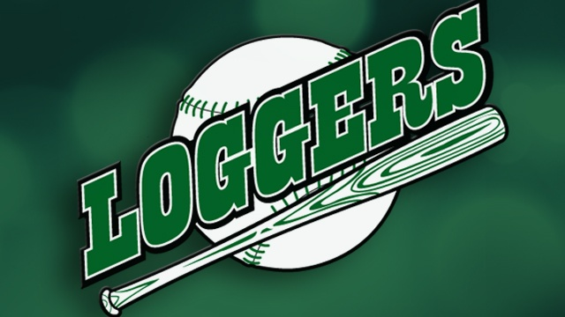

“Strike-Out Polio” Rotary Picnic
La Crosse Loggers @ Copeland Park
Thursday, July 20th 4:00 p.m. – 6:00 p.m.
Rain or Shine, Hot or Chilly—Picnic is under cover
Brickl Brothers Pavilion

Cost: $17 Adult; $12 Children 12 and Under
(Hat and voucher for another game included in price)

Includes: 2 sandwich items; 2 sides; all you can drink Pepsi Products;
$2 16 oz. beers; Reserved Bleacher Back Grandstand Seat

La Crosse Loggers vs. Eau Clair Express
Game time is 7:05 p.m.
The La Crosse Loggers will donate $2.50 of every ticket to Polio Plus

