OFFSITE MEETING
Thursday, February 22, 2018
UWL – Student Union – 35 on map
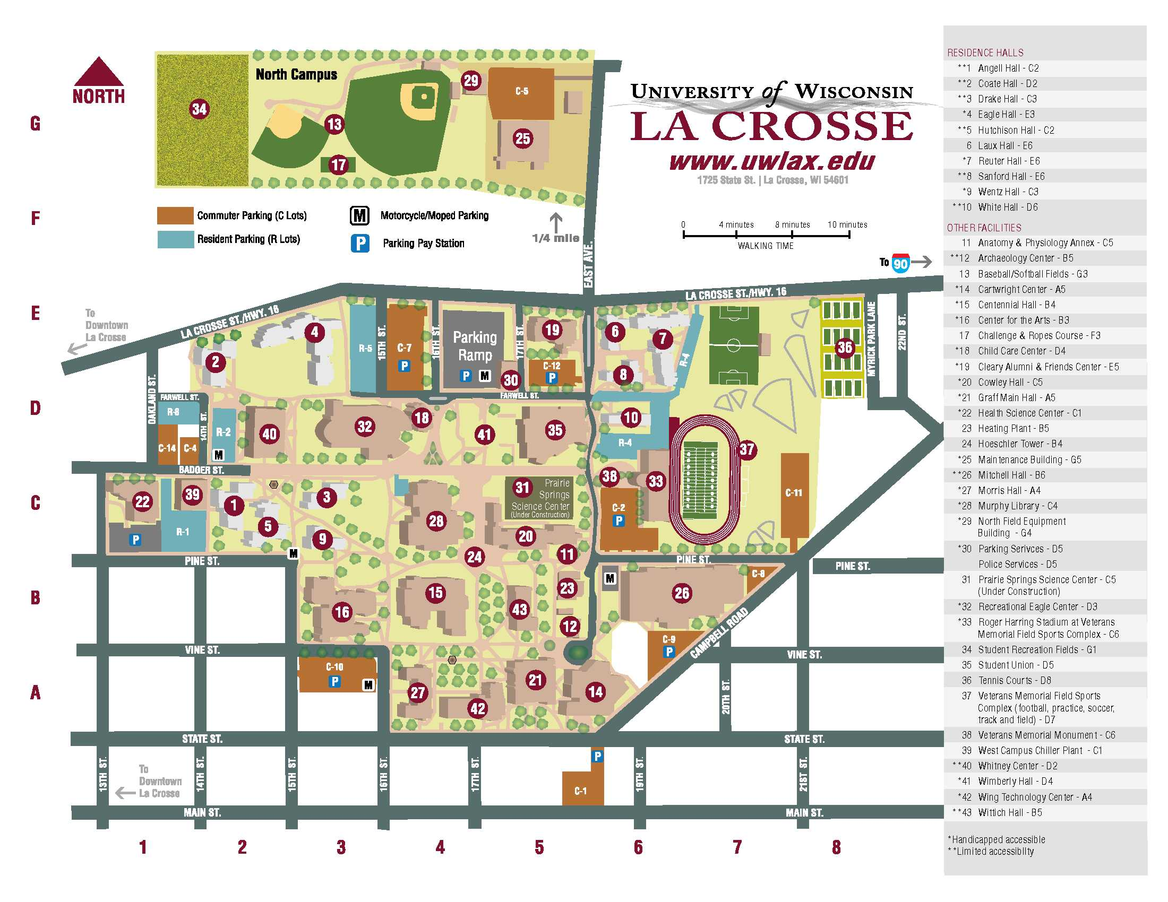

Complimentary parking is available at no cost on Level 3 of the parking ramp thanks to Rotarian Greg Reichert, UWL Foundation. An elevator is located at the southeast stairwell.
Pay stations that charge $1 per hour are located in commuter lots if you wish to park in a different location. Instructions to use the pay station are included in this video.
Please note that complimentary parking is only available on Level 3 of the ramp and you should plan to pay at a pay station or at the parking office (605 17th Street N.) if you wish to park in any other commuter lot. Parking in a resident (R) lot is always prohibited.
Persons with disabilities who display valid disabled placards or plates may park in any accessible (handicap) space on Level 1 without payment for the duration of the event.

It is important that your attendees understand that the complimentary parking is ONLY for Level 3 of the parking ramp. Should your guests choose to park elsewhere, they will be required to pay for parking and must observe the time allocation to avoid ticketing.

