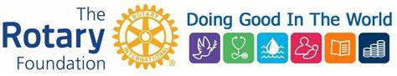

ROTARY INTERNATIONAL FOUNDATION MATCH OPPORTUNITY

Make an additional donation of $100 or greater to the Rotary International Annual or Polio Plus
through February 2019 and we will match your donation with foundation points.

Lindy Saline (Sue Durtsche’s father), who passed away a year ago, was a member of our club and a supporter of our Rotary Foundations. He had over 10,000 remaining points. After contacting Rotary International we were granted permission to use these points. Until February 28, 2019 any of your donations of $100 or greater to Rotary International Foundation-Annual or Polio Plus Fund will earn double the points. For example, a donation of $500 will receive an additional 500 points earning you 1000 points and you will receive a Paul Harris Fellow. If you are interested, please let Lyn know. We feel confident that Lindy would appreciate his points being used to benefit our world through the Rotary International Foundation.

