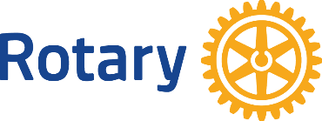

Rotary Four Way Test Award—Rising Star
2021 Nomination

The Rising Star award is given to a Rotarian who best demonstrates a commitment to Rotary’s Four Way Test. Among the criteria considered is the length of time in Rotary (two years minimum but not more than five years); a strong commitment to Rotary and its programs; a demonstration of high ethical standards in business/profession, personal, and community life.

Past Rising Star recipients: Johnny Brevik and Arien O’Heron, 2014; Matt Boshcka, 2015; Justin Garvey, 2016; Natalie Olsen and Spencer Niebur, 2017; Julie Nelson, 2018; Sarah Arendt-Beyer and Jeff Sexauer, 2019.

2021 Nominee: Club:

Please provide examples of involvement in the following:
Commitment to Rotary International and Rotary club programs.

Demonstration of high ethical standards in business/profession.

Commitment to the ideals of service in the Rotarian’s personal and community life.

Submit form to Patricia Boge at patriciaboge@yahoo.com or you may snail mail to Patricia Boge, 219 21st St N, La Crosse, WI, 54601, no later than July 15, 2021. Late nominations will not be considered. Club presidents will receive an email receipt for each nomination to avoid lost nominations.

Nominator: Club:

Nominator's Email:

