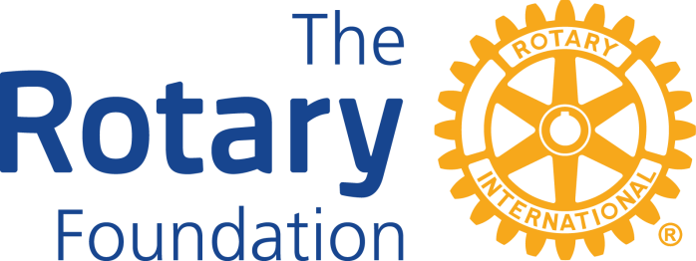

ROTARY FOUNDATIONS
Supported by Rotary Club of La Crosse Members

The Rotary Works Foundation, Inc. a 501 (c) 3 organization sponsored by Area 4 Rotary Clubs encourages Rotarians to enact the Rotary Four Way Test by financially supporting local and international charitable and educational activities.

The Rotary Works Legacy Club is composed of individuals who have made a planned gift ($750 or more) or a one-time gift to the Rotary Works Endowment Fund. Endowment income is an important part of our future. Earnings from the Endowment Fund will help finance local and international Rotary Service projects for generations to come. The principle goes forward into the future, while the investment income meets the needs of today.

Rotary Works grants approved throughout the years: La Crosse Police Canine Unit; Assistive Technology Loan Closet Equipment Update; Together Against Bullying; Parent and Caregiver Flex Fund; the Pause Project; Respect Retreat; A Peace of my Mind Exhibit; Rotary Lights; LIVESTRONG at the YMCA Program; Caring: A Collaboration Between Viterbo and Salvation Army; Responsibility Retreat-Rotary Ethics Committee; Semillero Mi Angel Guardian; Robotics Scrimmage Playing Field; Nick Quarberg Eagle Project; Mobile Meals Presentation Display; Blue Dragon Boat Race; La Crescent Neighbors Day 2014; Sandcastles; WisCorps Crew Program-Capacity Building Proposal; Viterbo Non-Traditional Student Scholarship; International Owl Center Temporary Facility First Year; Cameroon Water Project, Deerwood Park Shelter, Nigeria Water Project, Camp Winnebago, Habitat for Humanity, National MS Society and Back to School Program for La Crosse Area Youth.

The Rotary Foundation

Promoting Peace and Understanding One Rotarian, One Idea, One Project, at a Time.
The Rotary Foundation (TRF) supports Rotary Clubs and Rotarians in advancing world understanding, goodwill and peace through global, district and packaged grants. Through The Rotary Foundation Rotarians from around the world work together to eradicate disease, provide literacy, clean water, and economic development to thousands of people each year. The Rotary Foundation is a 501(c)3 organization that is supported by donations from Rotarians and friends of TRF who share its vision for a better world.

History of the Foundation
At the 1917 convention, outgoing RI President Arch C. Klumph proposed to set up an endowment “for the purpose of doing good in the world.” In 1928, it was renamed The Rotary Foundation, and it became a distinct entity within Rotary International.

Growth of the Foundation
In 1929, the Foundation made its first gift of $500 to the International Society for Crippled Children. The organization, created by Rotarian Edgar F. “Daddy” Allen, later grew into Easter Seals.
When Rotary founder Paul Harris died in 1947, contributions began pouring in to Rotary International, and the Paul Harris Memorial Fund was created to build the Foundation.

Evolution of Foundation programs
1947: The Foundation established its first program, Fellowships for Advance Study, later known as Ambassadorial Scholarships.
1965-66: Three programs were launched: Group Study Exchange, Awards for Technical Training, and Grants for Activities in Keeping with the Objective of The Rotary Foundation, which was later called Matching Grants.
1978: Rotary introduced the Health, Hunger and Humanity (3-H) Grants. The first 3-H Grant funded a project to immunize 6 million Philippine children against polio.
1985: The PolioPlus program was launched to eradicate polio worldwide.
1987-88: The first peace forums were held, leading to Rotary Peace Fellowships.
2013: New district, global, and packaged grants enable Rotarians around the world to respond to the world’s greatest needs.
Since the first donation of $26.50 in 1917, the Foundation has received contributions totaling more than $1 billion.
RI PolioPlus Fund After 30 years of hard work, Rotary and its partners are on the brink of eradicating this tenacious disease, but a strong push is needed now to root it out once and for all. It is a window of opportunity of historic proportions. Reaching the ultimate goal of a polio-free world presents ongoing challenges, not the least of which is a hundreds of million dollar funding gap. Of course, Rotary alone can't fill this gap, but continued Rotarian advocacy for government support can help enormously. As long as polio threatens even one child anywhere in the world, children everywhere remain at risk. The stakes are that high. "If we all have the fortitude to see this effort through to the end, then we will eradicate polio." - Bill Gates

