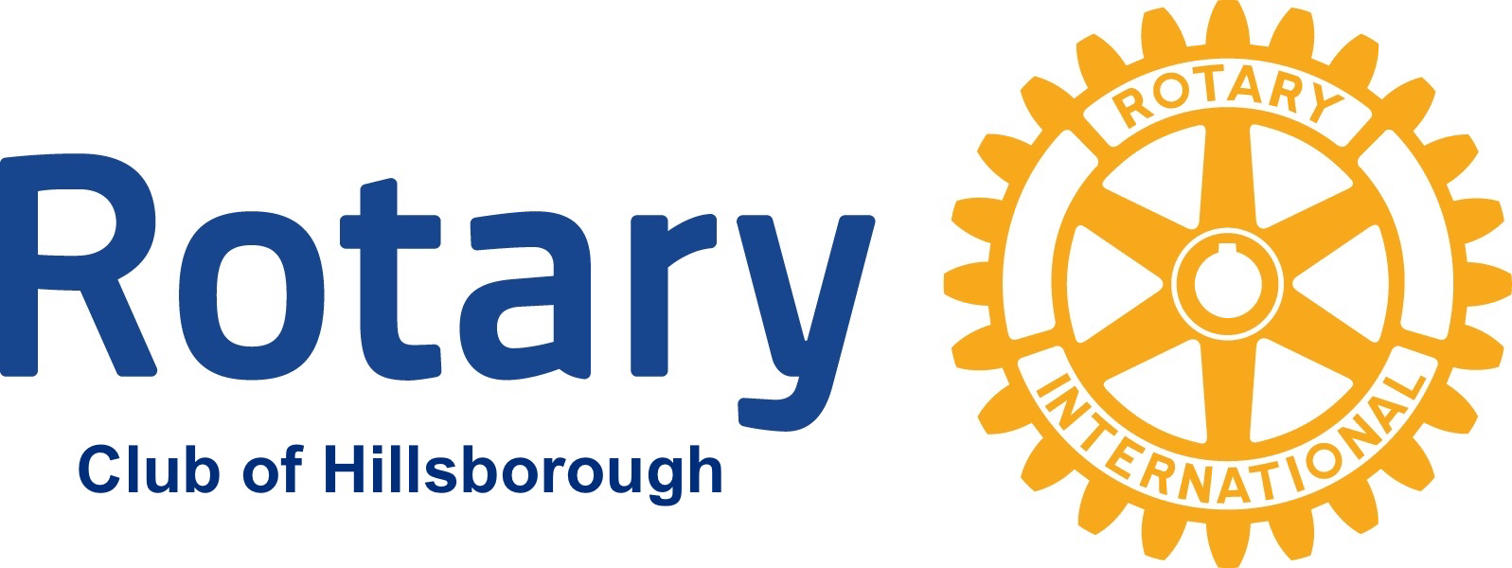

“Service Above Self”

For Immediate Release

MEDIA CONTACT INFO:

Rich Salem (908) 448-6630

Rotary Announces Availability of Post-Secondary School Scholarship Applications

Hillsborough, N.J., February 5, 2026…The Rotary Club of Hillsborough announced today the availability of applications for their annual post-secondary school scholarship program for Hillsborough residents. Now in its third decade, the program provides qualifying students with a scholarship to help offset the cost of their post-secondary education.
“A post-secondary school education often comes with significant expense,” noted Amrik Sahota, chair of the Rotary Club of Hillsborough Scholarship Committee. “Over the years, our scholarships have helped lessen that burden for many of Hillsborough’s brightest and most deserving students, who not only excel academically, but put Rotary’s commitment of community service into action in their own lives.”
“Our Rotary Club will provide ten scholarships of $3,000 each to residents of Hillsborough who are pursuing a post-secondary education,” commented Abed Medawar, president of the Rotary Club of Hillsborough. “All our scholarships consider both a student’s academic performance, as well as their commitment to community service, a hallmark of Rotary’s mission.”
Seven of the ten scholarships will be awarded to students attending Hillsborough High School (HHS), including one scholarship that is reserved specifically for a student with special needs. Selection of this scholarship, known as the Academic Achievement Scholarship, is awarded by the HHS Counseling Department. Of the remaining three scholarships, two are available to Hillsborough township students attending the Somerset Vo-Tech School, and one to a township student who attends a high school other than HHS, such as Immaculata High School.
Scholarship applications and deadline information for HHS students, including the Academic Achievement Scholarship, may be obtained from their school Counseling Department. Scholarship applications and instructions for Vo-Tech and non-HHS graduates may be downloaded directly from the Rotary Club of Hillsborough website, hillsboroughnjrotary.com. The non-HHS graduates must submit their applications by March 30, 2026.
# # #

