
Spring Request for sponsorship / donation
Rotary Club of Newtown
Date:
Organization Name
Name/Title of Contact Person
Address
City, State, Zip
Phone Number
E-mail address
Event Name (if applicable)
Date of the Event
Brief description of the event or how donation will be used (attach any relevant literature)
Date funds are needed by
Additional information, comments and/or requested dollar amount
Signature of requestee

Is your group/organization a nonprofit 501(c)(3)? YES NO If Yes, 501(c)(3) # ___________________________
All requests are due no later than March 31. Requests will be reviewed by the Allocations Committee in April/May and a decision will be forwarded to you no later than May 31. If your event includes recognition, your request may be voted on prior to the spring meeting. Newtown Rotary is dedicated to our members and our community. We are committed to supporting our community activities and to enriching our community through donations, sponsorships, scholarships, and volunteer activities.
In return for sponsorship/donation funds, Newtown Rotary may ask for: publicity opportunities (media release, or inclusion in photo opportunities in local publications); Newtown Rotary logo or advertisement to be placed in newsletter, on certificates, programs/signage, etc.; event announcements that give verbal acknowledgement to Newtown Rotary; and the potential for setting up a stand at your event.
Rotary Club of Newtown
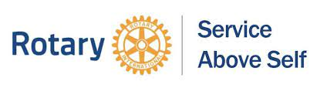
P.O. Box 123
Penns Park, PA 18943

