THE ROTARY CLUB OF COLBORNE

January 2014

Since June 1949, for 65 years, members of the Rotary Club of Colborne have met to serve our community, to network and to develop fellowship. As part of the world’s first service club, ROTARY INTERNATIONAL, Rotarians are part of a global network of volunteer leaders, people just wanting to make a difference. The Rotary Club of Colborne is dependent on and only successful because of the support and participation of the community.

For the year 2013-2014, the Rotary Club of Colborne is led by: President Don Spencer, President-Elect Lorne Bumstead, Director Community Service Donna Spencer, Director International Service Glenn Spence, Director Club Service Jim Williams, and Past President Garry Clement. The Club Secretary is Betty Brisco and Club Treasurer is Lee Clement.

Recently the Club: supported construction of the Colborne Habitat House Build on Baldwin Street; supported construction of the Bridge over Colborne Creek at the Suzanne Kernaghan Trail; contributed to the Santa Claus Parades in Colborne and Alnwick/Haldimand; contributed to the Colborne Public School Festival of Trees; contributed Home and Away shirts to Colborne Minor Hockey; contributed to New Beginnings Family Services; contributed to Transition House; contributed to the Salvation Army; contributed to the Northumberland United Way; contributed to the Colborne Curling Club; contributed to the summer Music in the Square program in Victoria Square; contributed to the Christmas Food Hamper program organized by Colborne Legion Branch 187. Major financial commitments to community projects have included: $40k to the Keeler Centre – Rotary Hall, $55k to the Northumberland Hills Hospital, $25k to the Children’s Playground in Rotary Centennial Park.

In 2003 the Rotary Club of Colborne sponsored the Probus Club of Colborne.

Our participation in Youth Programs is ongoing. Our Outbound Exchange Student, Meaghan Peterson, is busy learning the languages, lifestyles and culture of Belgium. Our Inbound Exchange Student, Rhea Scherer of Zug, Switzerland, is settling in to do the same for her year here in Canada. Rhea has just moved to live with her second host family and she is participating in many programs at East Northumberland Secondary School.

The Rotary Club of Colborne presents awards to students including: Camp Enterprise, a 3 day leadership weekend residential course held at the campus of Trent University; Adventure in Technology, a 3 day billeted training experience in Ottawa; Adventure in Citizenship, a 5 day billeted training experience in Ottawa; a French Award; an Athletics Award; and the ROTARY CLUB OF COLBORNE BURSARY in memory of Rotarian Gord Hoselton.

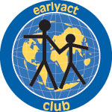
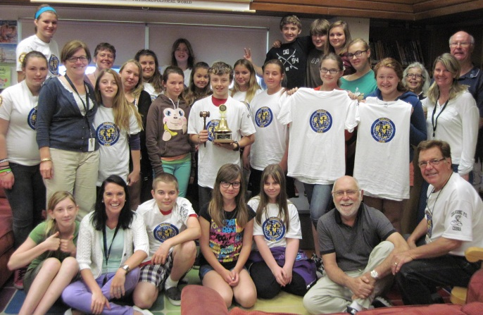
The Rotary Club of Colborne sponsored EarlyAct Club was launched at the Colborne Public School in 2011. Students there are embracing the world motto Service Above Self by completing many projects within the school and in the community. Already this year the members have held elections, attended their school garden, organized a clothing exchange at the school and devised a composting program for the classrooms in the school. We will hear more of their ambitious plans in the months ahead. This is the photo of Club members at their wrap meeting in June 2012.

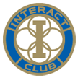
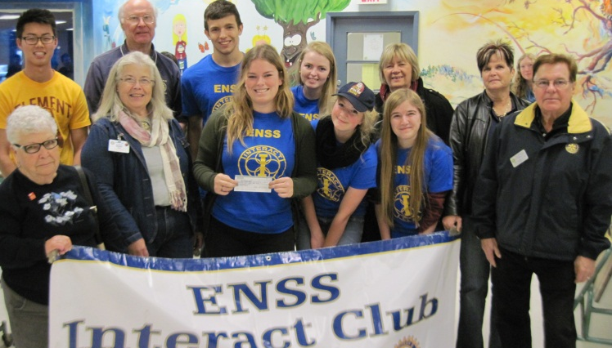
Co-sponsored by the Rotary Clubs of Colborne and Brighton, the ENSS Interact Club was launched October 18, 2012. This Club meets every Friday at their lunchtime to plan projects. This year they have won a Rotary District competition of other Interact Clubs and we will hear more of their plans for this win later this spring. The Club held a school awareness fundraiser to END POLIO NOW and they put together a carol sing to residents of Applefest Lodge in Brighton.

The Rotary Club of Colborne’s fundraising activities generously supported by the community this year included: the Annual Golf Tournament this year in support of the Colborne Habitat Build, and the Annual Apple Harvest Auction, Dinner and Dance with the theme this year, Riverboat Fantasy. Again this year, both of these functions were fun-filled events and they received great compliments from attendees.

Members also participated in: Mayor’s Clean-Up Day, the Colborne/Cramahe Apple Blossom Tyme Festival, the Colborne Santa Claus Parade, the Colborne Curling Club Fundraising Bonspiel and members helped to prepare the Legion’s Christmas Food Hampers. Inter Club and District events included: Toronto Rotary Peace Conference, Rotary Get-together at the Dr Bob Scott recognition Fundraiser for his leadership to END POLIO NOW, Brighton BBQ, Brighton Auction, Trenton Auction, Port Hope Lobster Night, Foundation Walk, Rotary Leadership Institute, Rotary District Seminar, and Rotary District Conference.

Our Club is part of District 7070, led this year by Whitby Rotarian and this year’s District Governor Valerie Wafer. Valerie and her husband Mark have visited our Club.

Rotary International is a worldwide network of inspired individuals who translate their passions into relevant social causes to change lives in communities. Members provide service to others; promote integrity; and advance world understanding, goodwill, and peace through fellowship of business, professional and community leaders. This year, the President of Rotary International is Ron Burton, a member of the Rotary Club of Norman, Oklahoma,USA. He has adopted the theme ENGAGE ROTARY CHANGE LIVES. This theme leads the work ahead for over 30,000 Rotary Clubs worldwide. Members met Ron Burton in Cobourg where he and now Past President Sakuji Tanaka along with now Past President of Rotary Foundation Wilf Wilkinson of Trenton, Ontario, honoured Dr Bob Scott for his years of leadership to END POLIO NOW. Our own Past President Garry Clement fulfilled his personal commitment to run 1,000 miles through his term as President and raised over a quarter of a million dollars to END POLIO NOW.

The ROTARY motto – worldwide – is SERVICE ABOVE SELF

The OBJECT OF ROTARY is to encourage and foster the ideal of service as a basis of worthy enterprise: … development of acquaintance as an opportunity for service … high ethical standards in business and professions; the recognition of the worthiness of all useful occupations; and the dignifying of each Rotarian’s occupation as an opportunity to serve society … the application of the ideal of service in each Rotarian’s personal, business, and community life … the advancement of international understanding, goodwill, and peace through a world fellowship of business and professional persons united in the ideal of service.

The AVENUES OF SERVICE are Rotary’s philosophical cornerstone and the foundation on which club activity is based: … Club Service focuses on strengthening fellowship and ensuring the effective functioning of the club … Vocational Service encourages Rotarians to serve others through their vocations and to practice high ethical standards … Community Service covers the projects and activities the club undertakes to improve life in its community … International Service encompasses actions taken to expand Rotary’s humanitarian reach around the globe and to promote world understanding and peace … Youth Service recognizes the positive change implemented by youth and young adults through leadership development activities, service projects, and exchange programs.

Rotarians are guided by their FOUR-WAY TEST: … Is it the truth? … Is it fair to all concerned? … Will it build goodwill and better friendships? … Is it beneficial to all concerned?

ROTARY FOUNDATION manages donations made to Rotary International and it considers funding programs internationally in 6 areas of focus: … Peace and Conflict Prevention/Resolution … Disease Prevention and Treatment … Water and Sanitation … Maternal and Child Health … Education and Literacy … Economic and Community Development

Some of the International Projects supported by the Rotary Club of Colborne include: Polio Eradication, Disaster Relief, Clean Water, Centres for World Peace, Picton Rotary’s Atorkor Project.

Would you like to learn more about ROTARY AND THE ROTARY CLUB OF COLBORNE?
Why not join us at a regular dinner meeting to discover more about Rotary! We need your skills, talent, knowledge and expertise to make our community more successful. There is a fundraising side to the club and a spirit of teamwork and fellowship, but there is absolutely no political or religious element. We have a broad spectrum of ages and professional expertise. Everyone is welcome!
We meet over dinner at 6pm Monday evenings at ROTARY HALL, KEELER CENTRE on Division St in Colborne. You are welcome to attend any meeting but please confirm your attendance by calling our President, Don Spencer, at 905 355 1508 or email Don at dspencer1@sympatico.ca for more information.
Our address is: The Rotary Club of Colborne, BOX 725, Colborne, K0K 1S0. Check us out at cramahe-now.com and on our website rotaryclubofcolborne.com. We are also on Facebook.

