Hartland Rotary Presents
The 4th Annual Sporting Clays Event
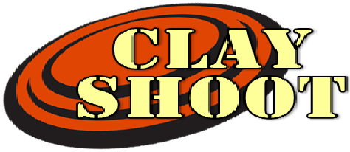

SUPPORTING: MEALS ON WHEELS
REACHING HIGHER

Held on Thursday, August 22nd, 2019
at the Michigan Shooting Center, Island Lake Recreation Center
1:00 pm - Registration
1:45 pm - Safety/Rules Review
2:00 pm - Shotgun Start
5-7 pm - After Glow Hosted By: 1-800 Water Damage
7792 Boardwalk Rd., Brighton, MI 48116
-Rental guns available upon request-

1st Place Rotary Team wins Rotary Shooting Trophy
1st Place Shooter $200
Other Prizes for Shooters by Class
-Lewis Class Scoring System-
SPONSORSHIPS _
Major Sponsor – Prominent position, 1 team, and entry in the Heads/Tails - $2,000

Title Sponsor–Your company name on all promotional material and a 3’x6’ banner (2 available)-$1,000
After Glow Sponsor – $750
Safety Sponsor – Acknowledgment during safety presentation and lunch - $350
Station Sponsor – Your company sign at a station (15 available) - $250 each

Award Sponsor – Your company name acknowledged during lunch and presentation of awards-$250
Ammo Sponsor – Your company logo on all boxes of shells - $200

SPONSORSHIP INFORMATION _
Company/Rotary: Contact Name: _
Phone Number: Sponsorship(s): Cost: _

CLAY SHOOT PARTICIPANTS _
Individual - $100 Includes 3 boxes of 12 or 20 gauge shells for sporting clays, After Glow, fun, and good fellowship.

PARTICIPANT INFORMATION REGISTRATION DEADLINE: THURSDAY, August 15th ,2019
Company: Contact Name: _
Phone Number: Number of Participants: Cost: _

PARTICIPANTS
All Shooters will be placed on teams of 5
1. 4.
2. 5.
3.

NUMBER OF RENTAL GUN(S) NEEDED: (limited number of guns available)

Make checks payable to Hartland Rotary and mail to 10051 E. Highland Rd. Ste. 29-137 Howell, MI 48843
Questions? Call (313)-418-8325

