THE GRAPEVINE
“The Somewhat Official Newsletter of the Rotary Club of Livermore Valley”
September 20, 2016
www.facebook.com/livermorevalleyrotary
www.LivermoreValleyRotary.org

Month 3, Meeting 11 in the Administration of 1/4Man.

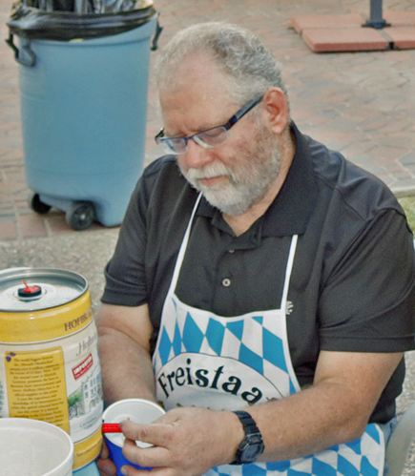
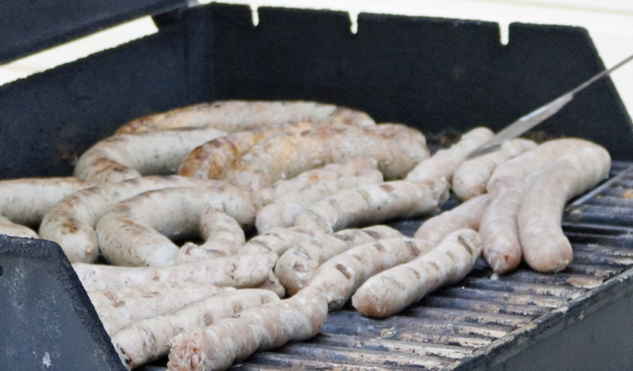
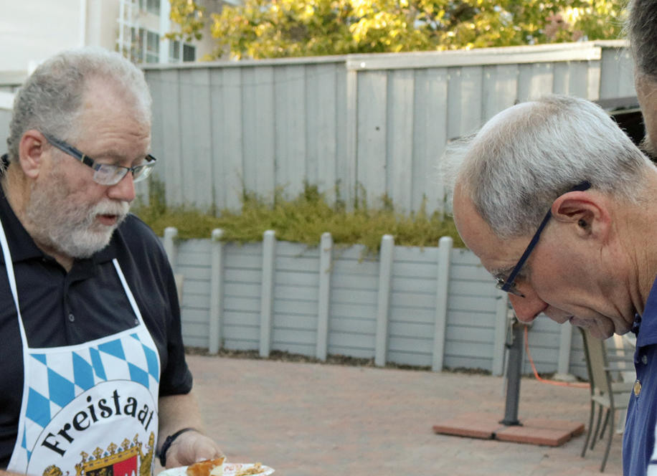
Oktoberfest at the Quinn’s
Thanks to Peter and Angelika for opening their home to our crew. What’s Oktoberfest without sausage and beer? Too bad not many of our crew could attend. We need to problem solve this because our socials should be one of our great social events.

If you still want to celebrate Oktoberfest. The Rotarian Foundation of Livermore is holding one at Alden Lane Nursery on October 16th from 2-5pm.

- Deb—Bocce
• This is not a misprint. Deb is telling us to start thinking Bocce, especially regarding raffle prizes. She is also requesting one of us to step forward to head the raffle and silent auction part. We’ve sold 88, half way there. Keep it going.

- Love’s Follies:
- week 3 in the books. Same format as last year.
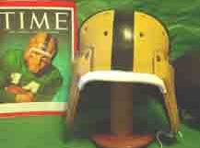
• $25 entry fee. We would like all members to play. You just have to pick one winner each week, without repeating the same team. Even if you do not want to play we would appreciated your $25 donation. (You can opt out of this “donation” by telling Bill not to bill you) We did not use the money last year and this year we are partnering with the GHS Interact Club to produce a Thanksgiving event. Dick and I met with the Interact Club last week to introduce our program and received positive feedback. To continue I have included the Week 3 schedule at the end of this newsletter, along with the current standings. New This Year: Quick Pick. If you miss a week, then I will select a team for you. Criteria: the team who is the biggest favorite based on Las Vegas odds. If you have already selected that team then you will get the next best odds in your favor. This Quick Pick is only good for the first three weeks of the season until everybody gets into a rhythm. This is the last week for you Quickpickers
Notre Dame Football circa 1930
- Travelers Return: “I’ve Been Everywhere”

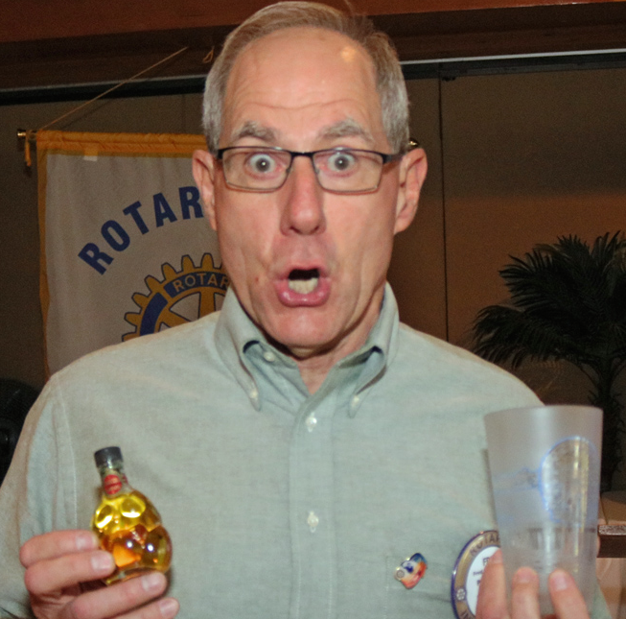
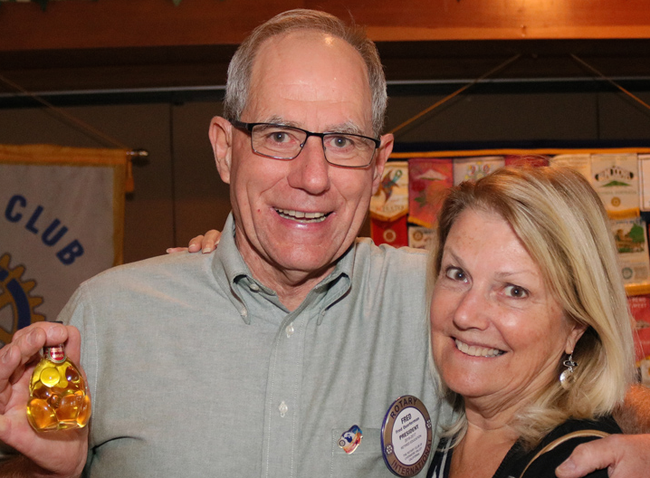
I was totin' my pack
Along the dusty Winnemucca road
When along came a semi
With a high and canvas covered load
"If you're going to Winnemucca, Mack
With me you can ride."
So I climbed into the cab
And then I settled down inside
He asked me if I'd seen a road
With so much dust and sand
And I said,
"Listen, Bud I've traveled
Every road in this here land."

(Note to our music people: This should be on our music list. Afterall we did Green Acres this morning.)

1/4Man received some gifts today from our travelers. Anne spent 7 days in Cabo, where she avoided the hurricane, and Frank gave us a heartfelt talk of his uncle who he visited in Albuquerque. Anne brought back the liquid, and Frank the glass.

OTHER STUFF: Sign-Up Sheet was circulated today:

- Blood Drive—Area 4 Rotary Event (This is our “Arms Race”)
- • Friday, September 30, 2016
- • 10:00-4:00
- • 6473 Sierra Lane, Dublin (Look for the American Red Cross Bus)

• Saturday, October 1, 2016
• 9:00-3:00
• 5301 Hibernia Drive, Dublin (James Dougherty Elementary School-MPR)
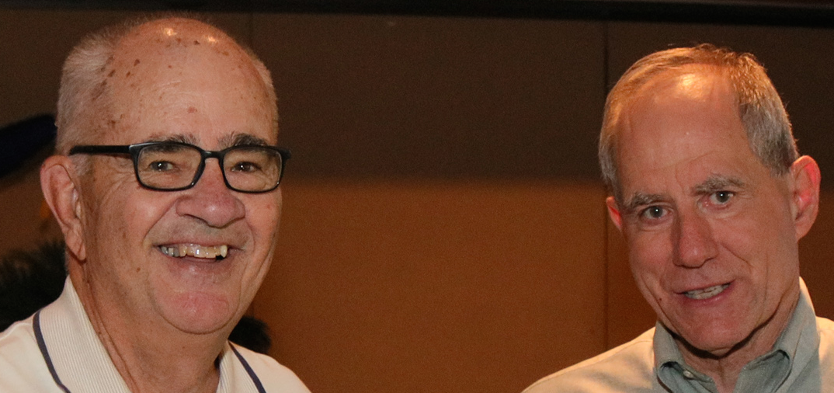
2. My Turn: Fred has asked me to give monthly talks on social, historical, and sports related topics. Today’s talk: The 154th anniversary of the Battle of Antietam. What Happened At Antietam:
- 1. General Lee invaded the North
- 2. A southern victory would end the war
- 3. North had Lee’s battle plan—3 cigars
- 4. Single most costly day in U.S. History
- 5. Showed the brilliance of Northern Generals
- 6. Guaranteed this was to be a long bloody war
- 7. Lincoln issued Emancipation Proclamation
- 8. Most of the above

3. Grants: Rosemary brought us up to date on are Fall Grant Program
• Applications are currently on the website
• They are due October 28th
• We hope to announce the winners at a meeting in early November

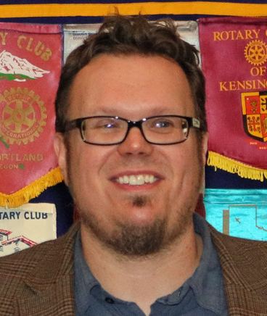
PROGRAM: John S. Berry, Social Media (AKA, Kristi’s Husband)

John covered the basics:
• Facebook
• Twitter (not too many tweeters among us)
• Instagram
• SnapChat

Interesting for our club is the ability to “boost” our message to the demographics and geography we want to hit.

THOUGHTS FROM THE END ZONE:
- Hey Colin. Those socks you wore a couple of weeks ago depicting the police as pigs. Well those “pigs” just saved a ton of lives in New York and New Jersey this past weekend. You’re Welcome!

- I really don’t want to hear anymore about profiling. There is a huge difference between racial profiling and garden variety profiling. If a dude takes multiple trips to Afghanistan I think a check of that guy’s activities is warranted. After all, Afghanistan? We can’t even get polio cured there. Not exactly your garden spot.

- Drake’s Heisman picks:

a. Christian McCaffrey—Stanford

b. Lamar Jackson—Louisville

c. J.T. Barrett—Ohio State

- For you Giant fans, do you think you’re watching the movie Groundhog Day?

- Interesting statistic: the Giants are leading the major leagues in one category---they have 9 losses after leading the game at the end of the 8th inning; woeful A’s have 5.

- Speaking of the Giants I made a prediction way back when that they would not win more than 86 games. One Dave Bedford took me up on that. They currently have 79 wins with 12 games to go. Let’s see, they have to go 8-4 for Dave to win. I’m not sure what the reward is. I’ll tell you if I win. But I will donate a “Happy 10” for the individual who can recite, without notes, (or sing) the remaining lyrics to the song started above (I’ve Been Everywhere)

- Get your Love Follies picks to me before the game you select starts.

- Two Minute Warning: 1/4Man says that pins will be checked next week. Ed is salivating.

- Only in America:
This weekend, products with Tim Tebow's name and jersey No. 15 started appearing on the New York Mets' online shop. Based on jerseys sold Monday, Tebow's was shown as the No. 1 best-seller on Fanatics and MLB's online shop, ahead of stars such as David Ortiz and Kris Bryant. (For those of you out of the loop, Tim Tebow was an All-American football player at U of Florida. The last time he played baseball was in high school.)

- Breaking News: Angelina Jolie is filing for divorce from Brad Pitt after 12 years of marriage. I wonder what the Vegas over/under line was for that one. But 12 years: Isn’t that like a golden anniversary for Hollywood types? Poor Brad—probably tough getting a date at his age.

- Thanks to Roy for the pictures!

Today’s Final Thought: “Good is not good enough, if better is expected” Vin Scully

Kevin Drake

“After all is said and done, there is usually more said than done.”

- TEXANS AT PATRIOTS
- SUNDAY, SEPTEMBER 25TH
- 1:00 PM ET CARDINALS AT BILLS
- 1:00 PM ET RAIDERS AT TITANS
- 1:00 PM ET REDSKINS AT GIANTS
- 1:00 PM ET BROWNS AT DOLPHINS
- 1:00 PM ET RAVENS AT JAGUARS
- 1:00 PM ET LIONS AT PACKERS
- 1:00 PM ET BRONCOS AT BENGALS
- 1:00 PM ET VIKINGS AT PANTHERS
- 4:05 PM ET RAMS AT BUCCANEERS
- 4:05 PM ET 49ERS AT SEAHAWKS
- 4:25 PM ET JETS AT CHIEFS
- 4:25 PM ET CHARGERS AT COLTS
- 4:25 PM ET STEELERS AT EAGLES
- 8:30 PM ET BEARS AT COWBOYS
- MONDAY, SEPTEMBER 26TH
8:30 PM ET FALCONS AT SAINTS

Almand R | Seattle | Panthers
Bedford D | Seattle | Panthers
Bickerton J | Seattle | Panthers
Crohare C | Dallas | Panthers
Drake K | Rams | Panthers
Duerig, J | Seattle | Panthers
Eccles, W | Seattle | Vikings
Fields, D | Seattle | Ravens
Gambs, D | Seattle | AZ
Goldstein, R | Seattle | Panthers
Hartwig, K | Seattle | Panthers
Hawkins, J | Seattle | Ravens
Karpenko, V | Seattle | Panthers
Kavanagh, J | Seattle | Carolina
Kuenning, B | Seattle | Panthers
McCartney, K | Colts | Seattle
Marcel, T | Seattle | Panthers
Minser, K | Seattle | Panthers
Perez, J | Seattle | Colts
Porfido, R | Colts | Bills
1/4Man, F | KC | Ravens
Quigley, D | Colts | Jets
Quinn, P | Seattle | Panthers
Rambo, P | Seattle | Panthers
Ramirez, B | Seattle | Panthers
Roessler, K | Seattle | Panthers
Rusca, M | Seattle | AZ
Rusca, K | KC | Carolina
Schumann, E | Seattle | Detroit
Scott, G | Phila | Baltimore
Souza, G | Texans | Bengals
Stevens, B | Texans | Raiders
Stevens, L | Seattle | Panthers
Tacker, D | Seattle | Panthers
Tucknott, B | Seattle | Raiders
Vallejo, F | Seattle | Baltimore
Wilburn, A | Seattle | Panthers
Wineinger, G | Seattle | Patriots

