THE GRAPEVINE
“The Somewhat Official Newsletter of the Rotary Club of the Livermore Valley”
June 18, 2019
www.facebook.com/livermorevalleyrotary
www.LivermoreValleyRotary.org

Who Dunnit?!!

The Prez tried to call the meeting to order (where’s the bell?!? Hey, and where’s the gavel?!). Roy Porfido led us in song with Grand ‘Ole Flag. Lori shared with us her “Diddy of the Day”. Seasons….Summer is almost here

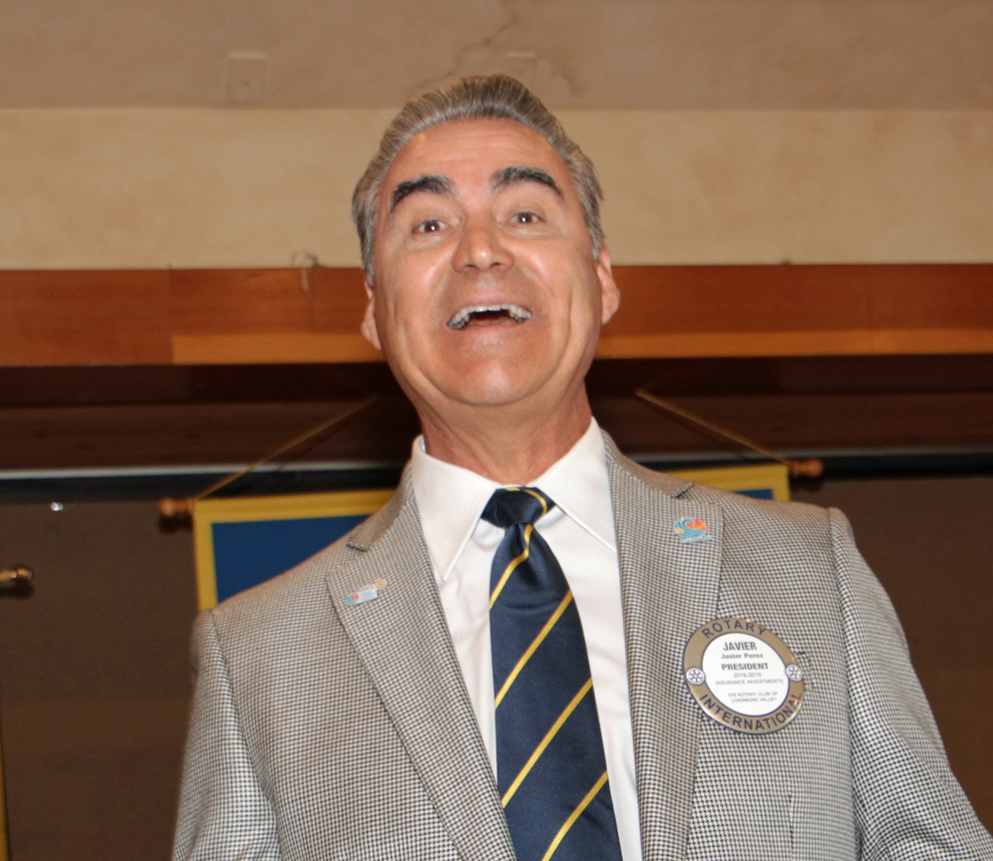

Visiting Rotarians, Bob Tucknott from Dublin and Ginger Faith from Pleasanton were welcomed. Gib is back (and almost mistaken for a visiting Rotarian).

10 Spot: Fred Quarterman announced the winner of the latest full 10 Spot Board. It’s Fred for the money and Charles Crohare for the bread and wine! Fred donated $600 to the club, $200 to RI and $200 to the Rotarian Foundation of Livermore.
Let’s start another board: Fred donated $20 for Lauren who has attended 2 weeks in a row. Gib gave $10 on behalf of the thief who stole the bell & gavel?! Jill wanted to recognize the birthday of Paul McCartney for $20. Lauren celebrated the birth of her niece for $20. Peter Quinn is back from Germany and he generously donated $100 to Polio Plus. He also gave Javier & Jill beautiful souvenirs from Germany. Beth recognized her son’s birthday for $10, and Charles is going to be a grandfather in November, $20. Javier bought two squares in recognition of his last meeting, and that he wasn’t saved by the bell!
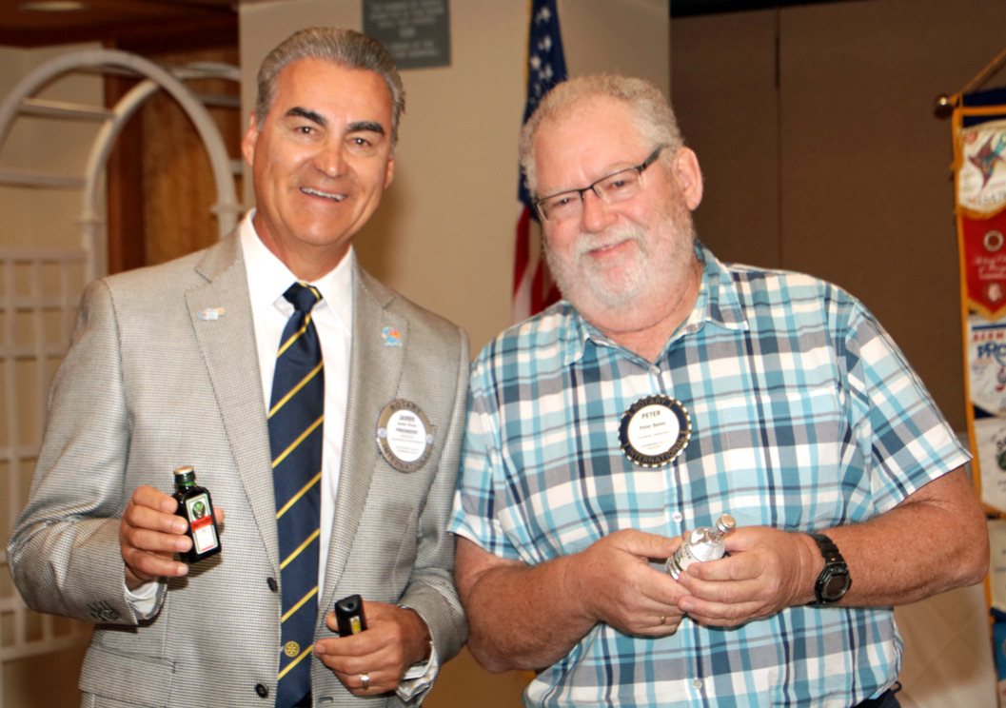
The Ed Schumann Show: It’s Baseball Season, so how many no hitter have been pitched? 300 (exactly), and the last one on May 7, 2019 by an Oakland A’s pitcher Fiers. So, what’s the difference between the Dodgers and the Giants winning a World Series? The Giants did it in technicolor?!
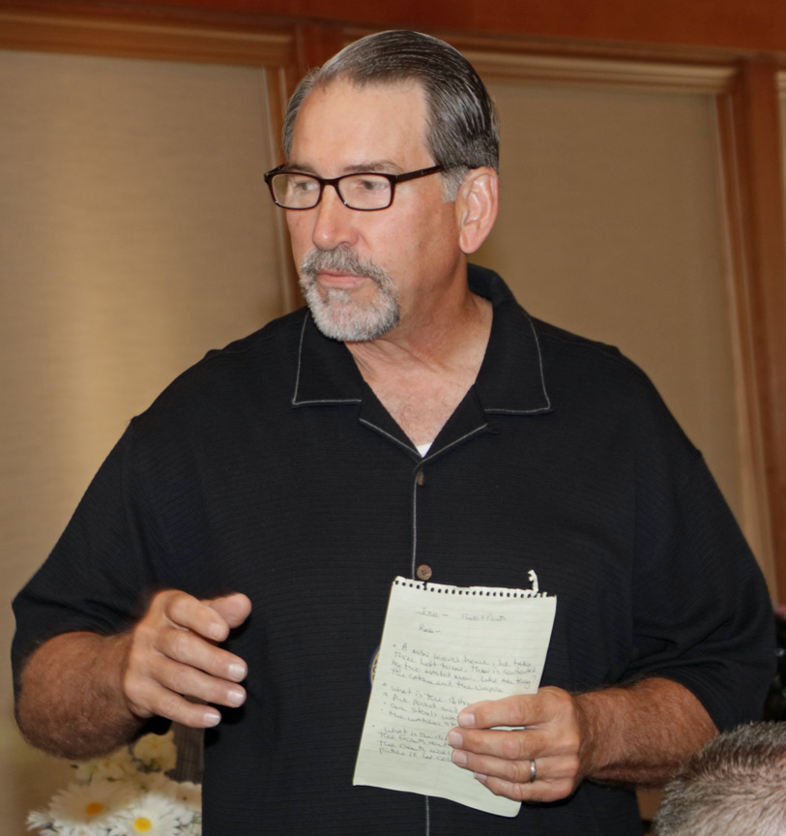

Member Talk: Steve Utley is a professional speech writer and has a passion for the subject. He’s excellent at giving impromptu speeches and was inspired to return to college and the speech team by a special friend. There are opportunities wrapped in challenges, and we’re all in the “connection” business. Steve asks himself each morning, “Who will I serve today, and why?” Welcome to Rotary Steve, it’s great having you share your enthusiasm!

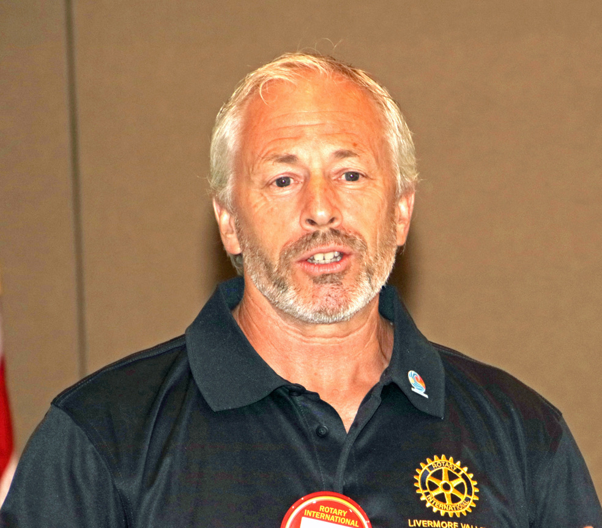

Announcements: Demotion dinner is MONDAY June 24 at Beeb’s at 6:00. Guests are welcome. Dinner will be hosted by the club (no charge for the food, but drinks are on you). Remember it’s Monday, not Tuesday. There is no meeting on Tuesday June 25. Please join us for the party, it’s time to roast the Prez.

The Program: Ginny Roth from the Alzheimer’s Association was our guest speaker. (That’s Alzheimer with a Z). Ginny is currently the chair for the Est Bay Walk to end Alzheimer’s. She has been a volunteer with the Alzheimer’s Association as both a policy advocate and chair for the past 4 years. The walks are conducted across the US, and are one of the most important sources of funding for research to combat the disease.
Alzheimer’s is a type of dementia that causes memory problems and by a show of hands half of us in the room have been directly impacted by it. The name of the disease comes from the first patient diagnosed with this form of dementia, Lois Alzheimer.

In 2019, Alzheimer was the 6th highest cause of death in the US, and the third highest in California. There is no cure or effective treatment, and the experts believe less than 50% of the cases get diagnosed. This year alone, they estimate the disease will cost $290B in Medicare expenses.

The Alzheimer Association wants the disease to be labeled a public health crisis, and they provide the private funding for innovative research to find a cure. Their mission is to eliminate the disease, with a vision for a world without Alzheimer’s.

Ginny encouraged us to join the fight. There will be an organized walk in San Ramon on October 26, 2019. Last year they raised more than $96M across the US, and $605k in the East Bay. The East Bay is in the top 30 regions in the US with the most funds raised. The goal for the East Bay this year is to top $1M.
Link to start a Rotary team alz.org/rotarianactiongroup. East Bay Walk to End Alzheimer's
Alzheimer's Association Mobile: 415.425.3591

