**Instructions for Self - Paced Online Orientation 2019-2020**

**Rotary Club of Livermore Valley**

**Page 1 of 2**

Welcome to the Rotary Club of Livermore Valley.

*One of the requirements of joining Rotary is to participate in an Orientation. This opportunity will familiarize you with all the aspects of Rotary and answer many of the questions you may have. We like to complete this process before your formal induction to make sure that you are aware of the opportunities and requirements of your Rotary experience.*

*The Orientation is conducted in two parts: Online and then a short visit with a Club officer to answer any questions you may have regarding Rotary.*

*To begin the online portion simply visit* [*www.livermorevalleyrotary.org*](http://www.livermorevalleyrotary.org) *– no password is required. Then proceed as follows:*

1. *Click on “Our Club”*
2. *A dropdown box will show “New Member Orientation’ – click on to enter*
3. *Orientation will load bottom left on your screen – Click to load*
4. *A PowerPoint presentation will appear – Click on “Slideshow”*
5. *Click on “From Beginning” – then click to stroll through pages at your pace.*
6. *Near the end of the Slideshow, you will notice a number on one of the slides. Please email* [*JHeavenston@calwater.com*](mailto:JHeavenston@calwater.com) *that number to signal that you are ready for Part 2 – your visit with a Club officer.*
7. *See page 2 for website illustrations.*

*Thank you for becoming a member of the Rotary Club of Livermore Valley and welcome aboard.*

**Instructions for Self - Paced Online Orientation**

**Rotary Club of Livermore Valley**

**2 of 2**



Click on Our Club - Click on New Member Orientation Drop Down

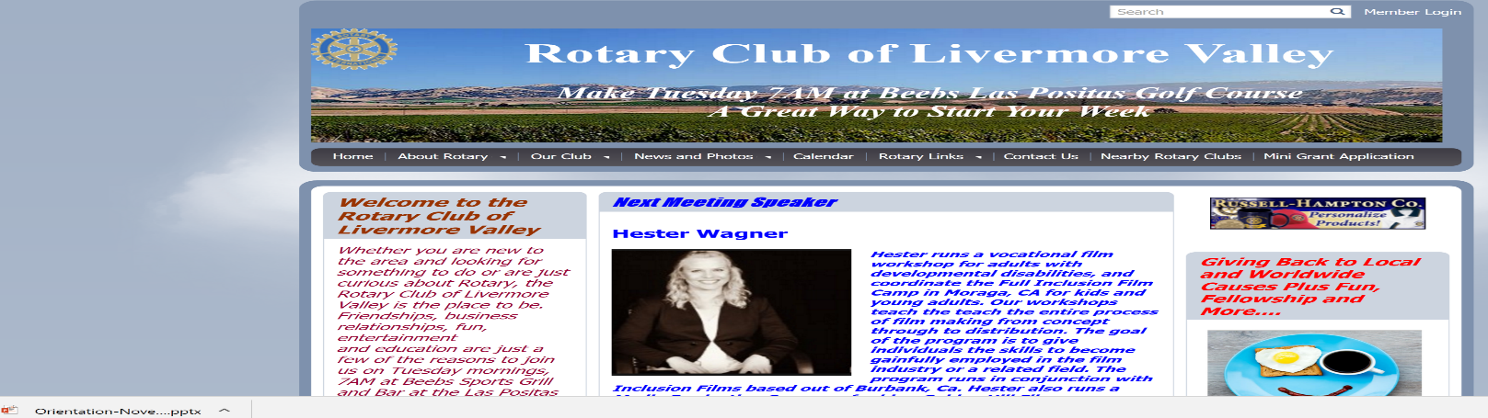

Open Orientation PowerPoint

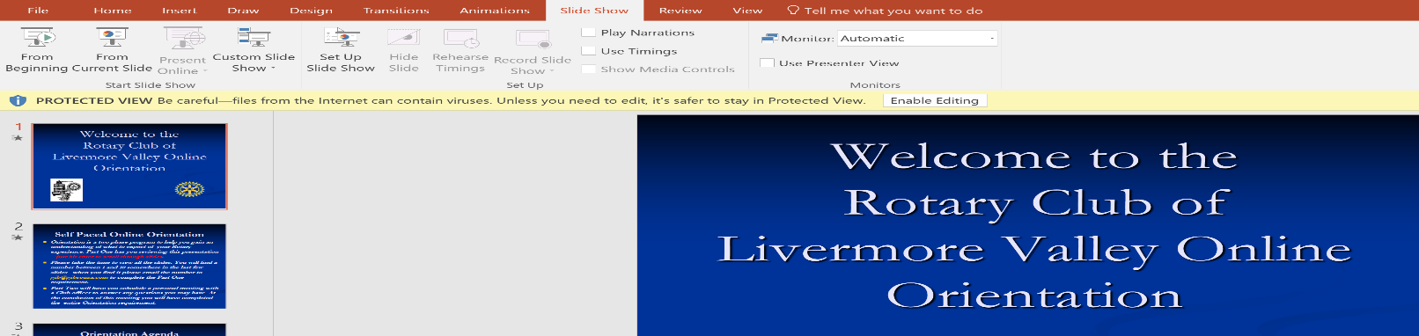

Click on Slideshow

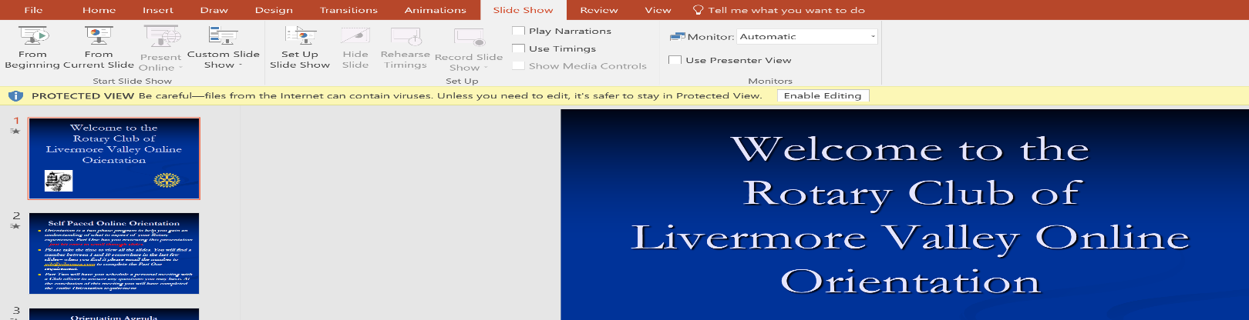

Click on From Beginning