Flags for Heroes

Sponsored by the Rotary Club of West Grove-Avondale

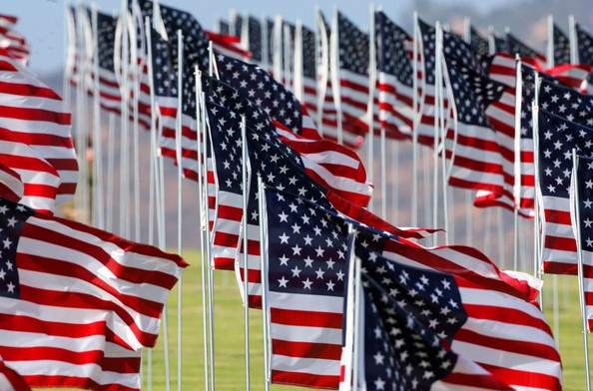

To commemorate Memorial Day, please consider sponsoring a flag to honor a hero. Whether it is someone who has or is currently serving our country, first responders, health care workers, and all essential personnel helping with the COVID-19 pandemic.

Flags will be 3 x 5 feet, pole mounted, and will be displayed at 796 & Baltimore Pike beginning Monday, May 18th through Memorial Day. Flag sponsorships are minimum $25 and all donations will support local community projects. These projects include The Garage, Bridge, Project Cure, and the local library reading initiative.

Thank you for helping us support Rotary service projects in the community and abroad.

--------------------------------------------------------------------------------------------------------------------------------------
Quantity: _________________ Total Cost: ($25 per flag) ______________________

Name: _______________________________________ Name of Hero: _____________________________________________

Email Address:_______________________________________________________________________________
(Preferred)

Address:_____________________________________________________________________________________________________________

Please make checks payable to:
West Grove-Avondale Rotary Foundation
Mail to: The Rotary Club of West Grove-Avondale
PO Box 280, West Grove, PA 19390

Payment or donation can also be made online at:
www.WestGroveAvondaleRotary.org
Address or email is required for tax receipt.

Rotary Foundation is a 501(c)3 nonprofit organization. Your contribution will be tax-deductible to the extent allowed by law

