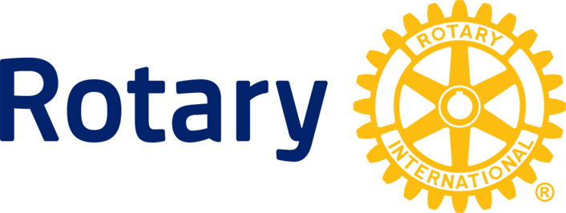West Kelowna Rotary Club
160-2417 Main Street,
West Kelowna, BC, V4T 2H8

May 30,2026

Royal Canadian Mounted Police

The West Kelowna Rotary Club is hosting an International Student who is under the age of eighteen. Rotary International requires that any Rotary member who may have close contact with the student and perform activities such as driving the student to events undertake a Criminal Records Check.

The holder of this letter is a member of the West Kelowna Rotary Club and a volunteer in our community work including youth activities.

The West Kelowna Rotary Club is responsible for the well-being of the student for the time they are in Canada.

Frank Proto
President, West Kelowna Rotary Club.

