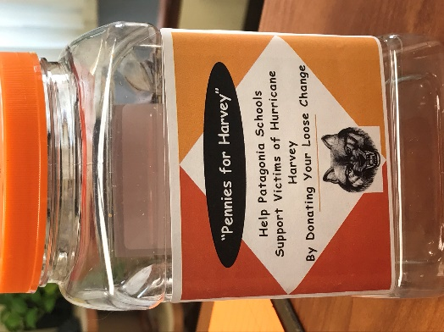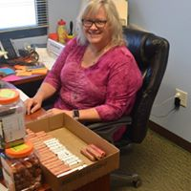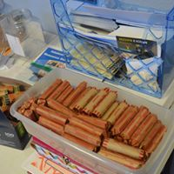
Rhonda Harrington, District Governor, Rotary District 5910
c/o Bobbie Applegate
985 IH-10N, Suite 111
Beaumont, TX 77706
Good morning, I have enclosed a check for $1,519.10 from the Mountain Empire Rotary Club, District 5500. We are a rural area in Southern Arizona and represent three communities - Elgin, Patagonia and Sonoita, AZ. The week after Harvey hit one of our members, Rotarian Rosann Clark, stated that the students at her school - she is the school counselor- wanted to do something to help students that are being affected. So, she came up with the “Pennies for Harvey” Project. Her school, Patagonia Elementary and High School K-12 has 175 students. The enthusiasm caught on and our second school, Elgin Elementary School K-8 with 112 students, jumped on board. The students raised $1,019.10 and our club added $500. As you can see Rosann had the “honor” of counting all that change!
The students also are sending some notes for you to share with students who suffered from the hurricane. The students would like their donation to go either to a specific class or school, so they can get whatever they need.
Please send us an update as to how the donation was utilized. The students here are excited to know what the outcome is. Pictures are great as well. I will make sure both school share the information with their students.
We are so happy to send this to you! I know it’s a small “drop” but it is coming to you with much love!
Yours in Rotary,

Sue Archibald, President, Mountain Empire Rotary http//www.facebook.com/Mountainempirerotary
PO Box 817, Sonoita AZ 85637 eggsuetrev@aol.com 520-990-4648

