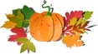

Lower Township Rotary Club
31st Annual Pumpkin Festival

23rd Share the Harvest Food Drive
(No glass or expired items, please.)

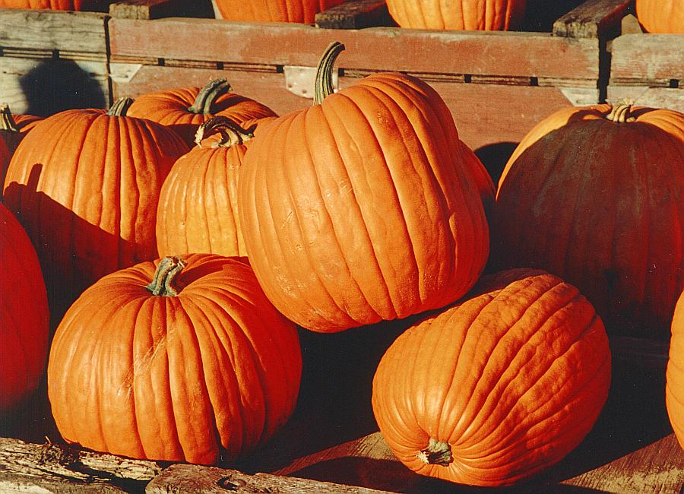
Saturday
October 14, 2023 10 am to 4 pm
Cold Spring
Village
Free Admission

Come out for a fun event the whole family can enjoy. Halloween parade, pumpkin painting, games, hayride, haunted barn, vendors, food and more.

Halloween parade information, call the Lower Township Recreation Center, 609-886-7880.

Vendor spaces available, email LTRotaryClub@gmail.com

Or Scan the QR Code
