www.scarboroughrotary.org

2019 Annual Christmas Wreath Fundraiser
Order Form

Name____________________________________________ Phone________________
Deliver to_________________________________________ Unit/Apt_____________
(Can only be delivered to Scarborough)
Email__________________________________________________________________

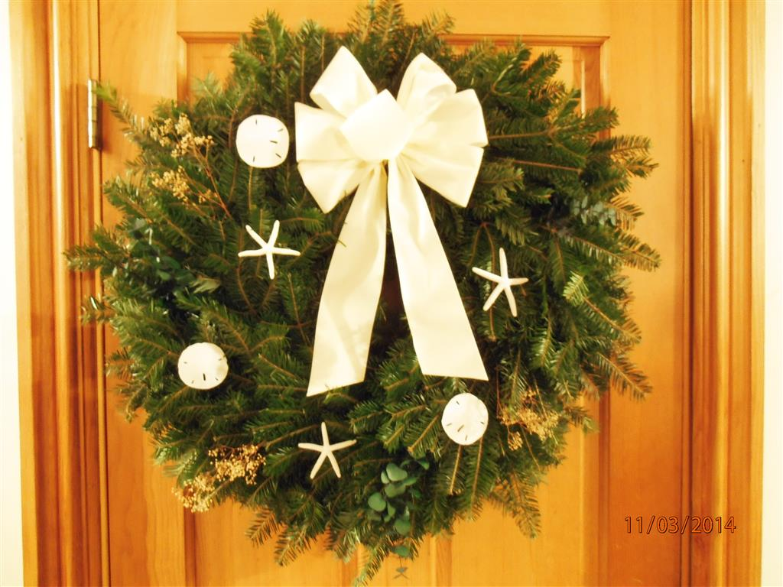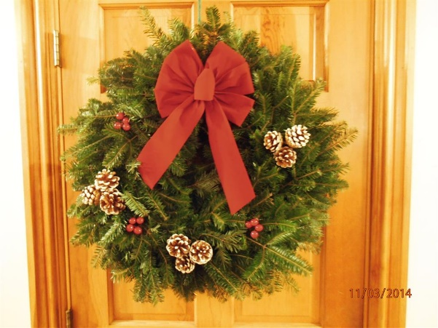

Seashell Wreath $25.00 Pine Cone Wreath $25.00

Seashell Wreath  Quantity____x $25.00=$_____ | Pine Cone Wreath  Quantity____x $25.00=$_____

Order must be received by November 30^{th.} Delivery expected week of Dec 1st.

Please mail order form and check to:

Rotary Club of Scarborough, Maine
P O Box 6455
Scarborough, Me 04070

For more information please call Deborah Pease 883-3964 or email debpease@outlook.com

