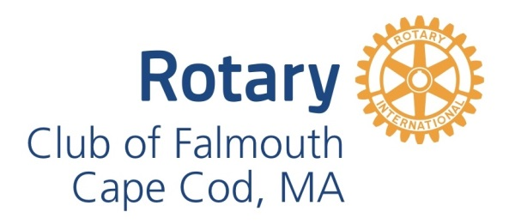
Rotary Club of Falmouth Guest Speaker Guidelines
Thank you for your desire to serve as a guest speaker and agreeing to share your expertise and experience at a meeting of the Rotary Club of Falmouth, Cape Cod.
Our Club meets for breakfast on Tuesdays at 7:30 AM at the Holiday Inn, 291 Jones Road, Falmouth, MA. The third Thursday of each month is a 6:00 PM Dinner Meeting beginning with a cocktail half-hour (cash bar) at 5:30 PM.
Our members start to arrive about 15 minutes prior to start of the meeting. Meetings usually run approximately 1 hour 15 minutes, sometimes longer depending on Q & A. You are our guest - so when you arrive, please let us know you are the guest speaker and enjoy your complimentary meal!
The Rotarian who invited you will introduce you. We do ask that you provide them with the introduction information you wish used well before the event date to allow us to promote your presentation on our website calendar.
The guest speaker is normally introduced after everyone has been served their meal. Club members expect our speakers to make a 15-20 minute presentation, followed by a few minutes of questions and answers. If possible, we will adjust our starting time to allow for your needs.
Please conclude your presentation within the alloted amount of time. Many members must leave to get back to work or other obligations. You may stay after the meeting and meet with members who wish to stay longer with questions.
Our club may have anywhere from 20 - 45 members and guests in attendance at any given meeting. Handouts for club members are always welcome. However, there are no copy facilities in the meeting room so you will need to make arrangements for copies of handouts in advance if they are required for your presentation.
Audio/Visual
Many speakers use Power Point or other presentation services to enhance their presentation. There is screen in the meeting space and a projector can be provided for you. Presenters will need to provide their own laptop computer, or request equipment to be provided by the Club..
Your presentation must avoid overt marketing. Making a "sales pitch" or directly soliciting purchases or donations is not in the spirit of Rotary. Presentations should not promote a specific business or its services and presentations should be non-political and non-sectarian, unless you have been invited specifically for that purpose.
Requests for donations from the club need to be made directly to the Board of Directors or Philanthropy Committee, as opposed to being solicited from the members during your presentation.

Thank you again for your willingness to be a guest speaker at the Rotary Club of Falmouth – we look forward to welcoming you!

