Rotary’s Areas of Focus

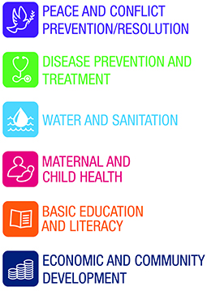
GRANT APPLICATION COVER SHEET
Rotary Club of Fairlawn

Date of Application: _________________

Legal name of organization applying: ______________________________________________________
(Should be same as on IRS determination letter and as supplied on IRS Form 990)

Year Founded: __________________ Current Operating Budget: ______________________________

Executive Director: __________________________ E-mail Address: ___________________________

Contact person/title/phone number:
(if different from executive director): ____________________________________________________________

Address (principal/administrative office): _______________________________________________________

City/State/Zip: ________________________________________________________________________

Phone number: ________________________ Fax Number: _________________________________
(include area code) (include area code)

Web address: _________________________________________________________________________

List any previous support from this funder in the last 5 years: __________________________________
____________________________________________________________________________________
____________________________________________________________________________________
Project Name: ________________________________________________________________________

Purpose of Grant (one sentence): ___________________________________________________________
____________________________________________________________________________________
____________________________________________________________________________________
Dates of the Project: ____________________ Amount Requested: $___________________________

Total Project Cost: $_________________________

Geographic Area Served: __________________________________________________________

GRANT APPLICATION FORMAT

Please provide the following information in this order. Use these headings, subheadings and numbers provided in your own word processing format, thus leaving flexibility for length of response.

- NARRATIVE

1. Executive Summary
- Begin with a half-page executive summary. Briefly explain why your agency is requesting this grant, what outcomes you hope to achieve, and how you will spend the funds if the grant is made.

2. Purpose of Grant
- Statement of needs/problems to be addressed; description of target population and how they will benefit.
- Description of project goals, measurable objectives, action plans, and statements as to whether this is a new or ongoing part of the sponsoring organization.
- Timetable for implementation.
- List of other partners in the project and their roles.

3. Organization Information
- Brief summary of organization’s history.
- Brief statement of organization’s mission and goals.
- Description of current programs, activities and accomplishments.
- Organizational chart, including board, staff and volunteer involvement.

- ATTACHMENTS

1. A copy of the current IRS determination letter indicating 501(c)(3) tax-exempt status.
2. List of Board of Directors with affiliations.
3. Finances:
  - Organization’s current annual operating budget, including expenses and revenue.
  - Most recent annual financial statement (independently audited, if available; otherwise, attach Form 990).

