Fellow Rotarians-
After the wonderful program presented by Emma VandenEinde at the 7/17/24 Rotary noon meeting, I just wanted to share some recent stories of John Matsushima’s Amache connections. (If you were unaware, John’s family was spared being interred, because they were living in Colorado, 1945 at the time of Japanese American’s that were sent to camps. Affected individuals were those living mostly on the west coast of the United States.) I had written these stories earlier for other family and friends to see (on Facebook) and emails, but wanted to share them with you all.
Enjoy the read, a bit long, but hope you enjoy with a nice cup (or 2!) of coffee or tea … Nancy

May 26, 2023
A hand-carved wooden relief brought two families together that began almost 80 years ago.
Before a thundering heavy rainstorm on the greenhouse roof could drown out our voices, some of the Matsushima and Yoshihara families met for the first time at the Lafayette Florist in Lafayette, Colorado.
In the mid-1940’s, the Yasutaro Yoshihara family was interred at Amache Relocation Camp, down in Granada, Colorado. When the incarcerated families were unsure of where they would go once “released” from the guarded gates, Mr. Yoshihara was able to leave the camp briefly, and brought his family up to Platteville, Colorado to meet with my grandparents. Since my grandparents lived in Lafayette for about 9 years before moving to Platteville, they were familiar with that area, and probably suggested they might like to start their “new life” in that town. As a Japanese custom, “omiyage” (a small gift or present) is often given to the person being visited. On this visit, Mr. Yoshihara brought a special present that he had carved and presented it to the Matsushima family.
Over the years, this carving stayed at the farm in Platteville, but during construction of a new home, it was in an entryway of the “old home” and was weathered and unfortunately collected some rain and mud. It was “rescued” from further damage and hung in my parents’ porch for many years.
Ron Inatomi writes stories on Facebook about Japanese Americans in the Produce and Floral Industry. He posted a story about the Yoshihara family’s Florist shop awhile back and later did a story on dad, on his work in the beef cattle industry.
Through an introduction of an email almost 4 years ago (just before pandemic started), Ron put me in touch with Lori Yoshihara Wheat, who, with her husband Brian, have continued the success of the family run florist/garden shop. After telling dad about the floral shop, he recalled right away who the Yoshihara’s were, and that the carving hanging in his porch came from Lori’s grandfather almost 8 decades ago, and told me how it became into possession at the Platteville farm. He also said that his parents would go and buy flowers from their shop for special occasions, like Memorial Day.
Once I knew there was a connection between the two families, and the story behind the wooden carving, it was a no brainer it had to go back to the family where it belonged.
Finally, some of both our family members met up this past Friday, and got acquainted with each other, and we brought this treasured carving back to the Yoshihara family. Coincidentally, my cousin Randy knows Lori’s aunt Ann, and she and her husband Bill extended their stay to join in the gathering. Both Ann and her brother Jim were featured in a recent CSU Alumni magazine article on Amache.
Small world with a great ending on the “circle of life of this beautiful carving”... our omiyage back to the Yoshihara’s.

**Note: Since the initial meeting, we have met up with some of the Yoshihara family members at various places: Loveland Art museum (Amache exhibit); Lafayette Florist- Lori Yoshihara Wheat (at the closing of the garden center, but opening a newer/smaller floral shop), visit at Amache in Sep 2023 to the museum and site (Ann and husband Bill), where we met and visited with John Hopper, and most recently saw John, Robert Fuchigami, and Ann & Jim Yoshihara at the Amache pilgrimage in May 2024.
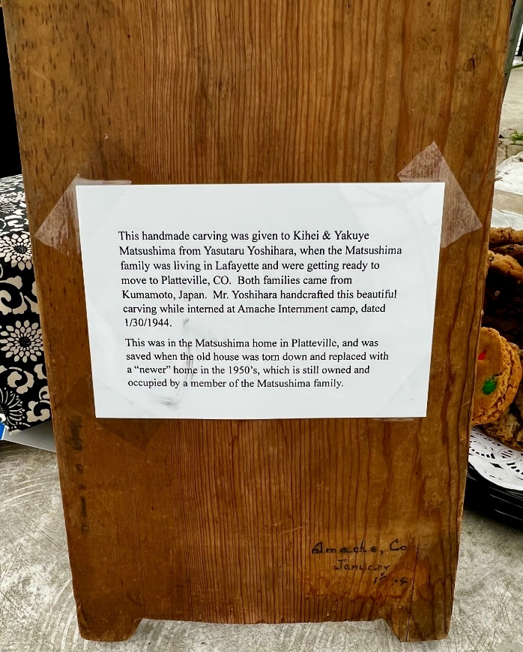
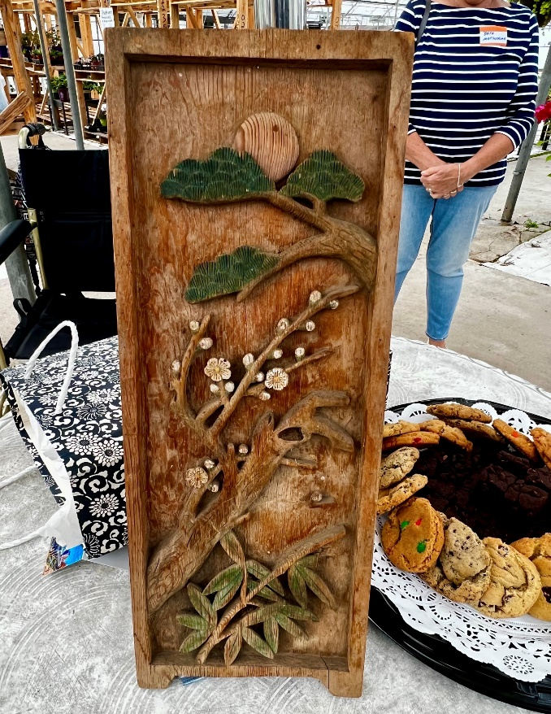

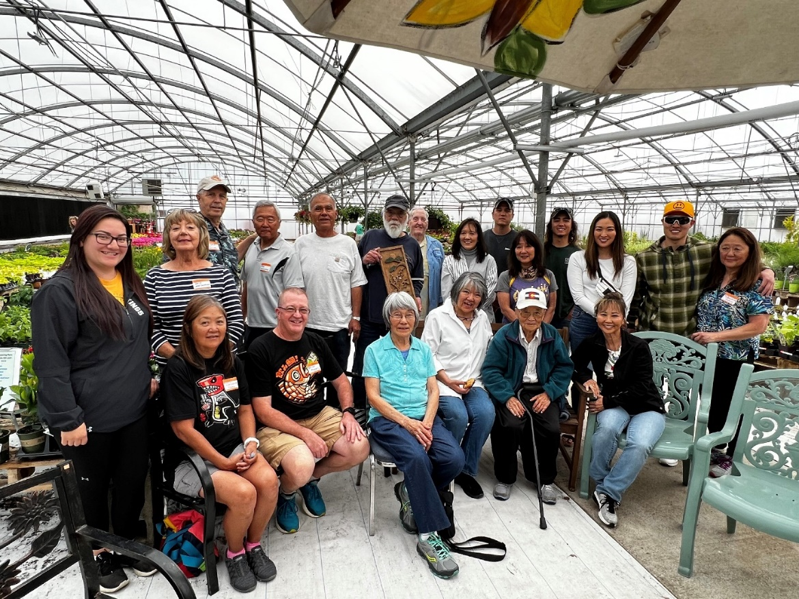

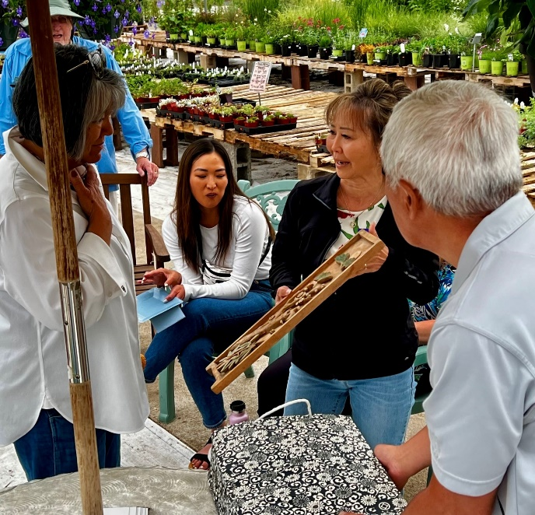
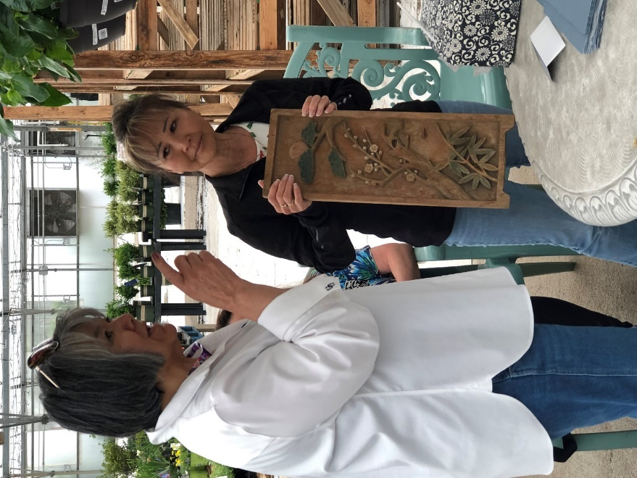

Presenting carving to Ann Yoshihara Murphy

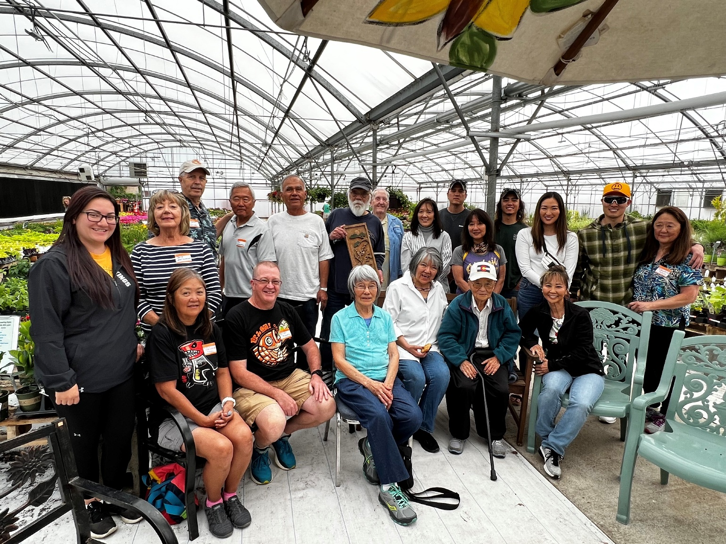
Matsushima cousins and Yoshihara families at the Lafayette Garden & Greenhouse 5/26/23
Gentleman holding carving: Jim Yoshihara and Ann Yoshihara Murphy (seated left of John), siblings that were children at Amache (their parents: father- Yasutaru and mother- Kumiko)
The story of the Yoshihara family was written in the STATE magazine of Colorado State University by Coleman Cornelius in December 2023. Link to the article: https://magazine.csusystem.edu/2023/02/13/amache/
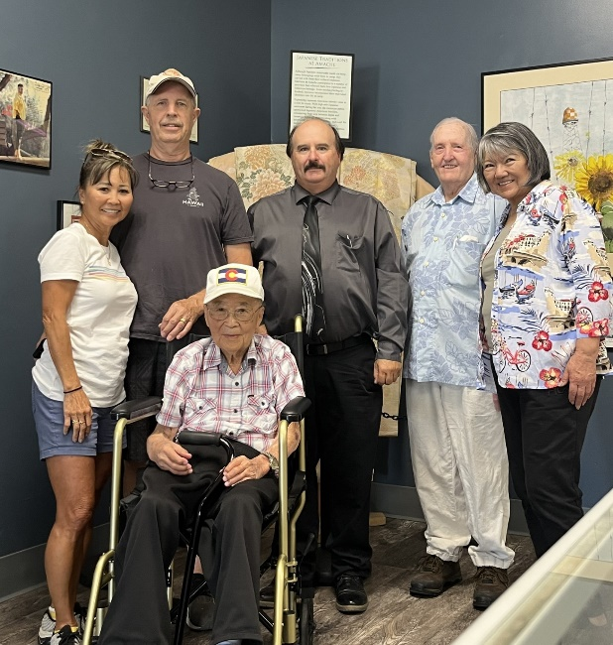

September 28, 2023
Visit to Amache museum – met John Hopper and Ann & Bill Murphy drove up to meet up with us from their home in New Mexico.

April 29, 2024
Another visit was made with Robert Fuchigami (Amache incarceree) and his daughters, Ellen and Kathy. It was a wonderful day, spent up in Evergreen, at Ellen's home.
This was set up by Margo Hamilton, whose father worked closely with John during the 70's at Colorado State University. Margo has kept in touch with Nancy, over the years, and she recently is working at Elk Run Assisted Living center in Evergreen, where Mr. Fuchigami is a resident. After they were talking about his background, and she mentioned John's name, and his history, Mr. Fuchigami was very interested in meeting him. So- a luncheon was set up with John, Robert, Margo and his daughters.
In Robert’s book, "Amache Remembered" he mentioned a few names that dad recognized, and they spoke of them. One of them - Nobuo Furuiye (who translated the names from Japanese of 114 internees who died at Amache). John said that Nobuo and his family lived next John’s family in Lafayette. Mr. Fuchigami’s book is a very good, informational book, if interested in reading up more about Amache.

A few very unique things we found out after conversations:
Both John and Robert were given Japanese names at birth, and were given "American" names from their first grade teachers, because the teachers couldn't pronounce their Japanese names, which the American names have stayed with them throughout their lives.
Both had 7 other siblings. Their mother's both had 5 boys and 3 girls. Robert was the youngest of the boys, and John was the oldest of the boys.
Both are the only living siblings of their family.
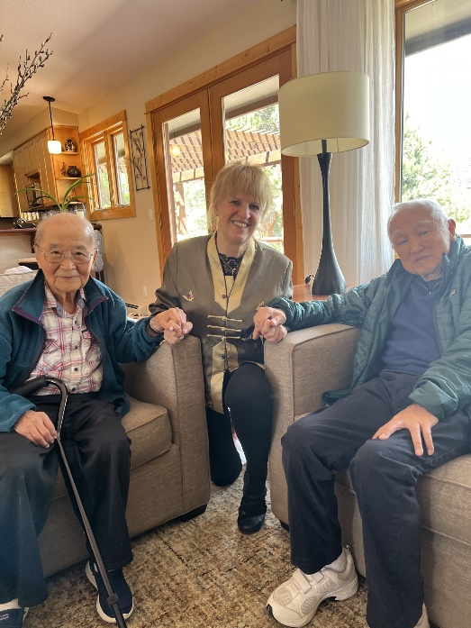
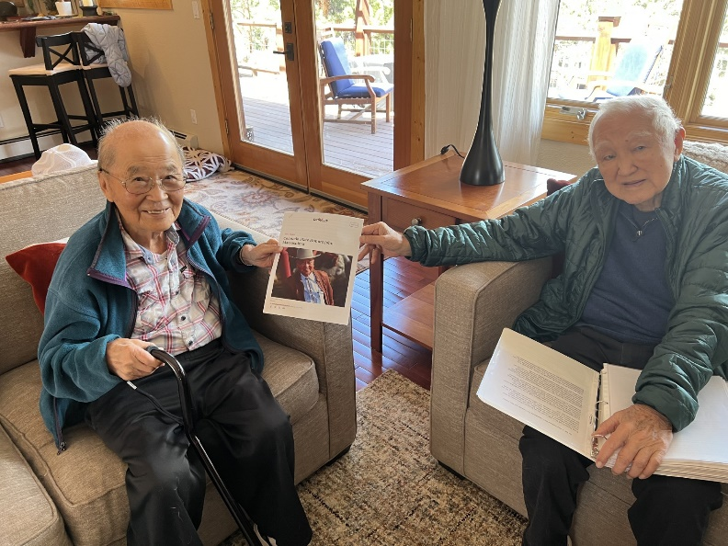

John & Robert Fuchigami – John signed an article that With Margo Hamilton Margo printed out for Robert (about John)

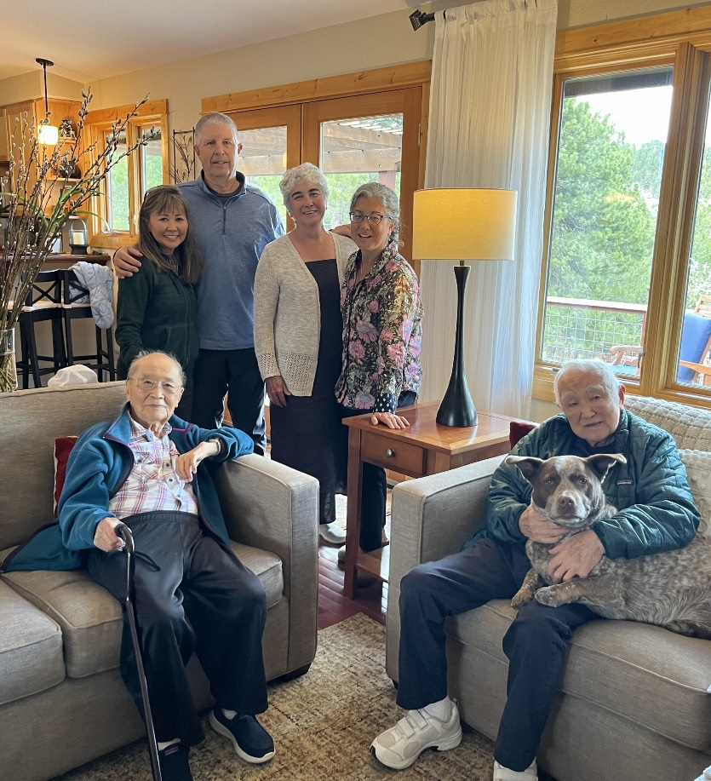
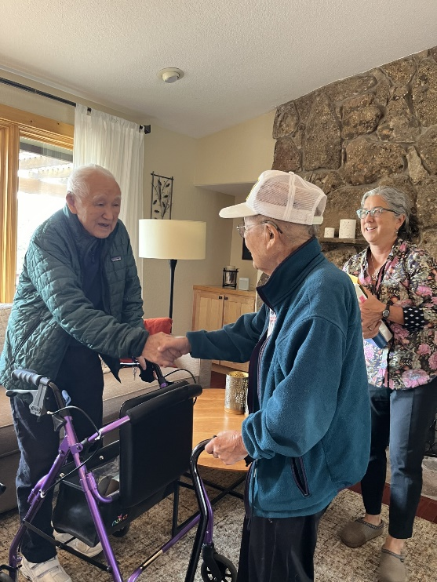

“

Until we meet again”

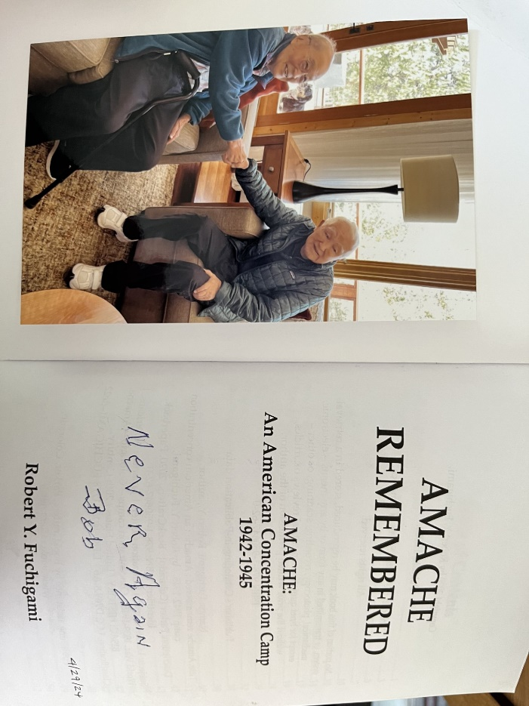
John, Nancy & Gene Oliver, Kathy, Ellen & Robert Fuchigami

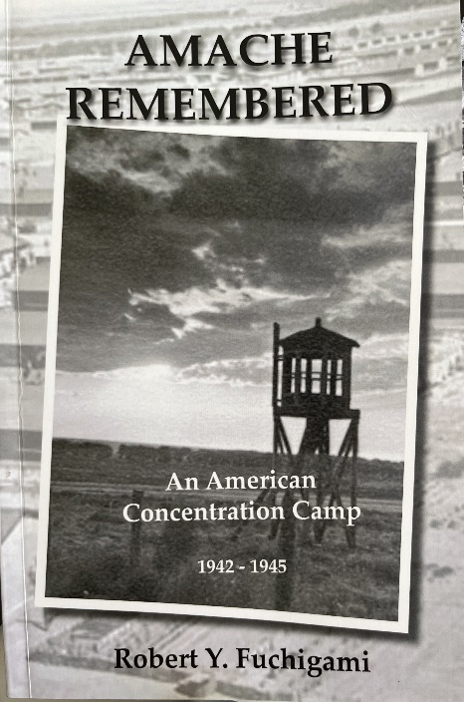

Also... Robert’s book had a short bio on Ernest Kuramatsu. Hi bio reads: “Ernest Kuramatsu was from Carmel Highlands. Mr. Kuramatsu was an artist, who received his training at the University of Minnesota. Born in Canada, he served six months in the Canadian Army in France during World War I. He had been working with Paul Dougherty, a famous artist of ocean water and wave paintings prior to his incarceration. In Merced Assembly Center he worked as a cook prior to arriving at Amache at the age of 58”.

Over the years there has ALWAYS been two paintings in my parents' living room (see below). I never really knew or asked about them when I was younger, they were just “always there”. It was after my mother's passing in 2011, that I started asking questions about them. One was signed (I thought "F") Kuramatsu, and the other was just the initials "G.K." I wondered, how could it be the same person with different signatures, but they were in matching frames, so I didn't really know.
John (dad) said that these paintings were from Dorothy, (my mother's) family, that he remembers them hanging in her parent's home. He also remembered my mother saying that the “water” painting was of Carmel. So they were probably a gift to my mother’s family when they lived in Alamosa.
Once I looked at the "F" again, I think it is actually an "E".
After I did more Googling, I found this link below. Reading it pretty much confirms that these two paintings were from this man. Thus – my question was finally answered over many years.
lp028-08-007 - CSU Japanese American Digitization Project - CSU Dominguez Hills Digital Collections (oclc.org)
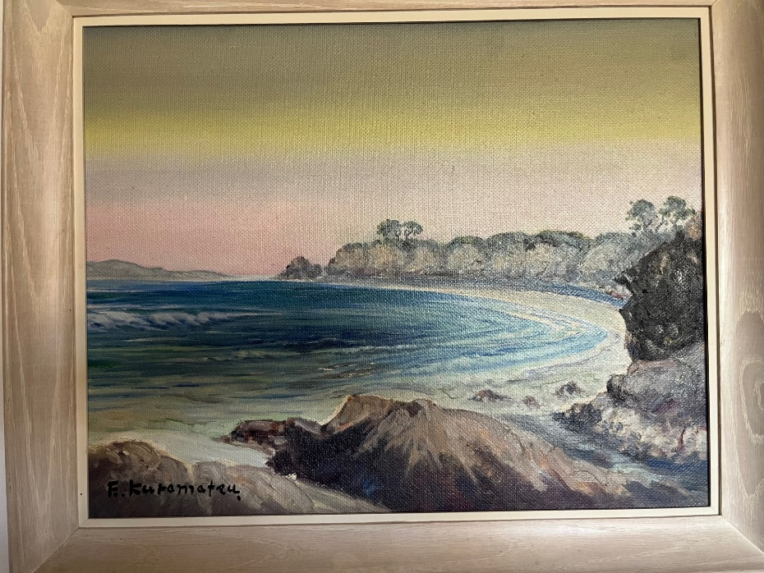

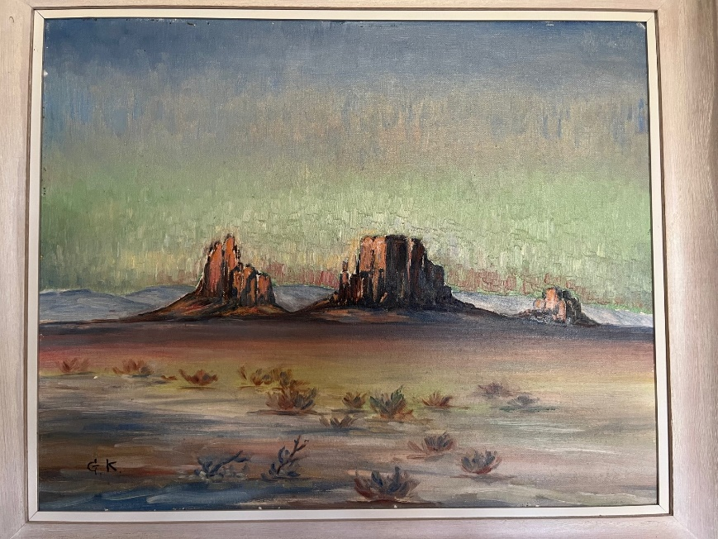

Small world… Treasured paintings

Finally – I wanted to send the link of the latest Amache newsletter. I thought you all might be interested in knowing, that the Rotary Club in Granada donated the display cases for the museum.
Newsletter Template (secureserver.net)

Some final photos to share from the Amache Pilgrimage that I took John to on May 18, 2024:
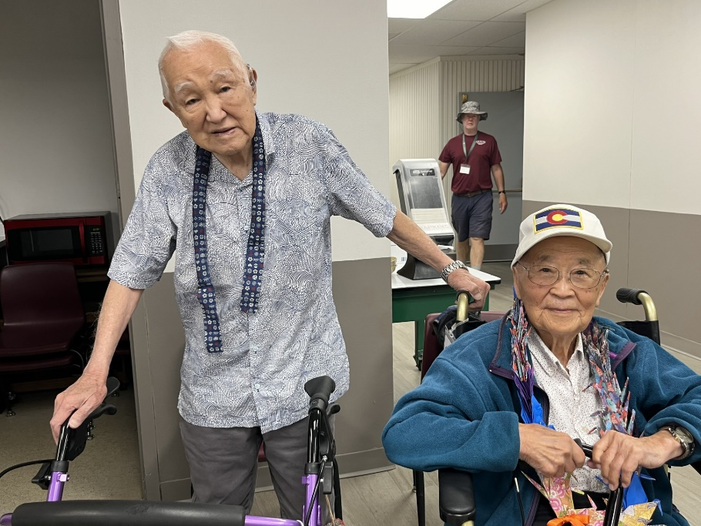
Robert Fuchigami and John at Granada High School after the visit to the Amache cemetery & ceremony

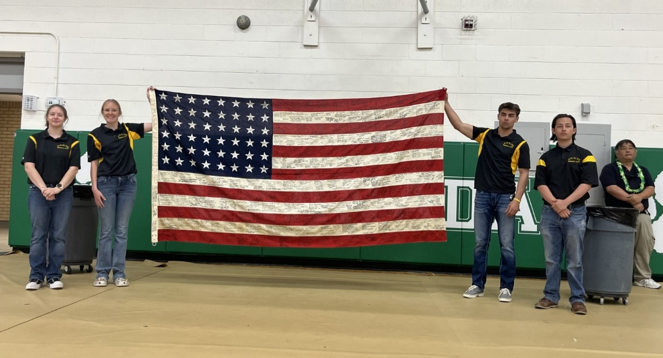
Students of John Hopper’s class program hold up flag #6 that is signed by internees and descendants that was donated to the Amache Museum.

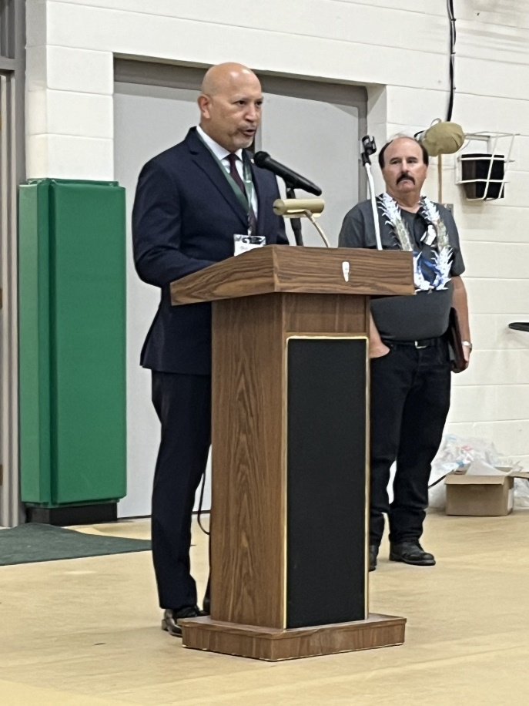
Judge Johnny Gogo from Santa Clara, CA organized the beginning of signing the flags with 48 stars (the US flag during 1945). These flags are signed by internees or descendants of families from the different camps. So far 13 (48 star) flags have been obtained and signed and have been/or will be donated to different museums in the U.S. John Hopper next to him, the Granada HS teacher. The goal is to obtain 5 more flags with 48 stars.

**Final note: I have contacted John Hopper about any interested parties in purchasing tshirts (like the one I wore at the meeting) or any other items they sell at the Amache Preservation Society. Presently the link to purchase is not on the website, but he informed me that when his website designer returns from their trip to Japan, he will make sure it gets put back on. In the meantime, if there’s an interest on items, he said to send an email to: amache@usa.com

Thanks for spending the time to read about John and our family’s new connections with some of these Amache families. Thank you Stacy Plemmons, for letting us know about the meeting presentation.
John VERY MUCH enjoyed seeing everyone again, the Rotary comradery is very special to him.
Take care!
Nancy Oliver

