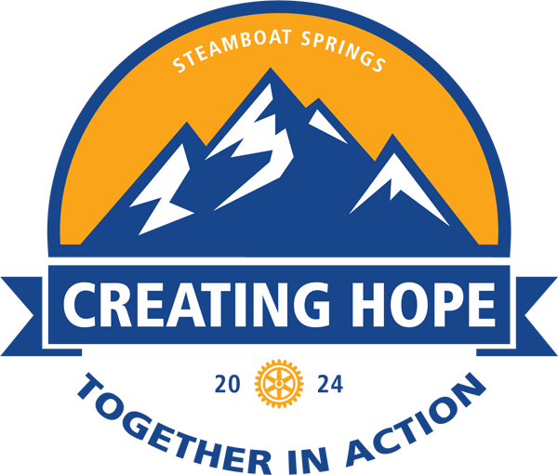

**DISTRICT 5440 CONFERENCE**

**May 16 – 18, 2024**

**Colorado Mountain College, Steamboat Springs, CO**

The ***Silent Auction Committee*** invites all Rotary Clubs of District 5440 to provide a basket, artwork, sculpture—whatever highlights the unique aspects of your community or region—for the silent auction. All proceeds will go to **Crutches 4 Africa**. Please provide information regarding your Club’s submission on this form so we may prepare for your donation. Thank you for your participation.

|  |  |  |  |  |
| --- | --- | --- | --- | --- |
| **Club Name** |  | | | |
| **Contact Name** |  | | | |
| **Contact Street Address** |  | | | |
| **City, State ZIP** |  |  | |  |
| **Telephone** |  | | | |
| **Email** |  | | | |
| **Preferred Method of Communication** | **Phone** | | **Email** | |
| **Delivery** | We will send our item **in advance** of the conference. | | We will bring our item **when we arrive for the conference.** | |

|  |  |
| --- | --- |
| **Basket / Item Name** |  |
| **Value** |  |
| **Minimum requested bid** |  |

**Please Email Complete Form To:**Randy Looper ([elkruninn@yahoo.com](mailto:elkruninn@yahoo.com))