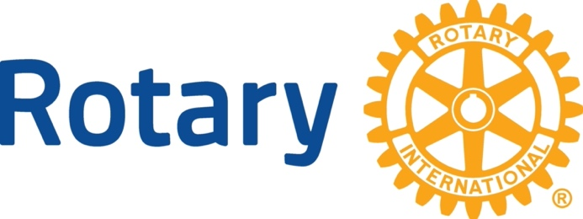
Lander Rotary Club 2024 Scholarship Application
The Lander Rotary Club is offering financial help to a selected high school graduate who demonstrates the values of the Four-Way Test of Rotary International. Rotary International is a worldwide service organization whose motto is “Service Above Self.”
About Rotary International
Rotary International is a global network of 1.4 million neighbors, friends, leaders, and problem-solvers who see a world where people unite and take action to create lasting change – across the globe, in our communities, and in ourselves. Solving real problems takes real commitment and vision. For more than 110 years, Rotary's people of action have used their passion, energy, and intelligence to take action on sustainable projects. From literacy and peace to water and health, we are always working to better our world, and we stay committed to the end.
Our Rotary Mission Statement
We provide service to others, promote integrity, and advance world understanding, goodwill, and peace through our fellowship of business, professional, and community leaders.
Our Rotary Vision statement
Together, we see a world where people unite and take action to create lasting change — across the globe, in our communities, and in ourselves.
Rotary’s Four-Way Test
Rotarians are guided in their daily lives and work, and in the service projects they undertake, by Rotary’s Four-Way Test, and review of your application will include consideration of how your educational work and extra-curricular activities have met these aspirational guidelines.
The Four-Way Test of Rotary International:
In everything we think, say and do:
Is it the truth?
Is it fair to all concerned?
Will it build goodwill and better friendships?
Will it be beneficial to all concerned?
Your scholarship application will be evaluated on a rubric consisting of your completeness of the application, the quality of your answers, your school transcript, ACT/SAT scores, your letters of support, and your service activities.
Submission requirements:
Please submit in 1 email:
- Your high school transcript
- Two letters of support
- This completed application
Email to: m2kidner2@gmail.com
Place “2024 Lander Rotary Club Scholarship” in the Subject line

-------- Submission Deadline: March 31, 2024 --------

Lander Rotary Club 2024 Scholarship Application

Your name:
Address:
Email address:
Your High School:
Your anticipated college:
Please answer the following questions fully and completely. You have 400 words maximum per answer.
Learning About You
- What are your current plans for college and your career? Why have you chosen this career path?
- Why do you think you should receive this scholarship?

- Considering all of your service activities, describe one person who impacted you and share how or why that person impacted you.

- This scholarship is money given directly to you to support your academic endeavors. We recognize that our $1500 scholarship will not cover a large portion of your expected college costs, yet all gifts are of great value when you are making big changes in your life. Please explain what you think you will use the 2024 Lander Rotary Club scholarship money for and why receiving this monetary scholarship is important to you in reaching your freshman year goals.

Service Above Self
In answering the following four questions, please describe in as much detail as possible how your actions and work have followed and applied the guidelines of the Four-Way Test (even though you might not have been aware of the Four-Way Test).
- Share an activity, event, project, or difficulty in your life in which you recognized the importance of being truthful as being critical to the success of the activity, event, etc.

- Share an experience where your volunteer work on a worthy project exemplified fairness to all who were participating in the project and whom you positively impacted.

- Share a time where, while volunteering, you developed an unexpected friendship and goodwill.

- Share an experience where you influenced the positive benefits to all concerned (yourself, your fellow volunteers, the people directly impacted by your volunteer work, and others [such as group(s) that financially supported or organized the volunteer work]).

Your academic goals
What academic career path are you planning to follow?
List your top three academic goals:
1.
2.
3.

