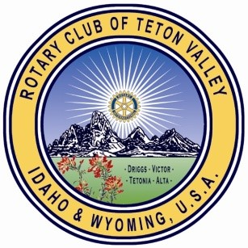
Rotary Club of Teton Valley Scholarship Application
Submit application by May 8, 2021 by email to tetonvalleyrotaryclub@gmail.com.
The committee will review applications and select candidates for interviews. Interviews will be held the week of May 10, 2021. Scholarships will be awarded by May 21, 2021. For questions, contact tetonvalleyrotaryclub@gmail.com.
______________________________________________________________________________
Name: Parent/Guardian Name(s):
Mailing address:
(Include city, state, zip)
Phone: Email:
Scholarship(s) applying for (all amounts are subject to available funds)
_______ Rotary Encouragement Scholarship $1000 - OPEN to ALL students
_______ Rotary Student of the Month $4000 - OPEN to students who have received Rotary Student of the Month
_______ Phyllis Morey Memorial Scholarship $2500 (renewable for four years) - OPEN to students with at least 50% Hispanic Heritage
A transcript is required for the application. Do you grant Rotary permission to request a high school transcript? Yes No
(Note: If you check no, your application will not be considered.)
What college/ university are you planning to attend? Why have you selected this school?

Have you completed FAFSA? Yes No
Rotary Club of Teton Valley Scholarship Application Page 2

What are your estimated expenses for your first year at school?
ESTIMATED EXPENSES | ESTIMATED INCOME SOURCES
Tuition: | Financial aid:
Room and Board: | Scholarships:
Books: | Anticipated Loans:
Other Expenses: | Family Contribution:
 | Your personal contributions:
Total: | Total:
On separate sheets:
Please submit your resume. This should include your academic accomplishments, GPA, work experience, service projects, and school and community participation.
Please submit a short essay (300 - 500 words) that describes a time in your life that has shaped who you are as a person. How will this influence your contributions to your community in the future? (Be sure your name is at the top of your essay)

