**Find Your Voice!**

**the Rotary Club**

**of Burkburnett**

**Rotary 4-Way Test**

**Speech contest**

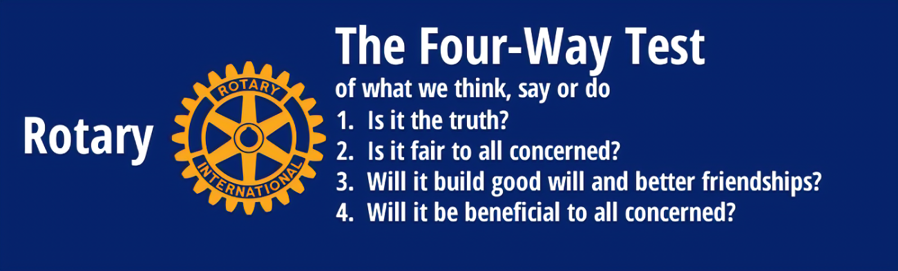

**4 Things to**

**Remember**

**When Finding**

**Your Voice ….**

**And the 5th – there are Monetary prizes for the first 4 places!**

**Top Prize is $150.00**

**Let your voice be heard!**

Find a subject that you are passionate about and apply the 4-Way Test!

Enter by Feb. 18, 2023. Contest will be February 28, 2023.

**The Contest Rules and entry form are attached. Contact Liz Talbert at (940) 781-6873 for questions.**



**Rotary District 5790**

**FOUR-WAY TEST SPEECH CONTEST RULES**

1. Contestants must be students from the 9th through 12th grade (public, private or home school)
2. The subject of “What the 4-Way Test Means to Me” should be closely followed.

Material must be original in content and be about applying the Rotary Four-Way Test to an important issue in our everyday relationships with other people. Contestants should write a speech with facts, statistics, stories, examples, and quotations. Contestants may add some humor and personal touches, but do not mention their names, schools or cities or the locations of their sponsoring Rotary Clubs. For important information about the 4-Way Test, go to [www.rotary5790.org](http://www.rotary5790.org) and click on “4-Way Contest”.

1. Written Scripts are not allowed; 3 x 5 cards may be used;
2. No props of any kind will be allowed.
3. A Five-minute time limit for each speech will be strictly enforced.
4. Speeches will be judged as follows:

* **Content – Counts as 1/3 of total score**
  + The speaker addressed the topic “What the 4-Way Test Means to Me”
* **Delivery – Counts as 1/3 of total score**
  + Vocal delivery including rate, volume, pronunciation, and variety; effective eye contact and gestures
* **Organization – Counts as 1/3 of total score**
  + Introduction of subject, main points, and conclusions



**Find Your Voice!**

**Rotary 4-Way Test**

**Speech contest Entry Form**

**Name of Student ____________________________________**

**Grade ____________________________________**

**Name of Parent _____________________________________**

**Student and Parent Contact Information**

**EMAIL ____________________________________________**

**EMAIL _____________________________________________**

**Cell Phone _________________Cell Phone_________________**

**Please Check**

**_________** Student will be able to attend the contest at the Rotary Noon meeting on February 28, 2023 @ the Culinary Arts Academy at 301 E. Third St. (With the Principal’s permission as requested by Rotary)

**_________** Student will be able to provide own transportation on February 28 at noon.

**_________** If student places first, student will be available to participate in one of the Rotary District 5790 Regional Competitions: Usually held around Saturday, March 25th; Saturday, April 1st ; or Saturday, April 8th. The first-place winner may choose the contest that best fits their schedule. Locations and confirmed dates will be announced soon.

**Email this Information to:**

**Liz Talbert at talbsac@gmail.com**