**Helping With Flags Instructions**

**Website (app.helpingwithflags.com)**

**If you do not have a login, ask Lenette Cox for your username and password.**

To generate your flag route:

On left side menu, click Flag Delivery

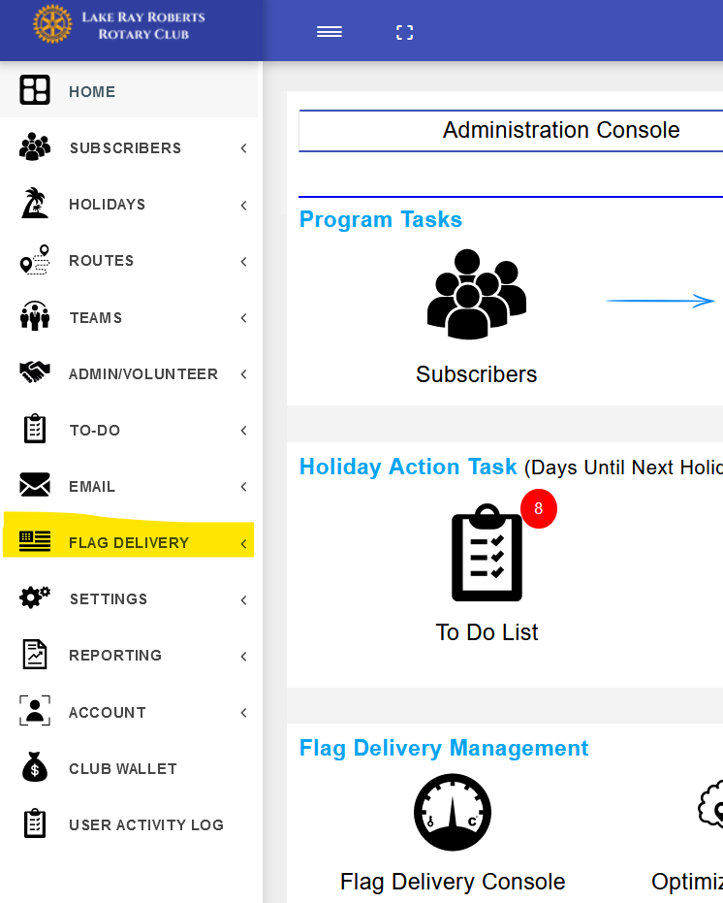Then click Optimize & Print

Routes from this page can be displayed and printed in:

* Map Form
* Excel Spreadsheet
* PDF File

PDF File will be color coded based on who has paid and is ready to be printed. Map view and Excel Spreadsheet both show all flags and has no way to show between Paid / Not Paid.

Map Form can be optimized by Shortest Distance. Select Start Point for your first address and End Point for your Final Address

Once flags are set, Go to “Flag Delivery Console”, Select Holiday at the top drop-down menu, Select Team from second drop-down menu, click individual flag and “Set Flag”

(you can zoom in on your flag area using the + and – buttons in the bottom right corner of the map)

Once Flag has been picked up, click individual flag and “Reset Flag”

Should there be notes regarding specific addresses (Flag Missing, Needs Flag Sleeve, etc.), they can be added in this panel.

**Mobile App (app.helpingwithflags.com)**

**It is the same Login as the Website (ask Lenette Cox for your username and password if needed).**

At top, Select Team from drop-down menu (Defaults to “All”)

Zoom in on map to Flags you are ready to Place

Number displayed on flag is number of flags for that address (See below – 1 is 1 flag at that address, 2 is 2 flags at that address)

Once flags are set out, click on Flag Icon and select “Set Flag”

You can also add To-Do notes for specific addresses, as well as Flag Placement Notes (Left / Right of Mailbox, Driveway, etc.)

When picking up flags, click on Flag Icon and select “Pull Flag”

Should you want to make notes for the next flag day, click “Next” below map, zoom in to address and add notes. That will change to the next Flag Day.

Hitting “Reset” will Undo the last change made to the address.