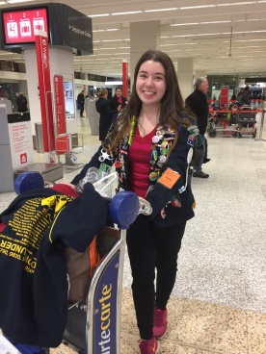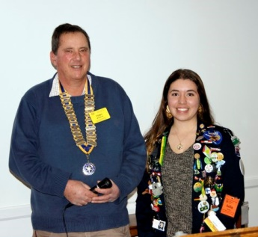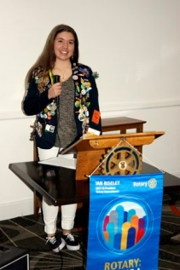

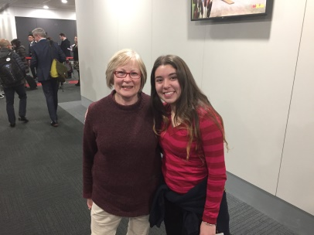

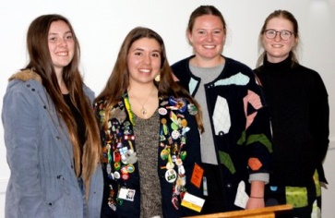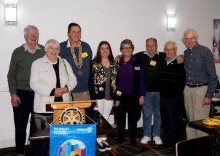

**JULIA’S FAREWELL**

Last week we said goodbye to our Youth Exchange Student, Julia and presented her with a few small gifts to remember her time with us. A laughing Kookaburra toy, a bag made locally, plus a book on East Gippsland written by our own Rosemary Douglas. We were lucky to have the company of her host father John, with host sister Cait.

Julia said that it felt like only yesterday that she arrived here and found it hard to put in words what the last ten months have meant to her. Delight, satisfaction and gratitude were a few good words to describe it. She has loved the culture and unique beauty of this country that we call home. She made some amazing friends while here, which have helped to make her a more mature and sensible person, her own words.

It has been honour for her to have been an exchange student and commented that to be amongst people, in a society where time is money, still give their time to try and make the world a better place. She believes that each one has been a big example to her and shaped what she would like to become, we have taught her that no matter where you are from, you deserve respect and equality.

She learned to appreciate different cultures and encourages us to identify with them somehow and in a world that is lacking in respect and union, all made apparent to her during her stay here. She thanked us for the opportunity that we have provided and wished that more people could have this same, incomparable experience in becoming a citizen of the world.

As you will agree these are wonderful words and we could all take on board this message and use them in our lives. Thank you Julia!!

Thank you to Margaret Macfarlane who in her first year as a Rotarian did a wonderful job looking after Julia during her time here plus made sure that she got to the airport and made her flight back home, together with her mountain of luggage

Some of the pictures from our great meeting last week, plus Julia at the airport.

Not forgetting that last week we welcomed club guest Michelle who is considering joining our merry band. We must have made a good impression

Celebrations

**No celebrations this week**

Guest Speakers

Last week we were treated to a wonderful talk by Claudia Duke and Zoe Vaughn, two medical students who are currently completing their rural year working in East Gippsland.

They are part of TeamMed, a student led organisation formed in 2009, that provides Monash University students with the opportunities to experience and contribute to Global Health.

10 students from years 1 – 5 (interestingly 70% female) will be travelling to the rural mountains of Nepal to provide medical aide, run a health promotion program and donate much needed supplies to the community. They will be working with the Kathmandu based organisation Himalayan Guge Organisation (HGO) together with a trained Nepalese doctor who will accompany and guide them in running the clinics. They will run a health promotion campaign together with health education and this year will be working with Days for Girls. Any money raised will be used towards building a permanent clinic in Bigu Gompa, the larger of the two villages that they will visit, an ongoing project is currently underway with HGO and the TeamMed. All expenses for the trip, travel etc is funded by the participants themselves, so any donations would be greatly appreciated to provide much needed medicine and facilities.

HGO is a family organisation established in 2013, providing support for the communities and has a strong alliance with the Bigu Nunnery which is where one of the clinics will be run. The nunnery will also be instrumental in helping distribute the Days for Girls kits. These kits will be sourced in Nepal where they have been made by the locals providing micro industry and a source of income.

They will fly to Kathmandu and spend a day working with the Days for Girls organisation, plus visit a local hospital, to get a better understanding of the health issues that they are facing. Then it will be a jeep ride, plus short hike to Dolangsa Sherpa village where they will set up the first medical clinic, running for two days.

A two day hike will follow to get to Bigu Gompa where they will run a three and half day clinic which will include a workshop in health care with the nuns. Bigu Gompa has a population of approximately 2500 including 80 nuns and is 200km north east of Kathmandu at an elevation of 2505 m. It was seriously affected by the 2015 earthquake with many buildings suffering dramatic cracks or reduced to rubble. The visitors quarters at the nunnery were completely destroyed so therefore the team will be staying in tents.

Some of the common conditions that they will be dealing with are – reflux, chronic pain (caused by the heavy loads and the amount of walking the Sherpas have to do), so they will be tailoring the medications to suit the situation.

We were all very impressed with these bright, bubbling young ladies who we know will do themselves proud in their work in Nepal

**WHAT’S ON**

**Our Meetings (5.45 for 6.15pm) & Other Events**

**25th July Board Meeting**

**All Directors to have a report prepared**

**1st August Steers for Students Update**

**8th August District Governor Don Ripper Visit**

**Partners welcome**

**15th August Trip USA - Gillian**

**OTHER CLUBS MEET**

Monday Mitchell River @ Bairnsdale RSL

5.45 for 6pm. Leave message Ph: 9517 1220

before 11am Mondays

Wednesday Bairnsdale Sunrise @ International Motel

Registration, Sue, Mobile 0438 278 258

Lakes Entrance @ Central Hotel, Esplanade,

6 for 6.30pm. Attendance, Lesley 0419871197

Thursday Orbost @ The Orbost Club

6 for 6.30pm. PH Wendy 0457 345 369

**Our Meetings (5.45 for 6.15pm) & Other Events**

**11th July Meeting. Club Planning & Membership**

**18th July Meeting. TBA. Send off to Julia?**

**25th July Open Board Meeting/Club Assembly**

**August Meeting. District Governor Don Ripper**

**Other Meetings & Events**

**13th July Inner Wheel Club of Bairnsdale at B/dale RSL**

**OTHER CLUBS MEET**

Monday Mitchell River @ Bairnsdale RSL

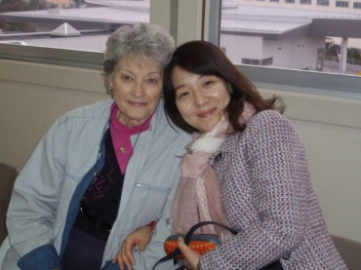

I have been advised by Pat Phillip that the father of Mitsuko Horamai has passed away Pat and Don were councillors for Mitsuko whilst an exchange student from Japan with our club in 1980-81. During her exchange Mr & Mrs Horamai visited us and were hosted by Don and Pat.

A strong contact has been kept with Mitsuko. Rhonda and Noel, Lea Anderson, Helen Gottschalk, Karen Phillips, Russell & Susan Anderson have all visited.

Mitsuko visited Australia for Karen Phillips wedding Mr Horamai was a dentist and lived in the Iwate Prefecture. We as a club extend our condolences to Mitsuko

*Rhonda*

Mitsuko with Helen Gottschalk

It is with sadness that I have to report that John Glass lost his battle with cancer last Thursday surrounded by his family The memorial service will be held:

Peter Murray Funerals – 30 Victoria Street

Monday 31st July 2017

2.00 pm

I am sure that many of our members will want to attend and say farewell to a dedicated Rotarian

**Condolences**