FRIENDS OF THE ROTARY CLUB OF MAFFRA

The Rotary Club of Maffra would like to invite local community minded people from Maffra and surrounding districts, such as Stratford, Briagolong, Newry and Heyfield, to become friends of the club.

We know how busy life is nowadays, with kids, sport, family and work commitments. There is simply not enough time in the day! We understand that it’s not possible for everyone to attend meetings twice a month, so we are offering the opportunity to participate in our activities without the responsibility of full membership.

By being a Friend of Maffra Rotary you would be able to join in club events and/or donate to club projects and fundraisers, as and when you are able to.

Club events include social activities (such as a recent boat trip to Wilson’s Prom) and guest speakers at our meetings. We also provide Maffra with a monthly market, Woolworths Sausage Sizzle, community caravan, Australia Day Celebrations and the annual Mardi Gras.

We have recently become involved in Rotary’s seventh area of focus, ‘Protecting the Environment’, by providing nest boxes and planning for replacement of the Alistair Fielding bird hide in Maffra Wetlands.

As a Friend you would also receive our club bulletin, which will give advance notice of our guest speakers and other events.

While you are welcome to come to any of our meetings, if you find that you are attending regularly, we hope that you would consider becoming a full member, as you are demonstrating the enthusiasm that we look for in Rotary. However, there is no pressure to take on full membership. In fact, if you wish to just support Rotary by becoming a Friend without participating, that is fine too.

If you wish to become a ‘Friend’, do please send us an email so that we know, to rotaryclubmaffra@gmail.com

PTO….
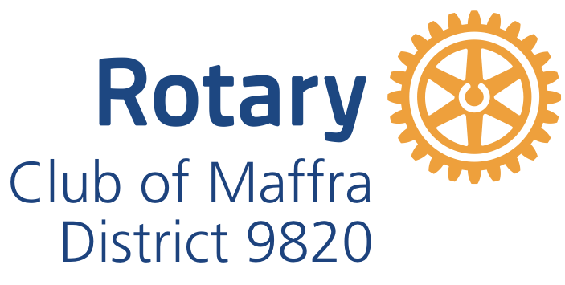
To become a Friend of Maffra Rotary, just pay an annual administration fee of $30 minimum, or by donation.

Fees can be paid by direct deposit or by card or cash at the Maffra Community Market, or at a Rotary meeting.

When you have paid the administration fee please send an email to:
rotaryclubmaffra@gmail.com
with ‘Friends of Maffra Rotary’ in the subject line.

Please include the following information:
Full name.
Email address
Phone number
Date of payment.

Details for direct deposit are as follows:
Rotary Club of Maffra
BSB 633000
119 707 511

For further information don’t hesitate to contact a Rotary member, or send us an email. Thank you for your interest in the Rotary Club of Maffra, and in Rotary!

We hope to meet you soon.

