


Rotary Club of Maffra
PO Box 154, MAFFRA 3860, VICTORIA AUSTRALIA
E: rotaryclubmaffra@gmail.com
WEB: www.maffrarotary.org
Rotary Club of Maffra meets every Thursday, 6.00 for 6.30 pm
Duart Receptions, 20 McLean Street, Maffra
Apologies and visitors to Nathan Smith by 1 pm. Telephone (03) 5147 1985

RI President Ian Riseley, District Governor Don Ripper, Assistant Governor Bill Degnan

Volume 70, Number 14 Thursday, 5th October, 2017
VICTORY THROUGH HARMONY
TOAST “TO THE PRIVILEDGE OF COMMUNITY SERVICE”

ROLES AND RESPONSIBILITIES 2017-2018
BOARD MEMBERS

President Graeme Hemming
Immediate Past President Sue Gray
Secretary Dianne Honey
Treasurer Helen Lanigan
Administration/Foundation Graeme Hemming
Service Projects Cath Noble
Membership/Public Relations Dianne Honey
Board Members Veronica Dwyer
Roger Malouf
Ted Mitchell

OTHER ROLES
Publicity Dianne Honey
Sergeant at Arms/Fines Cath Noble and John Watts
Program Co-ordinator Veronica Dwyer
Club Bulletin Dianne Honey
BBQ Co-ordinator Hans Van Wees, Brian Gray
Attendance Neil Wishart
Arthur's Swindle Sandra Houghton
Family of Rotary Dianne Honey
Club Protection Officer Sharon Knight
On to Conference Sue Gray
Club Website
Rosters – Registrations, Friendship, Property, Caravan, BBQ Helen Lanigan and Veronica Dwyer

COMMITTEES
FOUNDATION and  ADMINISTRATION | PUBLIC RELATIONS and MEMBERSHIP | SERVICE PROJECTS
Graeme Hemming  Helen Lanigan  Veronica Dwyer  Neil Wishart | Dianne Honey  Roger Malouf  Sharon Knight  John Watts | Cath Noble, Sue Gray, George Duursema, Brian Gray, Sandra Houghton, Ted Mitchell, Hans Van Wees, Nathan Smith, and John Osborn.

The past week in review and notes for 5th October, 2017
Apologies: Brian Gray, Ted Mitchell, Sue Gray, John Osborn and Sharon Knight. Leave of Absence: George Duursema, Veronica Dwyer, John Watts, & Hans Van Wees.
The Chairman, Neil Wishart proposed the Toast.
President Graeme Hemming welcomed members and our Guest, Sean to Gippsland Rotary Centenary House where we were hosted by committee member Dianne
Presidents Report
Board members are asked to meet at Duart at 5pm when the DG visits on 12th October, coinciding with Lift the Lid on mental health. Graeme asks members to wear a hat! October 19th is Mardi Gras, Committee Meetings and Board. Graeme has contacted Peter Quennell regarding manning a gate at the Maffra Show where we will have a trade stall to sell the brand new gumboots given to us by Daviesway. Graeme has had several people respond to the advertisement in the Gippsland Times about the Rotary Club of Maffra Mardi Gras.
Correspondence –
Publicity & Membership
Dianne has contacted the local town’s newsletter’s Editors requesting they could publish her article about the Rotary Club of Maffra Mardi Gras. She continues to post on Facebook with a good response to the posts. She is also updating our Club Runner website page. This is a work in progress. If you haven’t had a look recently, could I suggest that you do please. It is found at www.maffrarotary.org.au
Member’s Reports
Brian Gray continues to recover from his illness, staying inside in the cool evenings. Roger was at this tour of GRCH wearing soft shoes.
Meeting Attendance – from Neil Wishart – 7 present with 5 apologies, 1 Guests and 4 leave of absence.
Club Service: Brian Gray and Cath Noble did caravan duty. Thank you
Bits and Bobs
Caravan – Nathan Smith to deliver and John Osborn to pick it up and return to its home.
Next meeting: The DG’s visit! It’s also Lift The Lid on mental health week. Please wear a hat! Board members please meet at Duart at 5pm if you are available.
Guest Speaker
Committee member Dianne Wilkinson welcomed us to Gippsland Rotary Centenary House. Dianne Wilkinson is a member of the Moe Rotary club where their Assistant Governor is Carol Crewe. Carol is the Manager of Gippsland Rotary Centenary House. After a short PowerPoint presentation Dianne led us on a tour of the House. She is very proud of the House and the community commitment and support that is given to it.
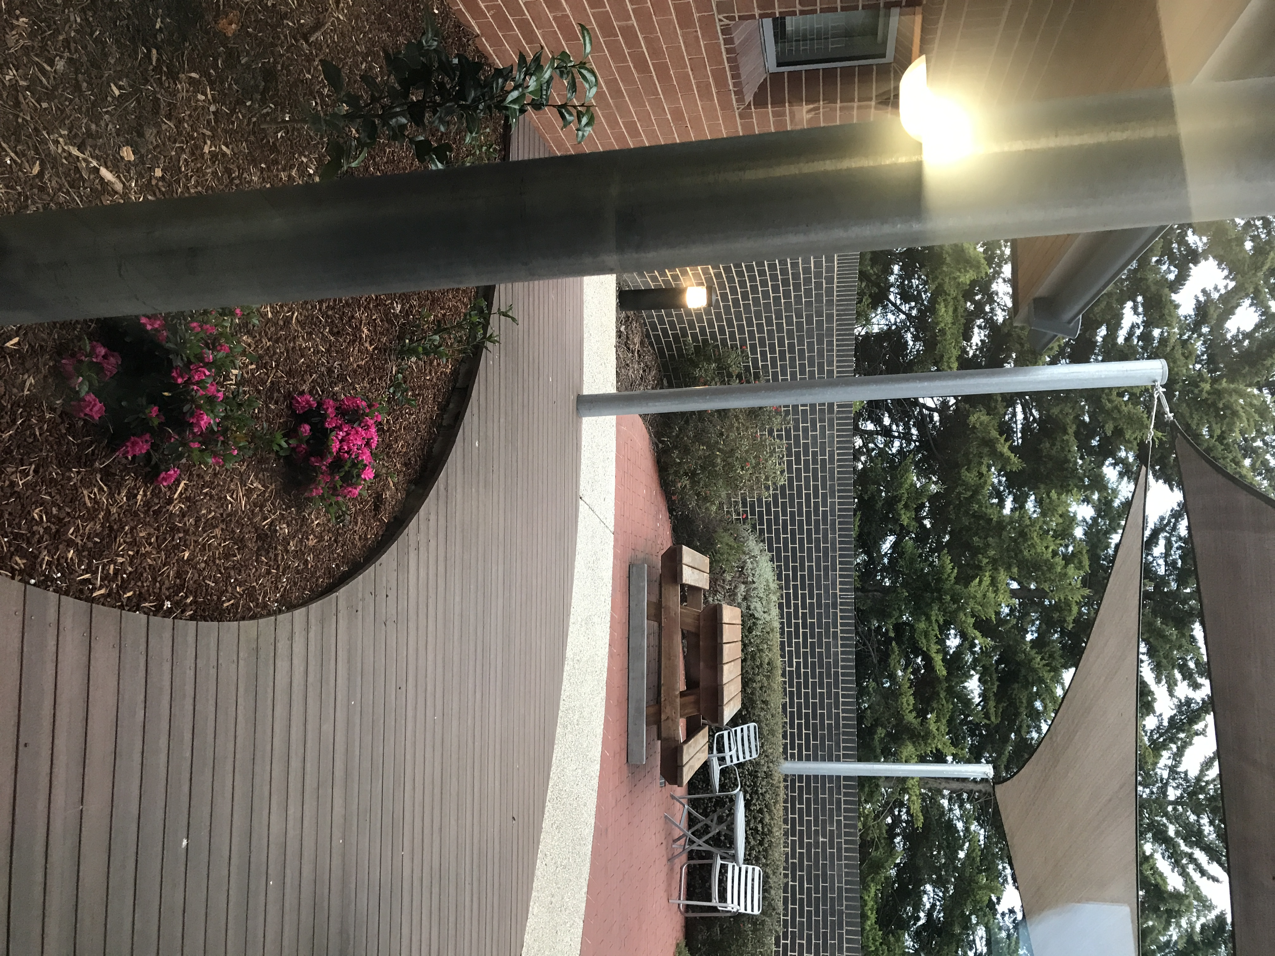

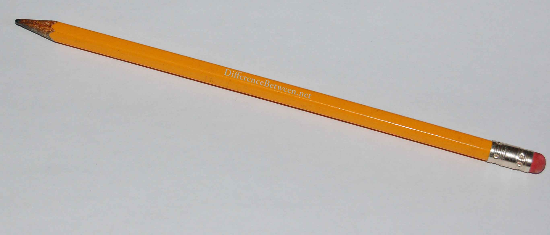
ROSTERS
PLEASE READ ALL THE ROSTERS.
When YOU are rostered on for duty and YOU are unavailable, please let Helen know as soon as possible so a swap can be arranged.
Special instructions for those on the BBQ rosters - please make sure YOU collect the tear drop flag.

DATE | PROGRAMME | MEETING CHAIR
12th October | DG & wife Jude’s visit | Helen Lanigan
19th October | Committee & Board meetings | Graeme Hemming

CARAVAN

Date | Deliver | Pick Up | Booked By
13th October | Nathan Smith | John Osborn | George Gray Auxiliary
20th October | Brian Gray | Cath Noble | St John’s Anglican Church
27th October | Nathan Smith | Maffra Show | Stratford Primary Shool

MEETING DUTIES/ WOOLWORTHS BBQ
MONTH | GREETING | REGISTRATION | PROPERTY | WOOLIE’S BBQ
OCTOBER | Sharon Knight | Sandra Houghton | Brian Gray | Saturday 14th  Dianne Honey  Graeme Hemming  Sharon Knight
NOVEMBER | Neil Wishart | Ted Mitchell | Cath Noble | Saturday 11th  Brian Gray  Sue Gray  Jean Heasley

MEMBER’S MILESTONES- OCTOBER
Name | MEMBER’S BIRTHDAY | PARTNER’S BIRTHDAY | WEDDING ANNIVERSARY | JOINED ROTARY
Sharon Knight |  |  |  | 15th October 1998

