


Rotary Club of Maffra
PO Box 154, MAFFRA 3860, VICTORIA AUSTRALIA
E: rotaryclubmaffra@gmail.com
WEB: www.maffrarotary.org
Rotary Club of Maffra meets every Thursday, 6.00 for 6.30 pm
Duart Receptions, 20 McLean Street, Maffra
Apologies and visitors to Nathan Smith by 1 pm. Telephone (03) 5147 1985

RI President Ian Riseley, District Governor Don Ripper, Assistant Governor Bill Degnan
Volume 70, Number 23 Thursday, 14th December, 2017
VICTORY THROUGH HARMONY
TOAST “TO THE PRIVILEDGE OF COMMUNITY SERVICE”

ROLES AND RESPONSIBILITIES 2017-2018
President Graeme Hemming, Immediate Past President Sue Gray, Secretary Dianne Honey
Treasurer Helen Lanigan, Administration/Foundation Graeme Hemming, Service Projects Cath Noble
Membership/Public Relations Dianne Honey, Board Members Veronica Dwyer, Roger Malouf, & Ted Mitchell
OTHER ROLES
Publicity Dianne Honey, Sergeant at Arms/Fines Cath Noble and John Watts, Program Co-ordinator Veronica Dwyer, Club Bulletin Dianne Honey, Attendance Neil Wishart, Arthur's Swindle Sandra Houghton, Family of Rotary Dianne Honey, Club Protection Officer Sharon Knight, On to Conference Sue Gray, Club Website Sue Gray & Dianne Honey Rosters – Registrations, Friendship, Property, Caravan, BBQ Helen Lanigan and Veronica Dwyer
COMMITTEES
FOUNDATION and  ADMINISTRATION | PUBLIC RELATIONS and MEMBERSHIP | SERVICE PROJECTS
Graeme Hemming  Helen Lanigan  Veronica Dwyer  Neil Wishart | Dianne Honey  Roger Malouf  Sharon Knight  John Watts | Cath Noble, Sue Gray, George Duursema, Brian Gray, Sandra Houghton, Ted Mitchell, Hans Van Wees, Nathan Smith, and John Osborn.

The past week in review and notes for 4th December, 2017
Apologies: Sharon Knight
Leave of Absence: George Duursema, John Watts, Veronica Dwyer & Hans Van Wees.
Sergeant At Arms, Cath Noble opened the meeting with the toast to Rotary.
President’s Report
President Graeme Hemming welcomed visiting Rotarian Richard McDowell and guest speaker Marie Clark. Graeme thanked the members who helped at Duart last Friday when the GVBR stayed overnight in Maffra. He also thanked Sue Gray, Roger Malouf and Ted Mitchell for their efforts in the debate. He reminded members about the Woolworths BBQ on Saturday and the Maffra Primary School breakfast next Wednesday. Sandra Houghton has asked members to take along their electric frypan (without a lid), an egg lifter and apron for a 7.30am start. The Thompson Street entrance is the best way in. Graeme also mentioned the MB&T Christmas festival on Friday 15th. He wished Lynne Malouf a happy birthday on the 10th.
Secretary’s Report
The correspondence board was circulated with Dianne Honey noting that the club had received a Christmas card from a former inbound YEP Maz Soriot. A board is on the table for members to indicate if they are coming to the Christmas dinner.
Member’s Reports
Helen Lanigan has placed Hannah Nicholl’s report on the table for all to read. Cath Noble took her pony to McDonald Wing last week for Social Inclusion BBQ. The pony was a great hit with the residents. Roger took a resident along to the Led Zeppelin concert and Graeme and Dianne won their monthly raffle. Cath also reported we have been given an Australia Day grant from the Wellington Shire.
Meeting Attendance – Neil gave a report of 11 present, 1 visiting Rotarian and 1 guest with 4 on leave of absence and 1 apology. Graeme and Brian Gray attended to the caravan. Sue, Brian, Roger, Cath, Helen, Ted Mitchell, Graeme and Dianne helped at Duart which was a fun night!
Bits and Bobs
Cath conducted a fine session. Caravan – Brian to deliver and John Osborn to pick up.

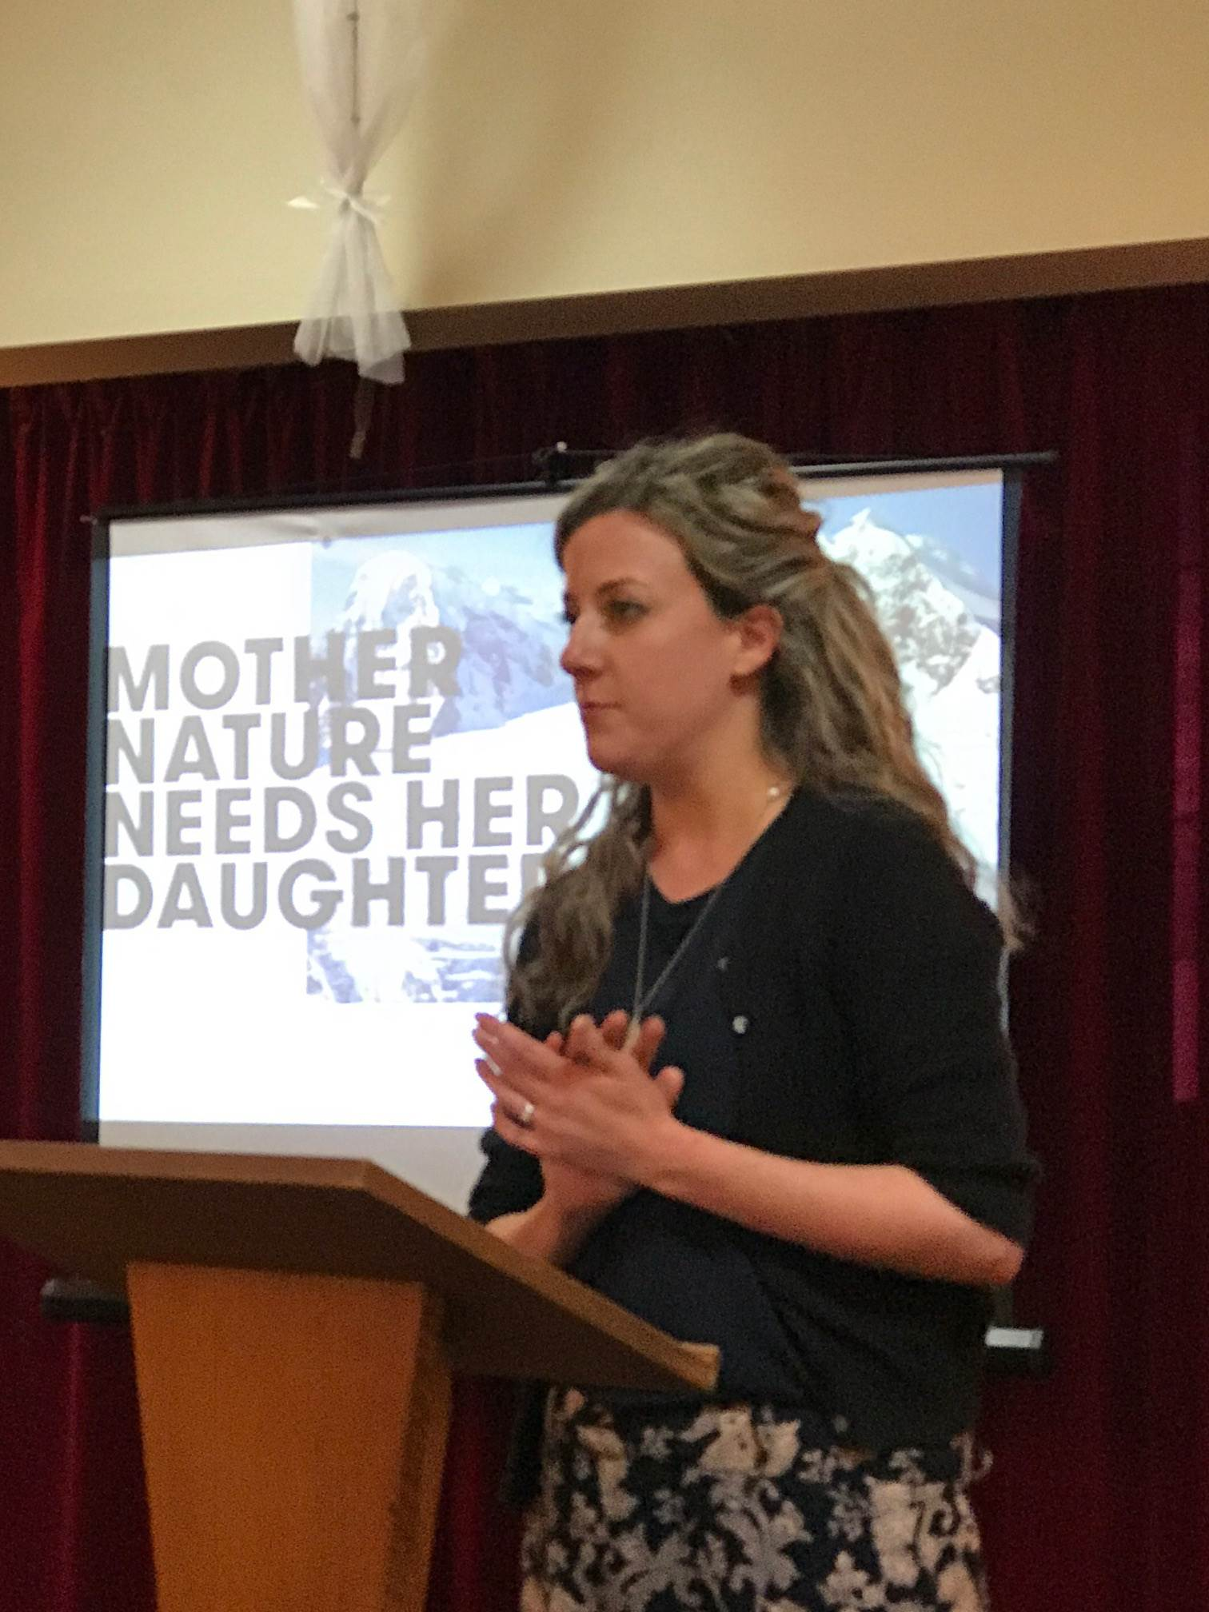
Marie Clark
Guest Speaker
Chairman, Roger Malouf introduced Marie Clark who is a scientist and teacher at Maffra Secondary School. Marie told us that Homeward Bound’s role is to support leadership in women especially in STEM fields over a 12 month period culminating with a trip to the Antarctica. Her thought provoking presentation commenced with a question “What does a scientist look like?” Most respondents drew a white male person. Only 14% of girls and 8% of boys drew a female. Sadly this attitude persists throughout life. Change in the community can be fostered. Marie citing her own children’s births and the reaction to that-pink for girls, blue for boys, cute/princess/looks printed on clothing for girls, while boys had superhero/awesome/positive affirmations printed on their clothing. She felt the message to the children was-girls = wearing clothes while boys = doing things. This disparity leads girls to be underrepresented in Science, Information Technology, Engineering and Math fields as well CEO of business and sitting on Boards. Marie’s qualifications are Bachelor of Arts & Science, Honors in Immunology, PHD in Immunology, Postdoctoral research and finally Diploma of Education. She has been at Maffra Secondary College for 5 years and has 2 children, 3 years and 1 year old. She became involved with Homeward Bound to collaborate with other female scientists to talk and teach about climate change. There are 80 scientists from 20 countries leaving February 14th from South Argentina heading to the Antarctica. They will be stationed off shore for 21 days doing research. The group Marie is in has been challenged on how to communicate climate change globally in language that everyday people can understand. Most scientists agree that climate change is accelerating rapidly, so much that humans and animals can’t adapt at the same rate. Marie told us climate change is represented by intense adverse weather events such as droughts, rain, hotter days, more tropical cyclones, diseases and rising sea levels. Currently rising sea levels are a reflection of the Earth heating up with the impact of melting ice and glaciers to come. Further information and to help Marie fund her trip go to www.chuffed.org/project.hoeward-bound-womens-leadership-for-our-planet-future-marie-clark Chairman Roger asked members if there were any questions before thanking Marie for her presentation.

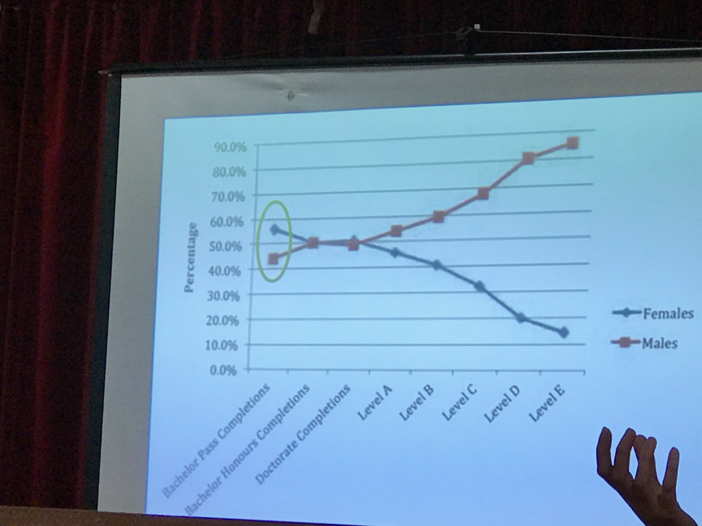
The infamous Scissor graph depicting Males and Females in STEM fields and further studies.
 | PROGRAM & OTHER DATES | MEETING CHAIR
13th December | Pancake Breakfast @ Maffra Primary School | Sandra Houghton
14th December | Mardi Gras, Committee & Board meeting | Graeme Hemming
15th December | Maffra Business & Tourism Assoc Festival | Graeme Hemming
21st December | Last meeting this year. Christmas dinner | Graeme Hemming
CARAVAN

Date | Deliver | Pick Up | Booked By
15th December | Nathan Smith | Cath Noble | Maffra Lioness club
21st December – 26th Jan | Not required | Not required | No bookings

MEETING DUTIES/ WOOLWORTHS BBQ
MONTH | GREETING | REGISTRATION | PROPERTY | WOOLIE’S BBQ
January 2018 | John O | Sue Gray | Helen Lanigan | No Booking

MEMBER MILESTONES-DECEMBER
DATE | MEMBER’S BIRTDAY | PARTNER’S BIRTHDAY | WEDDING ANNIVERSARY | JOINED ROTARY
31/12/2001 |  |  |  | Cath Noble

