


Rotary Club of Maffra
PO Box 154, MAFFRA 3860, VICTORIA AUSTRALIA
E: rotaryclubmaffra@gmail.com
WEB: www.maffrarotary.org
Rotary Club of Maffra meets every Thursday, 6.00 for 6.30 pm
Duart Receptions, 20 McLean Street, Maffra
Apologies and visitors to Nathan Smith by 1 pm. Telephone (03) 5147 1985

RI President Ian Riseley, District Governor Don Ripper, Assistant Governor Bill Degnan
Volume 70, Number 28 Thursday, 11th January, 2018
VICTORY THROUGH HARMONY
TOAST “TO THE PRIVILEDGE OF COMMUNITY SERVICE”

ROLES AND RESPONSIBILITIES 2017-2018
President Graeme Hemming, Immediate Past President Sue Gray, Secretary Dianne Honey
Treasurer Helen Lanigan, Administration/Foundation Graeme Hemming, Service Projects Cath Noble
Membership/Public Relations Dianne Honey, Board Members Veronica Dwyer, Roger Malouf, & Ted Mitchell
OTHER ROLES
Publicity Dianne Honey, Sergeant at Arms/Fines Cath Noble and John Watts, Program Co-ordinator Veronica Dwyer, Club Bulletin Dianne Honey, Attendance Neil Wishart, Arthur's Swindle Sandra Houghton, Family of Rotary Dianne Honey, Club Protection Officer Sharon Knight, On to Conference Sue Gray, Club Website Sue Gray & Dianne Honey Rosters – Registrations, Friendship, Property, Caravan, BBQ Helen Lanigan and Veronica Dwyer

COMMITTEES
FOUNDATION and  ADMINISTRATION | PUBLIC RELATIONS and MEMBERSHIP | SERVICE PROJECTS
Graeme Hemming  Helen Lanigan  Veronica Dwyer  Neil Wishart | Dianne Honey  Roger Malouf  Sharon Knight | Cath Noble, Sue Gray, George Duursema, Brian Gray, Sandra Houghton, Ted Mitchell, Nathan Smith, and John Osborn.

Presidents Report

President Graeme welcomed members and guests, Rotarian Janet Wallis, Jan Wishart, Claire Cochrane, Trish Vardy, Jean Heasley, Barb Pitman, Kirsty Synder and Isa Taylor to the Boisdale Stables. Graeme welcomed back Sharon Knight who is on holidays and Veronica Dwyer. Apologies were received from John Osborn, Cath Noble with George Duursema on leave of absence. The Boisdale Stables is a project of the townsfolk and the Community Representative Group, something which has the potential to meld the townsfolk together. The Stables used to house the horses for the Cheese and Butter Factory which was located across the road. Along with dining in the Stables, we were taken on a guided tour of the historical buildings situated along the Main Street. The tour highlighted the Boisdale Memorial Hall which has been refurbished recently with freshly painted interior and polished floor boards.
Graeme told members that only four Rotarians were available to attend the Vice Regal reception for Rotary International President, Ian Risely in March. Affirmative responses were received from Veronica Dwyer, Dianne Honey and Helen Lanigan. Neil Wishart had previously indicated he’d be available as a reserve while Sandra Houghton said she would be available as a reserve too.
Graeme welcomed new member Kirsty Synder who will be inducted soon.
Graeme gave an update on the proposed Rotary Maffra Community Market. Beth Ripper is trying to have the former Home hardware premises set up as a Community resource centre. She envisages the Sunday market using the open yard space instead of Johnson St. This would be a cost effective alternative than using Johnson St because of the cost of training members for traffic management, using a contractor, and purchasing signs. There would need to be a small payment made towards utilities and rates. There is front and rear access along with wire fences where advertising signs could be hung. Graeme suggested signs at all the entrances to Maffra along with advertising in the paper, and Facebook. This proposal will be discussed at committee next week.
There is a Woolworths BBQ on Saturday. Helen Lanigan will work it with two others. Ted Mitchell, Jean Heasley and Barb Pitman volunteered to assist Helen. Thank you.
A President Elect is needed!!! Please consider putting yourself forward. The club members will support you!!
Graeme also reminded members of the Clubs decision to trial meeting on the 1st and 3rd Thursday of each month until the end of June. Any month that has a 5th Thursday will be a social evening with guests and partners.
The correspondence board was circulated.
Guest Speaker
Judy Traill spoke to members and guests about the Boisdale Stables project. The stables were donated to the community, by the owners the Foster, for use as a community centre back in the 2007. When the door was opened, Judy said it was like opening a time capsule to the early 1990s. The building, which is over 116 years old, is in its original condition except for the roof which blew off in the early 2000s. Regional Development Victoria, Wellington Shire Council and Regional Arts Victoria have all made grants available as well as donations from a host of local families, businesses and tradesmen. Judy said the stable project is a reflection of Boisdale’s ability to change, adapt and survive. It has not officially opened yet.
ROSTERS
PLEASE READ ALL THE ROSTERS.
When YOU are rostered on for duty and YOU are unavailable, please let Helen know as soon as possible so a swap can be arranged.
Special instructions for those on the BBQ rosters - please make sure YOU collect the tear drop flag.

DATE | PROGRAM & OTHER DATES | MEETING CHAIR
15th – 19th January | Meals On Wheels 11.45am – 12 noon collection from Alfred St. | Cath Noble
18th January | David Hanlon Membership Matters  Mardi Gras, Committee & Board meeting | Dianne Honey
25th January | TBA
26th January | Australia Day and Quiet Achiever Awards  At Victoria Park, Kent St, Maffra
Sat 24th February | Burnet Park Girl Guide Camp  50th Birthday celebrations | Chris Oliver  burnetparkcamp@gmail.com

CARAVAN ROSTER

Date | Deliver | Pick Up | Booked By
21st December – 26th Jan | Not required | Not required | No bookings

MEETING DUTIES/ WOOLWORTHS BBQ
MONTH | GREETING | REGISTRATION | PROPERTY | WOOLIE’S BBQ
January 2018 | John | Sue Gray | Helen Lanigan | No Booking

MEMBER MILESTONES-January
DATE | MEMBER’S BIRTDAY | PARTNER’S BIRTHDAY | WEDDING ANNIVERSARY | JOINED ROTARY
2nd |  | Stephen Dwyer

Meals on Wheels Roster: 12 midday or a bit earlier at the back of the hospital, Kent Street, Maffra
Mon 15th Jan Brian Gray (0418132956) and Neil Wishart (51471145)
Tues 16th Jan Sandra Houghton (51471325) and Dianne Honey (0413569954)
Wed 17th Jan Graeme Hemming (0419533680) and Helen Lanigan (0409030918)
Thur 18thJan Cath Noble (0427149253) and Neil Wishart (51471145)
Fri 19th Jan Cath Noble (0427149253 and Brian Gray (0418132956)

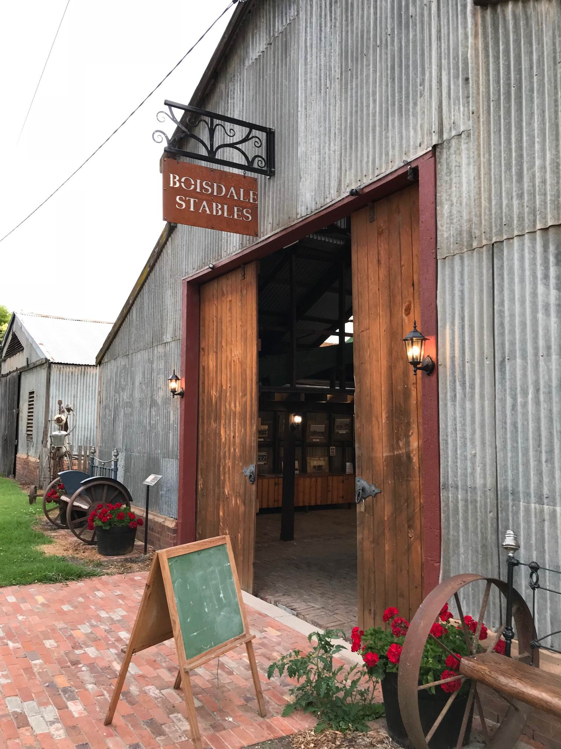
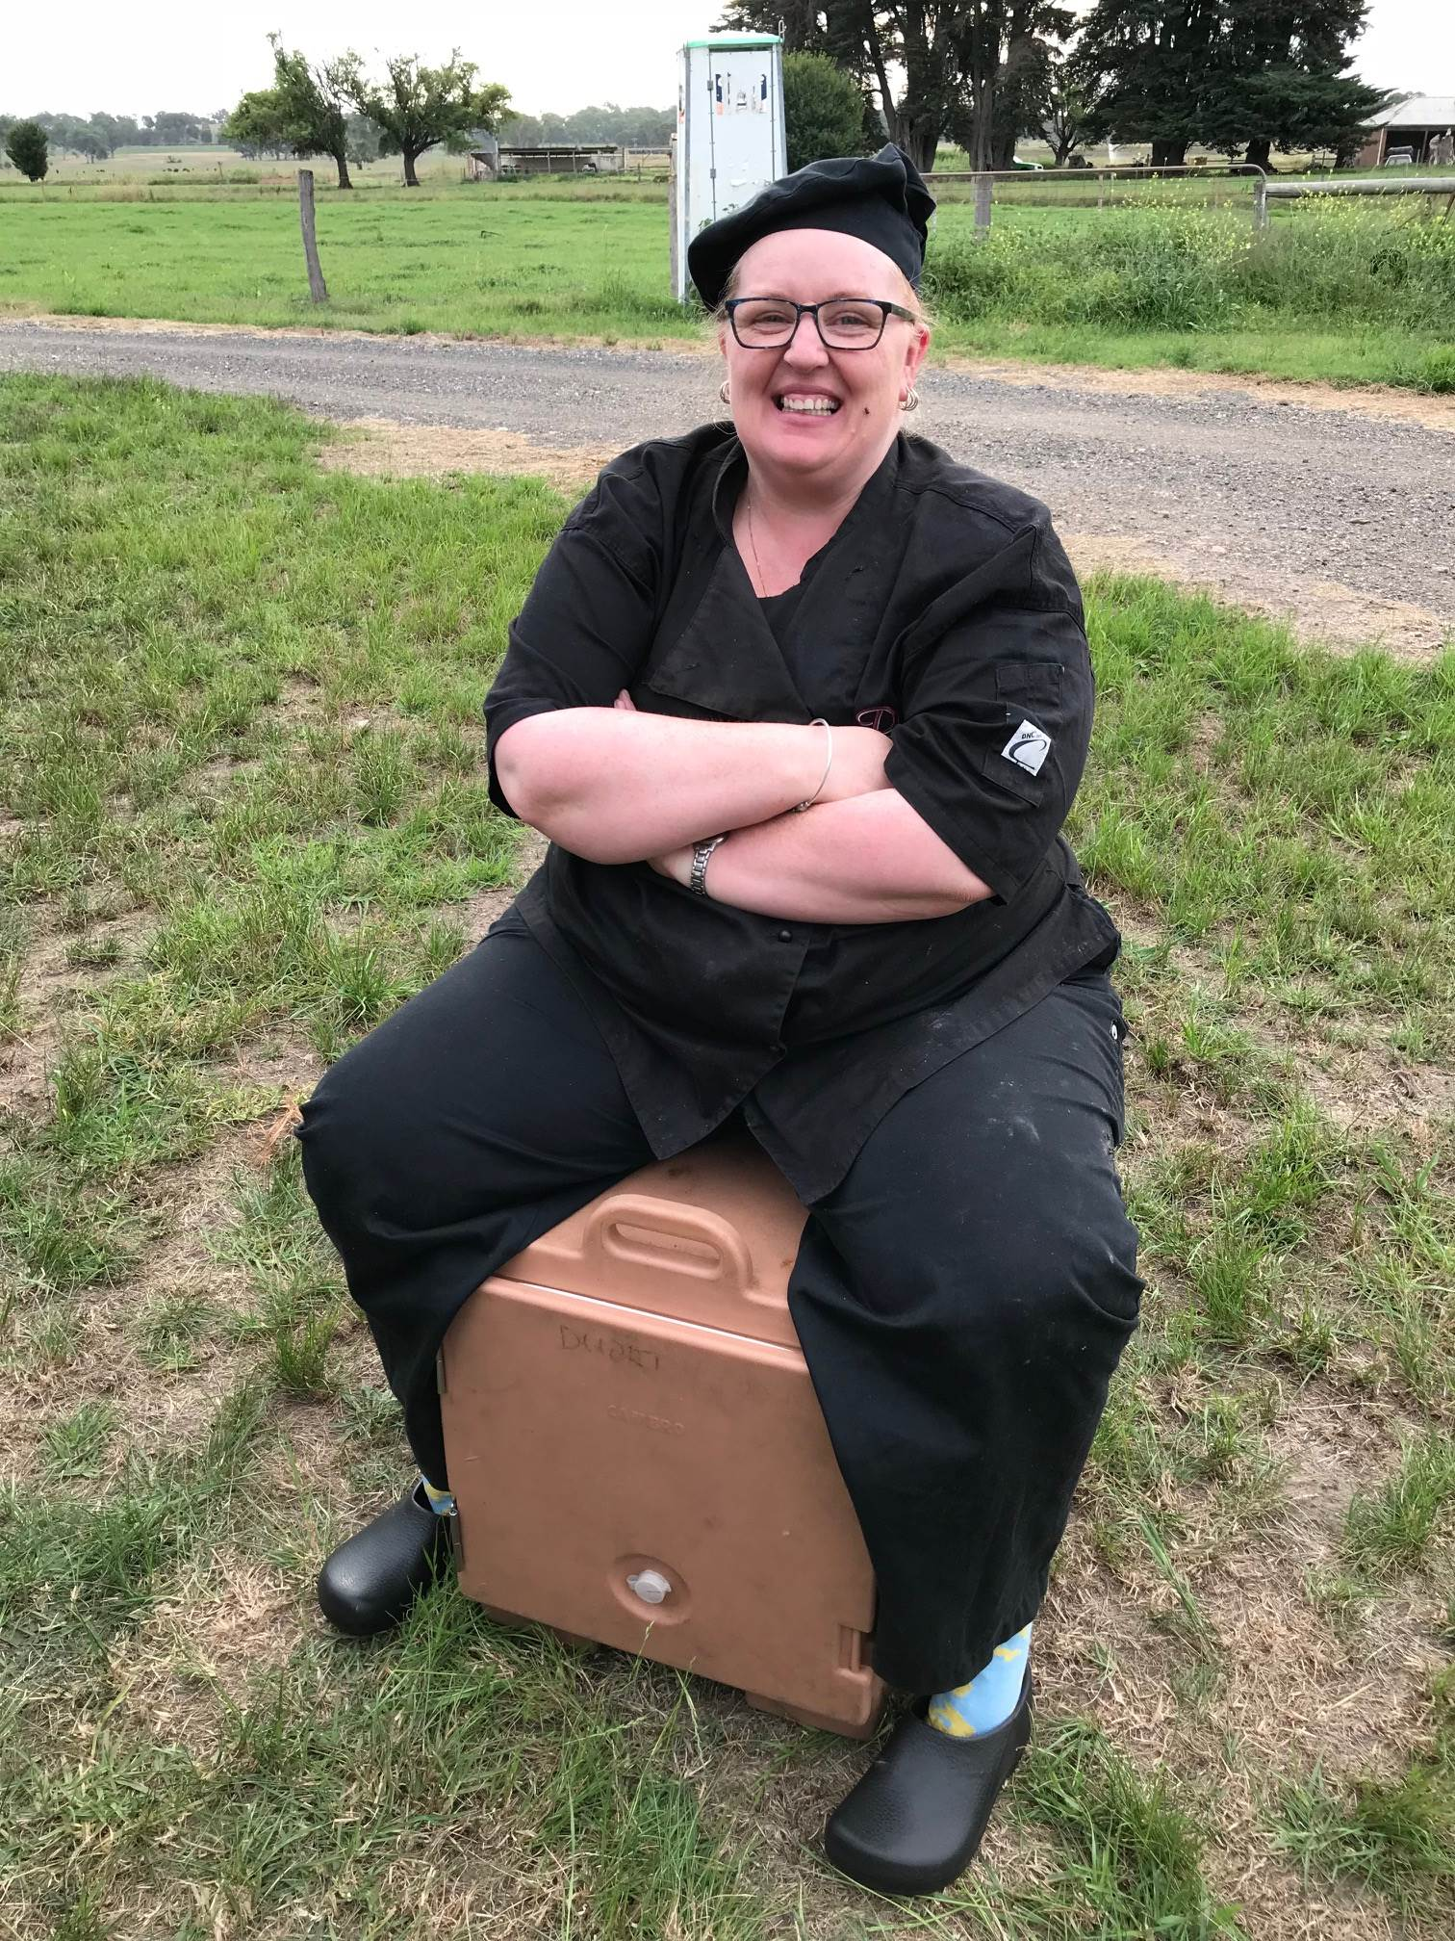Tash supervising

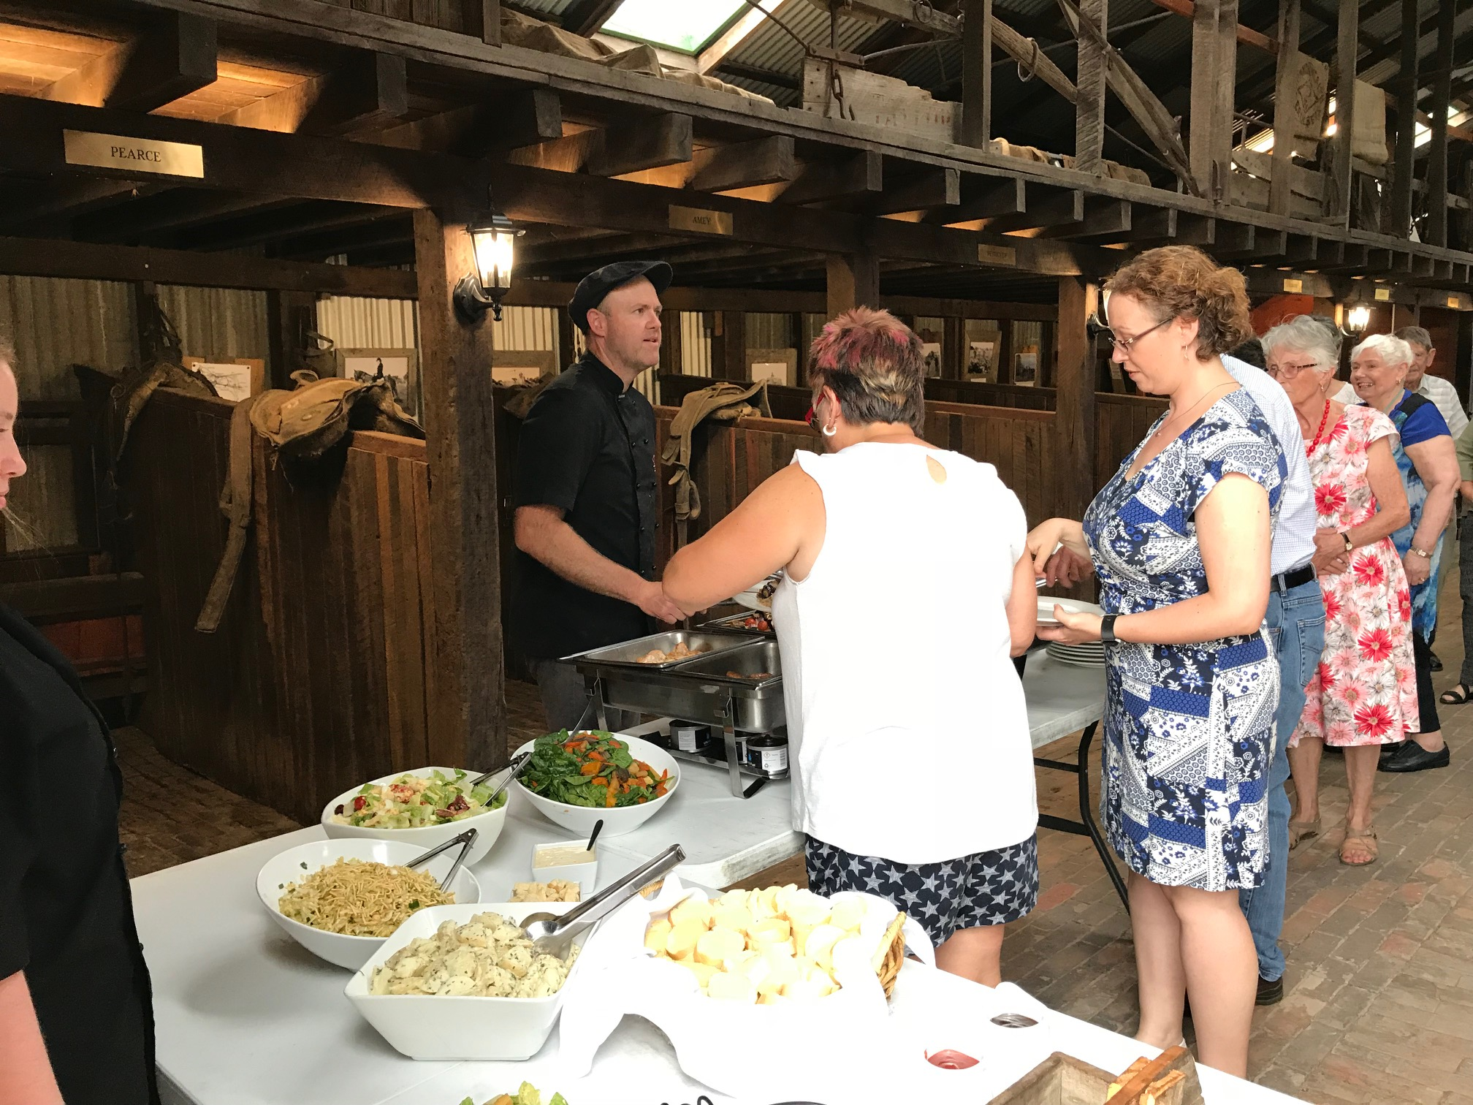Nathan serving the queue
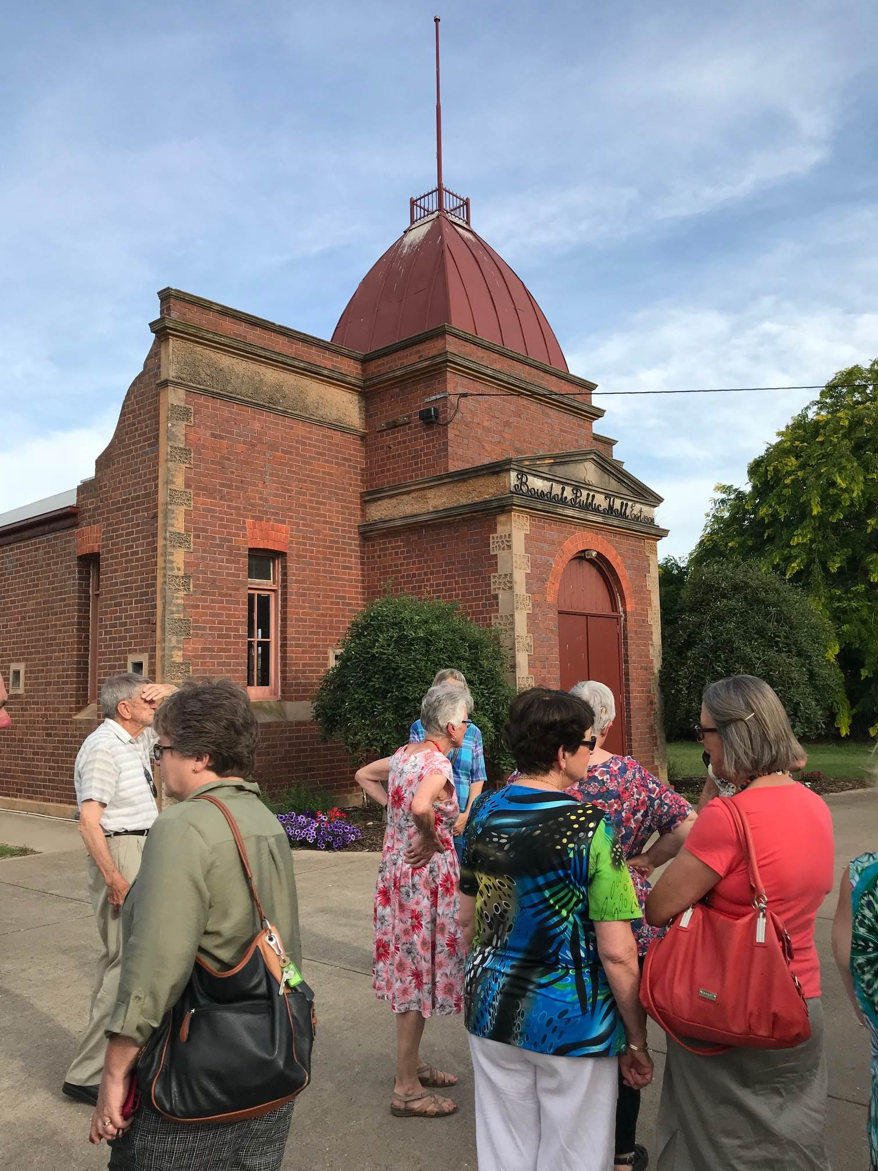The guided tour

Come along to the District Conference Friday 16th – Sunday 18th February to find out why the world needs more Rotarians.



