


Rotary Club of Maffra
PO Box 154, MAFFRA 3860, VICTORIA AUSTRALIA
E: rotaryclubmaffra@gmail.com
WEB: www.maffrarotary.org
Rotary Club of Maffra meets every Thursday, 6.00 for 6.30 pm
Duart Receptions, 20 McLean Street, Maffra
Apologies and visitors to Nathan Smith by 1 pm. Telephone (03) 5147 1985

RI President Ian Riseley, District Governor Don Ripper, Assistant Governor Bill Degnan
Volume 70, Number 29 Thursday, 18th January, 2018
VICTORY THROUGH HARMONY
TOAST “TO THE PRIVILEDGE OF COMMUNITY SERVICE”

ROLES AND RESPONSIBILITIES 2017-2018
President Graeme Hemming, Immediate Past President Sue Gray, Secretary Dianne Honey
Treasurer Helen Lanigan, Administration/Foundation Graeme Hemming, Service Projects Cath Noble
Membership/Public Relations Dianne Honey, Board Members Veronica Dwyer, Roger Malouf, & Ted Mitchell
OTHER ROLES
Publicity Dianne Honey, Sergeant at Arms/Fines Cath Noble and John Watts, Program Co-ordinator Veronica Dwyer, Club Bulletin Dianne Honey, Attendance Neil Wishart, Arthur's Swindle Sandra Houghton, Family of Rotary Dianne Honey, Club Protection Officer Sharon Knight, On to Conference Sue Gray, Club Website Sue Gray & Dianne Honey Rosters – Registrations, Friendship, Property, Caravan, BBQ Helen Lanigan and Veronica Dwyer

COMMITTEES
FOUNDATION and  ADMINISTRATION | PUBLIC RELATIONS and MEMBERSHIP | SERVICE PROJECTS
Graeme Hemming  Helen Lanigan  Veronica Dwyer  Neil Wishart | Dianne Honey  Roger Malouf  Sharon Knight  Kirsty Snyder | Cath Noble, Sue Gray, George Duursema, Brian Gray, Sandra Houghton, Ted Mitchell, Nathan Smith, and John Osborn.

Presidents Report
President Graeme welcomed members, guest speaker the District Membership Chairman David Hanlon, visiting Rotarian Shaun Lennard, and visitors Kirsty Snyder, Lou Alexander and Jenny Marshall. Apologies were received from Sharon Knight, Veronica Dwyer, Roger Malouf, and Brian Gray with George Duursema on leave of absence. Reports were held over for discussion at committees.
A President Elect is needed!!!
The correspondence board was circulated so all members can read it and stay informed.
Sandra Houghton conducted Arthur’s swindle which was won by Brian Gray. Congratulations Brian!
Neil Wishart gave an attendance report on service provided by our members during the past week. There were 7 members doing Meals On Wheels Brian Gray, Neil Wishart, Sandra Houghton, Dianne Honey, Graeme Hemming, Helen Lanigan, and Cath Noble, Helen and Dianne attended a District conference planning meeting and Helen had a District leadership meeting.
President Graeme asked Kirsty Snyder and her sponsor Dianne Honey to come forward. He inducted Kirsty into our club and asked Dianne to introduce her to members. Kirsty was warmly welcomed by our members.
Guest Speaker
Chairman Dianne introduced District Membership Chairman David Hanlon. David commenced by commenting on the effort the past Chairman Tim Moore had done. David said it is not the numbers that Rotary is struggling with; it is the age of the members with the average age being 71. As time progresses he asked “How many will be active members in time to come say 5 years?” Retention is the key. The excuses are just that, excuses as volunteerism has grown over the past 5 years. People today can go online and volunteer for a cause they like, people in the workplaces are encouraged to do workplace volunteering. He suggested that meetings become time efficient ie business first then friendship. Expenses can be an issue to both younger people with families and people who have retired on a fixed income. Clubs are evolving where they meet for coffee and cake, or breakfast or an hour on a Sunday afternoon. Satellite clubs are easier to create (only 8 members) as they are sponsored by a charted Rotary club who does some of the administration. He challenges clubs to look at their relevance to their community, asking questions such as delivering projects-does your community want that project and the lack of diversification in gender and vocations. Other suggestions were corporate membership and Skype – go to meetings. What about an interact club in the local secondary college? The changes to the rules in 2016 have enabled clubs to become more flexible with meetings, membership structure and attendance. The future of rotary is in the hands of club leaders and all members, keeping in mind the Four Way Test.
Chairman Dianne asked if there were any questions from members and thanked David for his presentation.
Rotary club of Maffra Mardi Gras committee meeting
Cath reported she has sent out 49 letters to stall holders. Ross Neilson has the stencils to mark the stallholder sites. Brian is contacting Bedggoods for the use of the flat top trailer as a stage. Sashes have been ordered. John Osborn asked that the numbers for the floats are placed on the front and back of each float.
Australia Day, Rotary club of Maffra & Gippsland Quiet Achiever Award
Graeme and Dianne met with Abby from WSC to check the key to the flagpole. It didn’t work! Abby will have it checked out and leave it with Helen. The Maffra Girl Guides are raising the flag this year. Ted Mitchell will collect chairs from the Geoff Webster centre after getting the key from Jean Heasley. Sue Gray will make the presentations. Helen will do the shopping. Neil will collect the awards if ready and the flags from the library. Nathan is taking his trailer for the BBQ. Cath will organise the certificates. Members who are available are, Sue, Helen, Ted, Nathan, Neil and Kirsty(Guide Leader).Helen to check with Sharon Knight.
ROSTERS
PLEASE READ ALL THE ROSTERS.
When YOU are rostered on for duty and YOU are unavailable, please let Helen know as soon as possible so a swap can be arranged.
Special instructions for those on the BBQ rosters - please make sure YOU collect the tear drop flag.

DATE | PROGRAM & OTHER DATES | MEETING CHAIR
26th January | Australia Day and Quiet Achiever Awards  At Victoria Park, Kent St, Maffra | Sue Gray
1st February | Launch of Rotary club of Maffra Mardi Gras | Graeme Hemming
4th February | Rotary club of Maffra Community Market | Graeme Hemming
5th-9th February | Meals On Wheels | Cath Noble
15th February | Mardi Gras, committee meetings & Board | Graeme Hemming
Sat 24th February | Burnet Park Girl Guide Camp  50th Birthday celebrations | Chris Oliver  burnetparkcamp@gmail.com

CARAVAN ROSTER

Date | Deliver | Pick Up | Booked By
21st December – 2nd Feb | Not required | Not required | No bookings

MEETING DUTIES/ WOOLWORTHS BBQ
MONTH | GREETING | REGISTRATION | PROPERTY | WOOLIE’S BBQ
February 2018 |  |  |  | TBA

MEMBER MILESTONES-January
DATE | MEMBER’S BIRTDAY | PARTNER’S BIRTHDAY | WEDDING ANNIVERSARY | JOINED ROTARY
2nd |  | Stephen Dwyer

Meals on Wheels Roster: 12 midday or a bit earlier at the back of the hospital, Kent Street, Maffra
Mon 5th Feb Cath Noble (0427149253) Brian Gray (0408132956)
Tues 6th Feb Sandra Houghton (0428649243) Dianne Honey (0413569954)
Wed 7th Feb Graeme Hemming 0419533680) Dianne Honey (0413569954)
Thur 8th Feb Helen Lanigan (0409030918) Neil Wishart
Fri 9th Feb Helen Lanigan (0409030918) Cath Noble (0427149253)

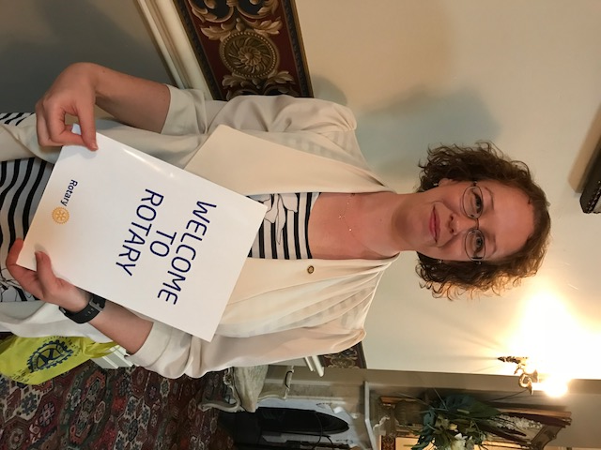

New Rotarian Kirsty Snyder inducted into Maffra Rotary on 18th January, 2018. Welcome Kirsty.

