


Rotary Club of Maffra
PO Box 154, MAFFRA 3860, VICTORIA AUSTRALIA
E: rotaryclubmaffra@gmail.com
WEB: www.maffrarotary.org
Rotary Club of Maffra meets 1st, 3rd & 5th Thursday, 6.00 for 6.30 pm
Duart Receptions, 20 McLean Street, Maffra
Apologies and visitors to Nathan Smith by 1 pm. Telephone (03) 5147 1985

RI President Ian Riseley, District Governor Don Ripper, Assistant Governor Bill Degnan
Volume 70, Number 34 Thursday 15th March, 2018
VICTORY THROUGH HARMONY
TOAST “TO THE PRIVILEGE OF COMMUNITY SERVICE”

ROLES AND RESPONSIBILITIES 2017-2018
President Graeme Hemming, Immediate Past President Sue Gray, Secretary Dianne Honey
Treasurer Helen Lanigan, Administration/Foundation Graeme Hemming, Service Projects Cath Noble
Membership/Public Relations Dianne Honey, Board Members Veronica Dwyer, Roger Malouf, & Ted Mitchell
OTHER ROLES
Publicity Dianne Honey, Sergeant at Arms/Fines Cath Noble and John Watts, Program Co-ordinator Veronica Dwyer, Club Bulletin Dianne Honey, Attendance Neil Wishart, Arthur's Swindle Sandra Houghton, Family of Rotary Dianne Honey, Club Protection Officer Sharon Knight, On to Conference Sue Gray, Club Website Sue Gray & Dianne Honey Rosters – Registrations, Friendship, Property, Caravan, BBQ Helen Lanigan and Veronica Dwyer
COMMITTEES
FOUNDATION and  ADMINISTRATION | PUBLIC RELATIONS and MEMBERSHIP | SERVICE PROJECTS
Graeme Hemming  Helen Lanigan  Veronica Dwyer  Neil Wishart | Dianne Honey  Roger Malouf  Sharon Knight  Kirsty Snyder | Cath Noble, Sue Gray, George Duursema, Brian Gray, Sandra Houghton, Ted Mitchell, Nathan Smith, and John Osborn.
Sergeant at Arms Cath Noble proposed the Toast, introduced the Chairman Helen Lanigan who introduced President Graeme Hemming.
Presidents Report
President Graeme Hemming welcomed DG Don Ripper and his wife Jude, Rotarians and Guest Hannah Nicholl and her mum Rachael. Apologies were received from Kirsty Snyder, and Brian Gray. George Duursema was AWOL.
President Graeme thanked Neil Wishart for chairing the Men’s Probus club. Cath Noble will attend the AGM for the Ladies Probus club next Monday. President Graeme read out the milestones. Chairman Helen Lanigan introduced DG Don Ripper who thanked the Maffra Rotarians who helped out at the District conference. He thanked Helen Lanigan and Ted Mitchell who were on the committee from the start and Dianne Honey who joined the committee half way through. DG Don Ripper said he was pleased to be here to listen to Hannah Nicholl’s talk. Next “meeting” is on the 5th Thursday of the month and is a social night at Blue Gables. Book in with President Graeme and a 6pm start. Car pool from Duart leaves at 5.40pm
Secretary’s Report
Dianne reported the correspondence list is on the table for members to read.

Treasurer’s report
Helen has requested the Centurion towers be returned ASAP. Sandra Houghton has returned 2 towers.
Swindle & Fines
Sharon Knight drew #8 which is Helen Lanigan who then drew #7 which is Sharon Knight!!
Cath conducted a fine session.
Attendance and Service
Neil Wishart reported thirteen members at the meeting, two apologies and 1 AWOL. Caravan duties were performed by Brian Gray, Nathan Smith, John Osborn, and Graeme Hemming. The Woolworths BBQ was manned by Veronica Dwyer, Sharon Knight and Roger Malouf. Four members attended the Governor of Victoria’s civic reception for RI President Ian Riseley. They were Graeme Hemming, Dianne Honey, Helen Lanigan and Veronica Dwyer. Neil Wishart represented RC of Maffra chairing the AGM for the Men’s Probus club. Interestingly Neil was the President of Maffra when the Probus club was commence.
Members Reports
Ted Mitchell is bringing Bowel scan kits to the community market for John Osborn. There appears not to be a team available for MUNA at MSC. Ted will approach Sale College.
Guest Speakers
Chairman Helen Lanigan welcomed YEP Hannah Nicholls who has returned from her 12 months away in Austria where 8.5million people live. Shortly after arriving Hannah attended a 2 week intensive language course which taught them how to learn German. She stayed in Klagenfurt with 4 host families who all had children. Hannah attended a school for art, drama and music. The RC of Klagenfurt hosted her for 3 meetings. Hannah got the impression they weren’t really interested in her exchange. Fortunately the Euro tour engaged the YEPs as they toured Europe. Hannah loved Monaco, Venice, Rome and Pisa. She met up with BJ (Bjarne) in Velden and visited Slovakia to visit BJ’s sister who lives in Bratislava. While there they visited Prague, Dresden and Berlin. Hannah enjoyed a week long skiing camp with other YEPs, hiking, and a traditional Austrian Christmas, complete with snow! Hannah answered questions from our members before thanking everyone for giving her the opportunity.
ROSTERS- PLEASE READ ALL THE ROSTERS.
Please let Helen know as soon as possible if you are unavailable for any roster.
Special instructions for those on the BBQ roster - please make sure YOU collect the tear drop flag.

DATE | PROGRAM & OTHER DATES | MEETING CHAIR
29th March | Social evening @ Blue Gables
1st April | RC of Maffra Community Market | Graeme Hemming
5th April | Kirsty Snyder-Person behind the badge
19th April | RC of Maffra Mardi Gras wind up dinner

CARAVAN ROSTER
Date | Deliver | Pick Up | Booked By
23rd March | Brian Gray | Graeme Hemming | MSC-CLP team
29th March NB Thursday | Nathan Smith | Cath Noble | Tinamba Red Cross
6th April | Brian Gray | John Osborn | Lioness Ladies
13th April | Cath Noble | Graeme Hemming | St Johns

MEETING DUTIES
MONTH | GREETING | REGISTRATION | PROPERTY
March 2018 | Brian Gray | George Duursema | Graeme Hemming
April 2018 | Helen Lanigan | Neil Wishart | Sharon Knight

MEMBER MILESTONES-March
DATE | MEMBER’S BIRTDAY | PARTNER’S BIRTHDAY | WEDDING ANNIVERSARY | JOINED ROTARY
27th |  | Trevor Knight
28th |  |  | Sharon & Trevor Knight
30th |  |  | Jan & Neil Wishart
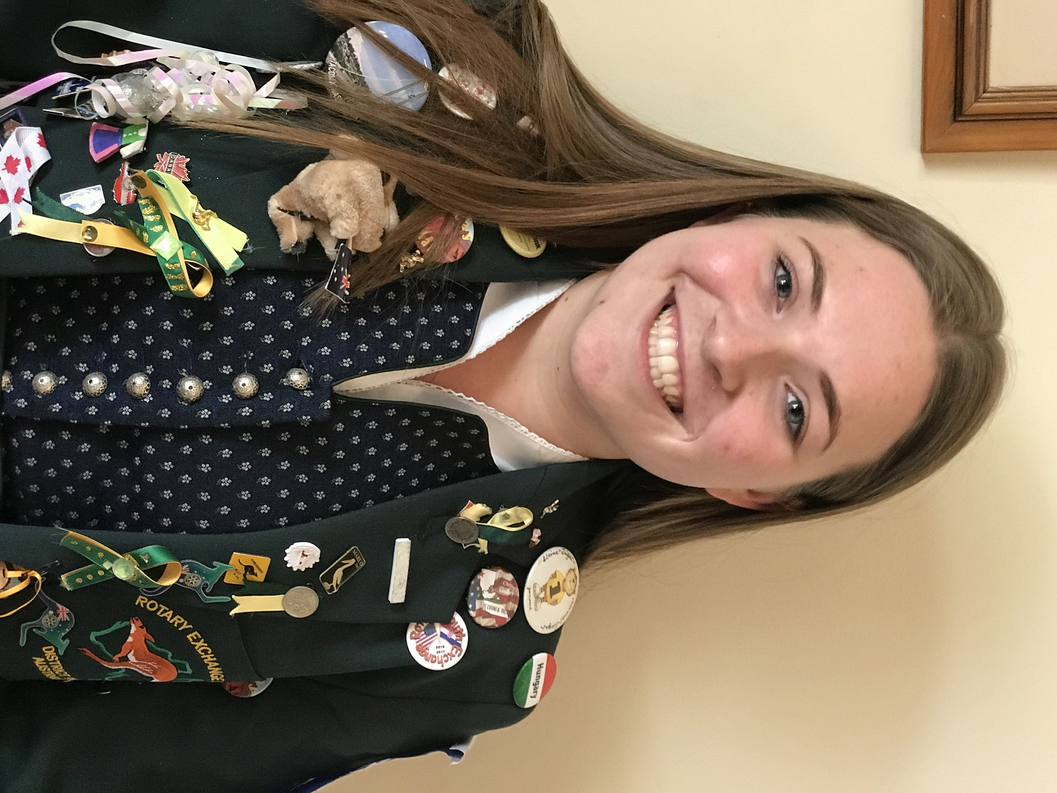
Hannah Nicholls in her YEP blazer.

