


Rotary Club of Maffra
PO Box 154, MAFFRA 3860, VICTORIA AUSTRALIA
E: rotaryclubmaffra@gmail.com
WEB: www.maffrarotary.org
Rotary Club of Maffra meets 1st, 3rd & 5th Thursday, 6.00 for 6.30 pm
Duart Receptions, 20 McLean Street, Maffra
Apologies and visitors to Nathan Smith by 1 pm. Telephone (03) 5147 1985

RI President Ian Riseley, District Governor Don Ripper, Assistant Governor Bill Degnan
Volume 70, Number 39 Thursday 7th June, 2018
VICTORY THROUGH HARMONY
TOAST “TO THE PRIVILEGE OF COMMUNITY SERVICE”
ROLES AND RESPONSIBILITIES 2017-2018
President Graeme Hemming, Immediate Past President Sue Gray, Secretary Dianne Honey
Treasurer Helen Lanigan, Administration/Foundation Graeme Hemming, Service Projects Cath Noble
Membership/Public Relations Dianne Honey, Board Members Veronica Dwyer, Roger Malouf, & Ted Mitchell
OTHER ROLES
Publicity Dianne Honey, Sergeant at Arms/Fines Cath Noble Program Co-ordinator Veronica Dwyer, Club Bulletin Dianne Honey, Attendance Neil Wishart, Arthur's Swindle Sandra Houghton, Family of Rotary Dianne Honey, Club Protection Officer Sharon Knight, On to Conference Sue Gray, Club Website Sue Gray & Dianne Honey Rosters – Registrations, Friendship, Property, Caravan, Helen Lanigan and Veronica Dwyer
COMMITTEES
FOUNDATION and  ADMINISTRATION | PUBLIC RELATIONS and MEMBERSHIP | SERVICE PROJECTS
Graeme Hemming  Helen Lanigan  Veronica Dwyer  Neil Wishart | Dianne Honey  Roger Malouf  Kirsty Snyder | Cath Noble, Sue Gray, Brian Gray, Sandra Houghton, Ted Mitchell, Nathan Smith, Jean Mawhinney, and John Osborn.
Presidents Report
President Graeme Hemming proposed the Toast and welcomed members and guests. Guests were returning YEP Lisa Kennedy, and her host families Sue and Kirsty Hewitt, along with Karen and Brendan Callahan. Apologies were received from Mark Hewitt, Kelly and Kevin Gray, John Osborn. The last market cleared $501. Graeme thanked Treasurer Helen Lanigan for her huge contribution to the District and her efforts at club level.
Member’s report
Cath circulated a roster for MOWs commencing Monday 18th June.
Attendance
Neil Wishart reported 1 apology, 2 AWOL and 1 leave of absence. The caravan was moved by Nathan Smith, and John Osborn. Helen attended District Leadership meetings for finance and a District board meeting along with meeting the DG. The community market was Cath Noble, Kirsty Snyder, Roger Malouf and John Osborn.
Arthur’s Swindle
Cath Noble drew #1 which is Veronica Dwyer. Well done!
Fines
Just like old times Lisa took around the fines box!

Guest Speaker #1
President Graeme Hemming introduced our first guest speaker, Phil Clifford who is the Chairman of Stretton Park. Phil gave some background information on Stretton Park. It was built in 1977 when people entering aged care were a lot fitter than today that looked after themselves. Today’s residents are frailer and need a higher level of care. Stretton Park was built by the community and is owned by the community. The board contract CGHS to provide various services to Stretton Park. Currently there are 42 rooms and 19 Independent Living Units. Once the refurbishment is completed there will be 44 rooms. While the refub is being done none of the residents will have to move away from Stretton Park. While Stretton Park has over $6million invested they are regulated to using only 30%-35% because this is bond money from the residents which is returned. Their target of raising $100,000 from public donations has been exceeded! The government grant that was applied for recently and denied was because the bed licences had not been transferred back in the 1980s. This has been corrected and the subsequent grant application should be known in 2-3 weeks’ time. President Graeme presented Phil with a cheque for $13,000 which was happily received.
Guest Speaker #2
Chairman Sue Gray introduced Lisa Kennedy. Sue said it was a lovely thrill to welcome Lisa back after her departure home 5 years ago. Lisa’s mum is the Chair of Youth in District 7430.She said they had students in from 7 different countries. She has finished college and graduated with a degree in Marketing. When Lisa returns home she will commence a 2 year stint with JP Morgan Chasse as a program business analysist. While at college she travelled and rowed. She has three and a half weeks in Australia and will visit Cairns and Sydney. Lisa expressed her appreciation to our members for supporting YEP and her gratitude to her host families. Lisa thought people are more similar than different in this day and age. Lisa heard about YEP through Interact, she is now a Rotaractor and next time she comes back she hopes to be a Rotarian.
ROSTERS- PLEASE READ ALL THE ROSTERS.
Please let Helen know as soon as possible if you are unavailable for any rosters.

DATE | PROGRAM & OTHER DATES | MEETING CHAIR
17th June | District 9820 Changeover Dinner
18th June | Meals On Wheels | Cath Noble
21st June | Marie Clark – Homeward Bound
5th July | Club Changeover

CARAVAN ROSTER
Date | Deliver | Pick Up | Booked By
8th June | Nathan Smith | Cath Noble | Stratford Football Netball club
15th June |  |  | Not required
22nd June | Brian Gray | John Osborn | Boisdale Consolidated School
29th June - 10th August |  |  | Not required atm
MEETING DUTIES
MONTH | GREETING | REGISTRATION | PROPERTY
June 2018 | Sandra Houghton | Roger Malouf | John Osborn

MEMBER MILESTONES- May/June
DATE | MEMBER’S BIRTDAY | PARTNER’S BIRTHDAY | WEDDING ANNIVERSARY | JOINED ROTARY
2nd June |  |  |  | Sandra Houghton 2002
30th June |  |  |  | Dianne Honey 2008

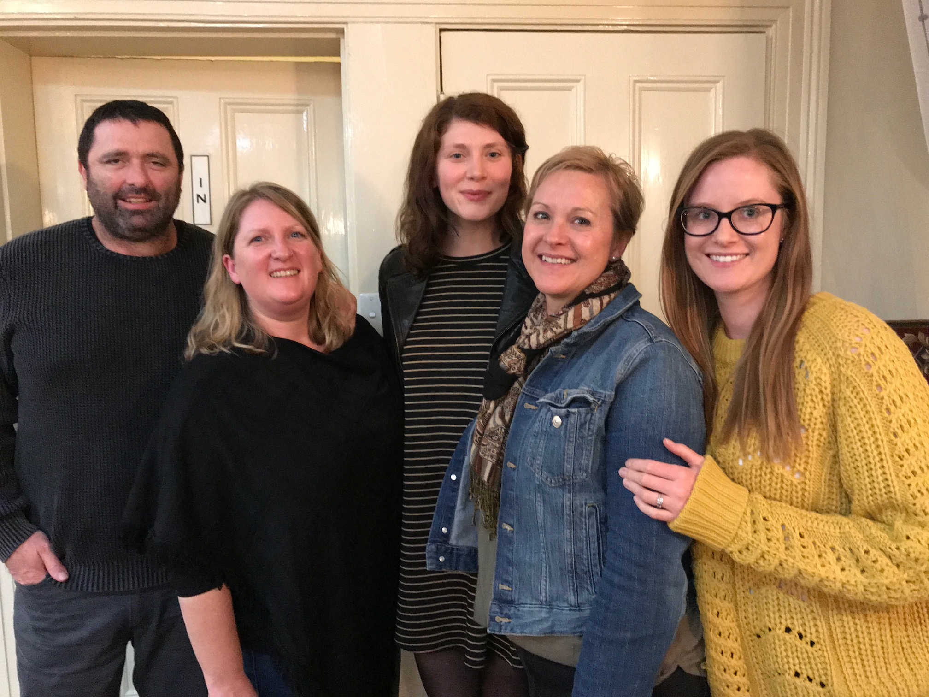

L-R Brendan, Karen, Lisa, Sue and Kirsty

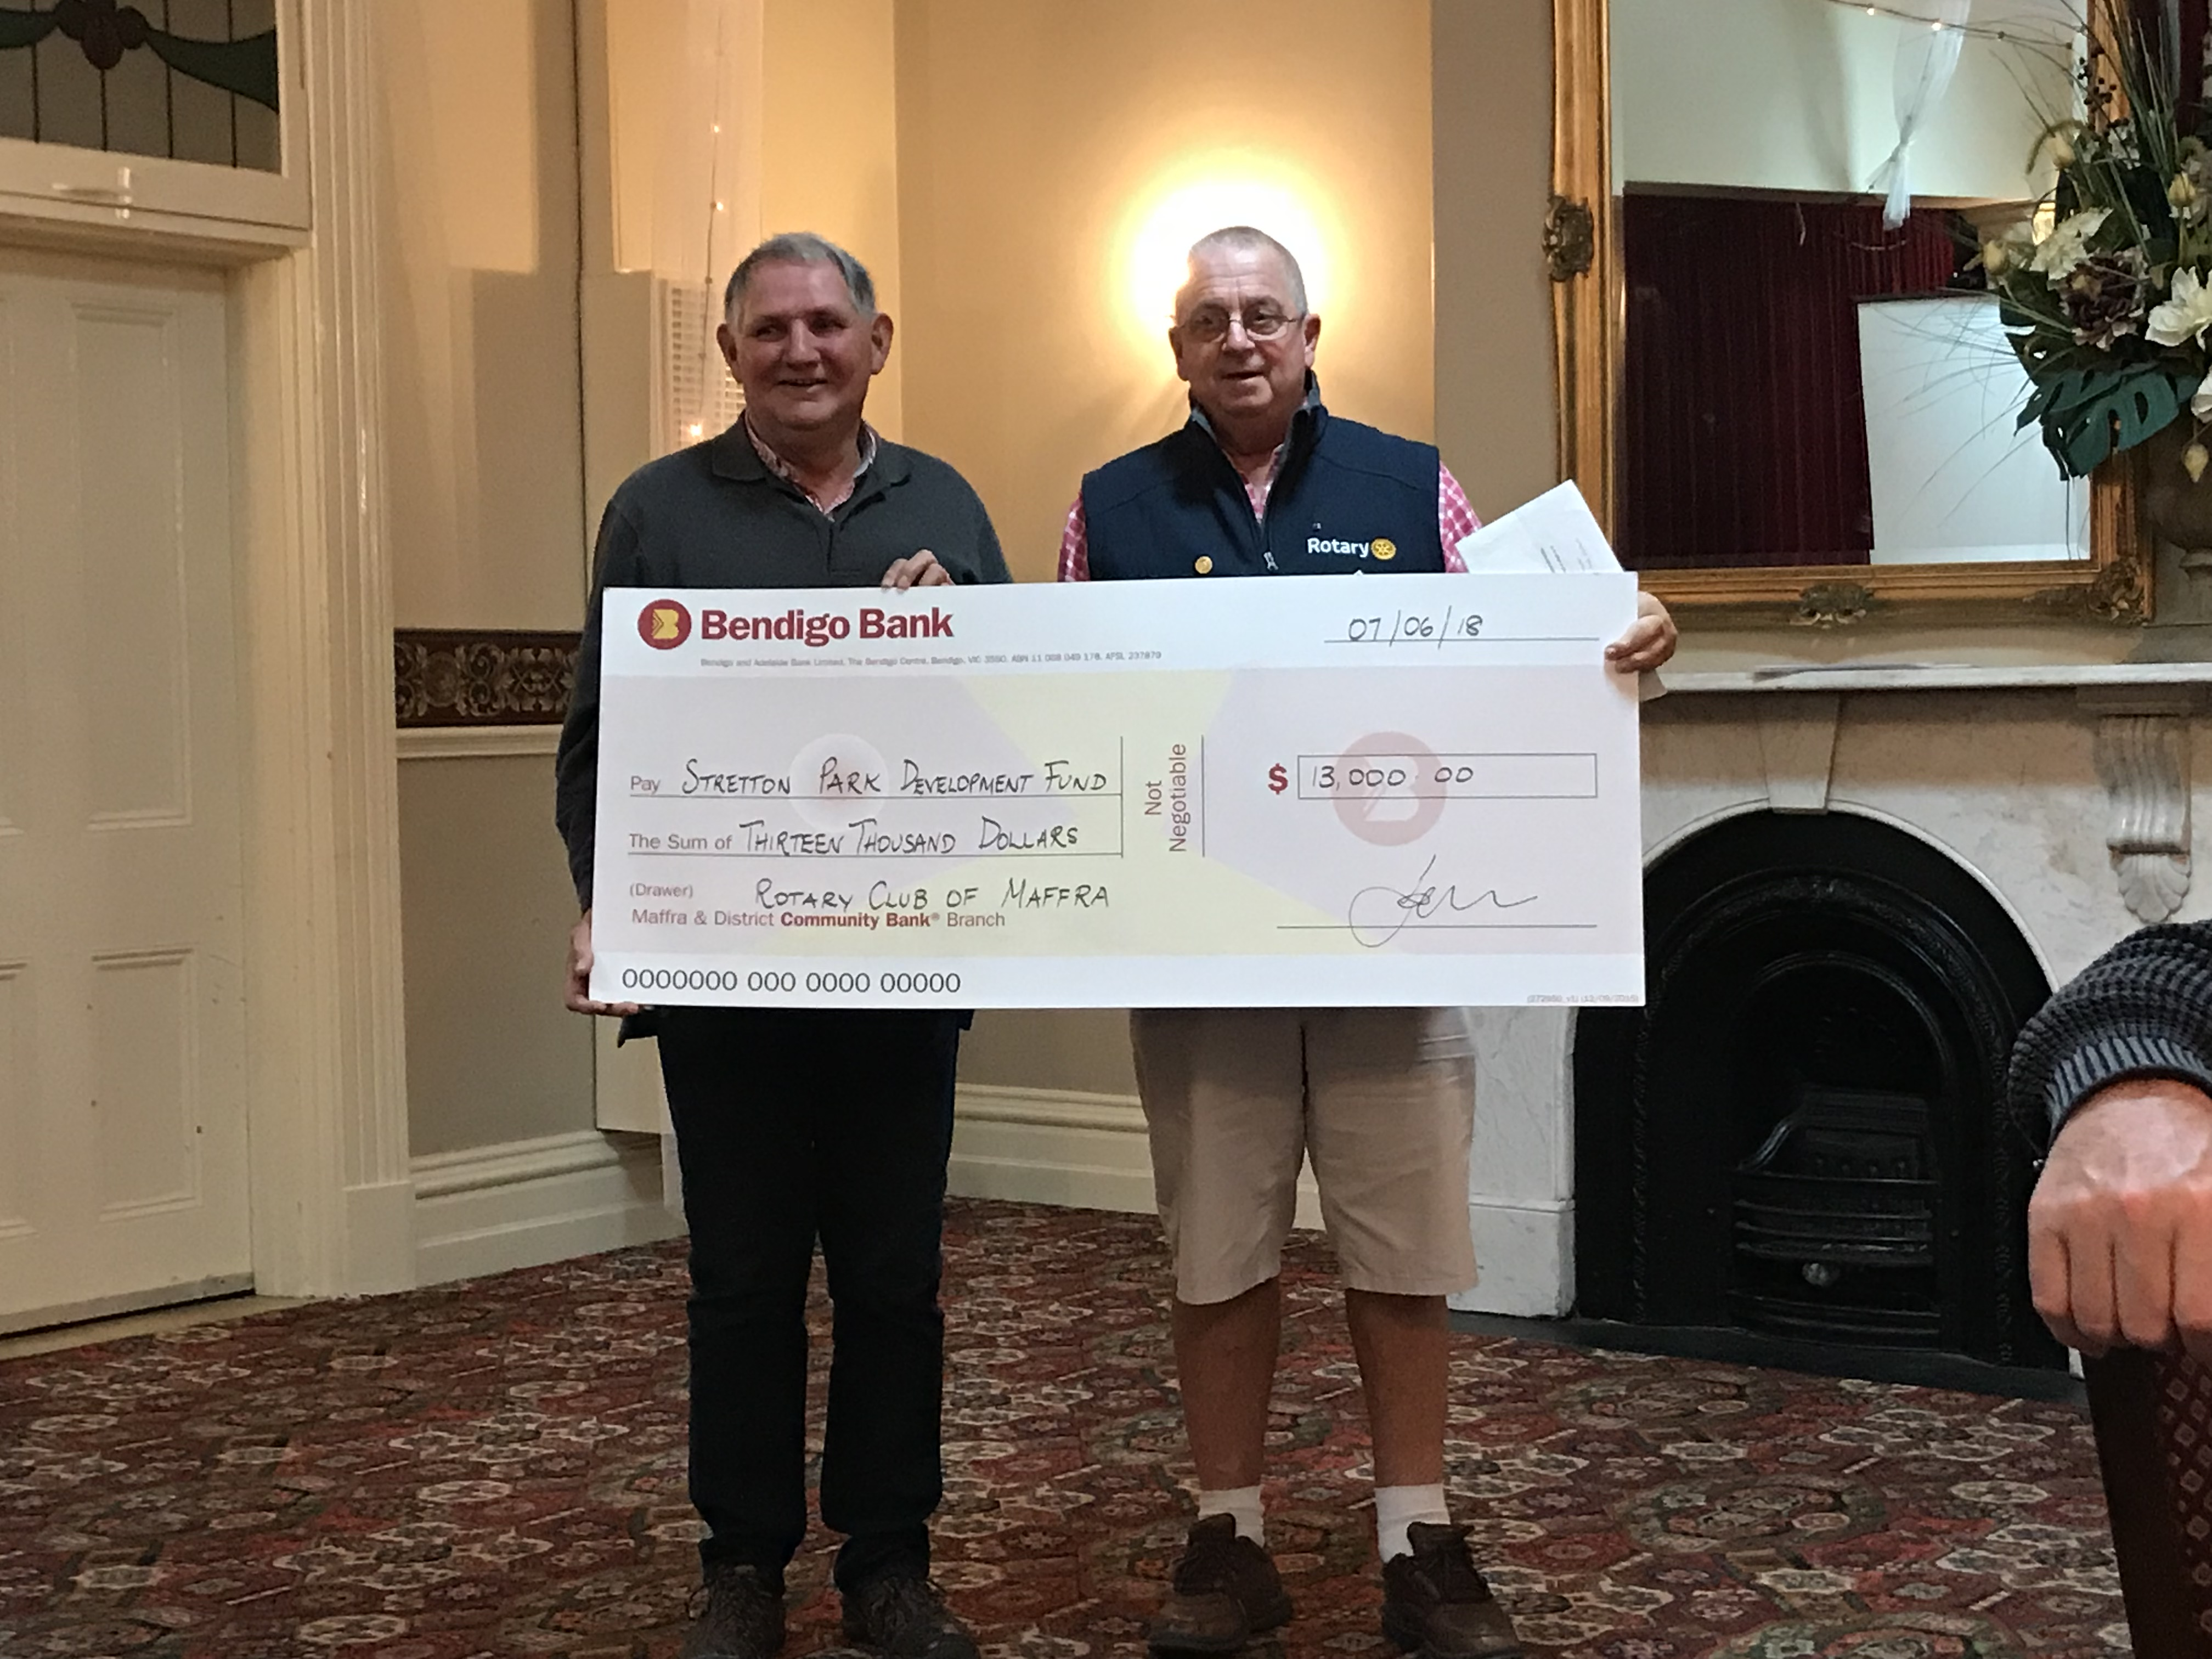
Phil and Graeme.

