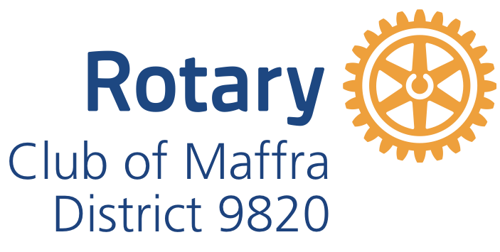
INSURANCE COVER provided by ONE-UNDERWIRTER INSURANCE BROKER
Prior to participation, stall holders shall purchase public liability insurance cover. For all Stallholders that do not provide their own insurance, or is not sufficient, and current, we shall automatically purchase cover on your behalf from One-Underwriter brokers at an extra cost of $7.00.
Our public liability insurance is provided by Lloyd’s of London under One-Underwriter insurance brokers.
If Market and Food stall holders do not have their own Public Liability Insurance cover, please read before applying to conduct a Market and Food stall at
- The Rotary Club of Maffra Mardi Gras or
- The Rotary Club of Maffra Community Market.
Please tick the event you are attending.
One-Underwriter Insurance Brokers Cover will NOT provide cover for the following:
It should be noted that this insurance cover includes terms and conditions as following;
- Second hand mechanical/electrical goods and toys (new mechanical/electrical goods and toys will be covered);
- Medicines, potions, oils, fragrances, soaps and beauty products (but oils, fragrances, soaps and beauty products will be covered if predominantly consisting of natural ingredients);
- Massage, manipulation, chiropractic or similar;
- Hazardous inflammable or dangerous goods;
- There is no cover for massage therapies or treatments provided by stallholders.
I am aware of the requirements of the Rotary International Insurance Policy and undertake to comply.
Please sign and date_________________________________________________________
Please return the Application Form to
Rotary Club of Maffra by email: rotaryclubmaffra@gmail.com
post to Rotary Club of Maffra, P.O. Box 154, Maffra 3860 or hold for collection.

