2023 Memorial Tree Program
Remember a loved one this holiday season.
Donate a light for the Holiday Memorial Tree at the Baron Hugo Gazebo on the Town Green. The Tree Lighting ceremony will include a reading of names of all those remembered herein at the gazebo in front of the Town Hall
Tree Lighting Ceremony: 7 pm on Friday, December 8, 2023.
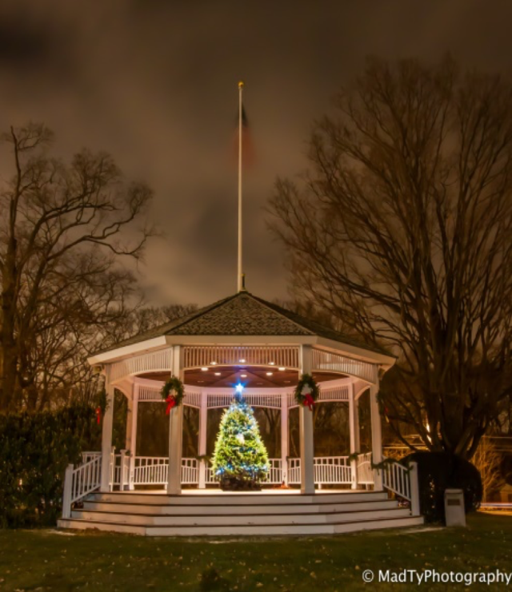

Contributions will be used for community Rotary Club services, such as Student Foreign Exchanges, Substance Abuse Prevention, ShelterBox, Elimination of polio world wide - “Polio Plus” and High School Scholarships.

Please return this form with your contribution for the Memorial Tree Lighting by December 1, 2023.
Checks should be made out to “Milton Rotary Club Foundation”, PO Box 243, Milton, MA 02186.

Donate online at: miltonrotary.org

Memorial light: $25 Sponsor Memorial Light $50 Patron Angel Light $100 Memorial Star $1000

Remember Our Loved Ones with a Light on the Memorial Tree:

Person Remembered: Memorial Level (check one)
- _________________________________________________________ $25__$50__$100__$1,000___
- _________________________________________________________ $25__$50__$100__$1,000___
- _________________________________________________________ $25__$50__$100__$1,000___
- _________________________________________________________ $25__$50__$100__$1,000___
Attach additional sheet if needed.
Donated By: Name:________________________________________________________
Address:_______________________________________________________
Tel. No._______________________ Total Amount of your contribution: ________
Milton Rotary Club Foundation is a 501c3 charitable corp.
May we publish your name as a contributor in the Milton Times Thank You announcement? Yes____ No ____

