ClubRunner Instructions for Version 3.0, 2014-2015

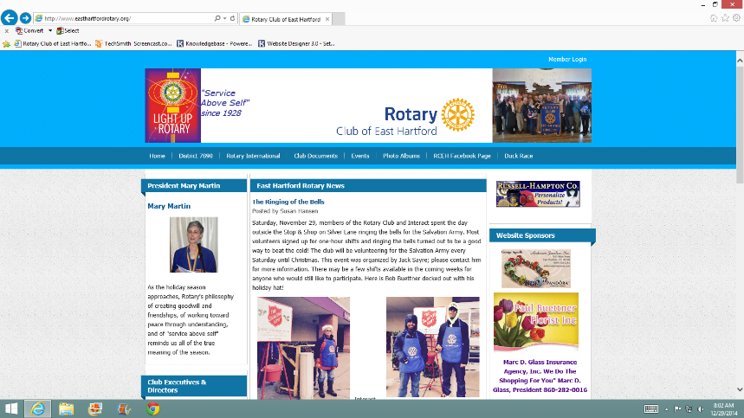
From the club’s website, http://www.easthartfordrotary.org, click on the “Member Login” link on the top right of the page.

On the next screen, enter your user name and password and click the “Login” button. If you don’t remember your user name or password, click the blue link to have that information emailed to you.
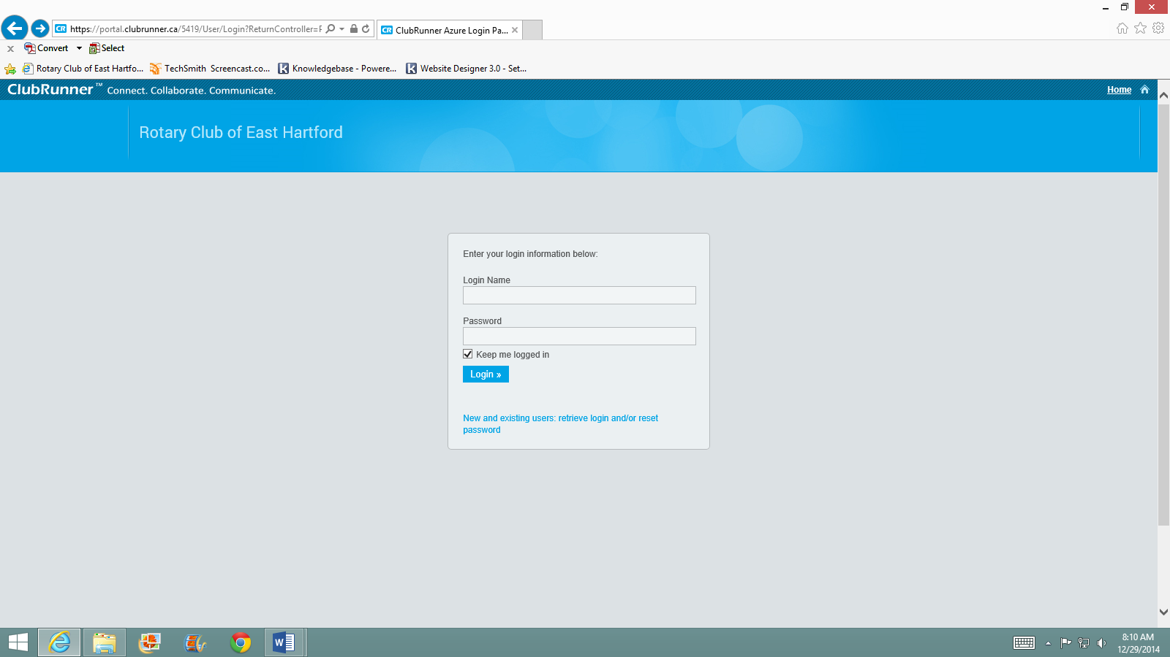
Click this link if you don’t remember your user name or password
Once you login, you are returned to the club’s home page. To update your profile information or to add/edit items on the website, click on the “Member Area” link on the top right of the page.
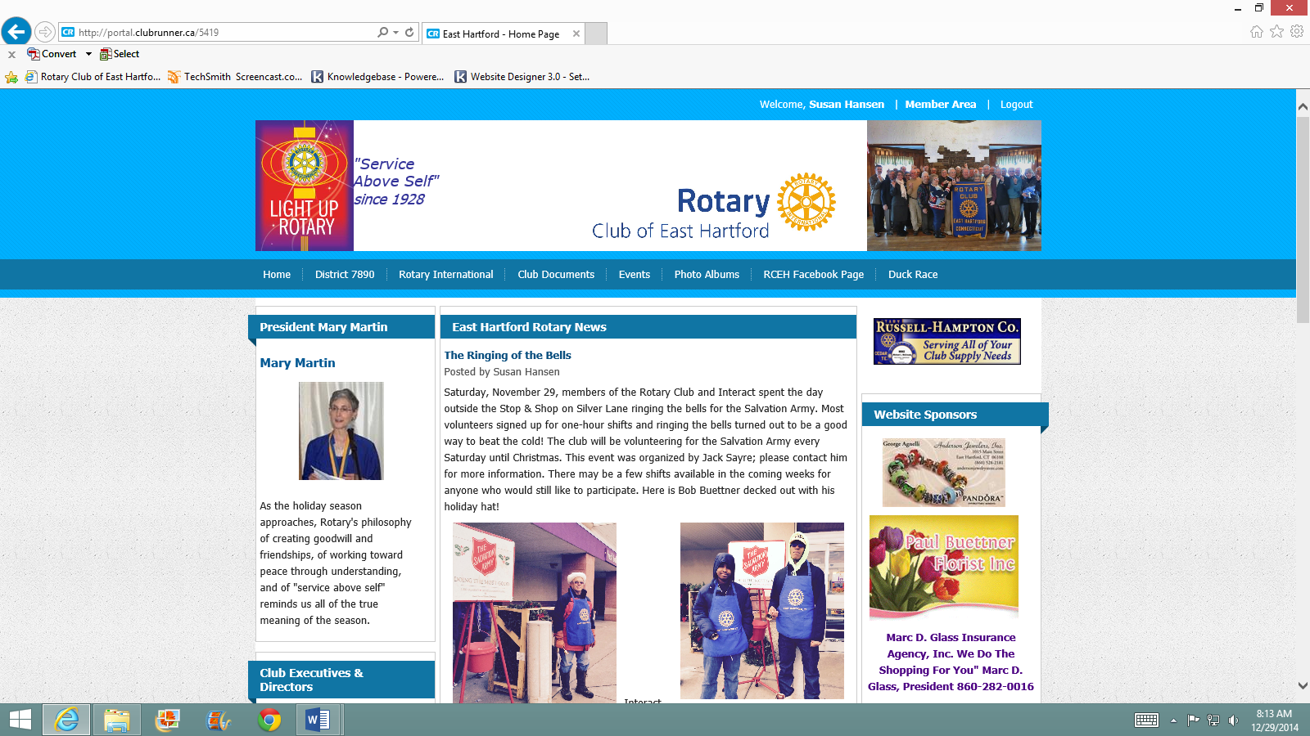

The next screen is the Administration Dashboard. From this screen you can find all of the features you need.
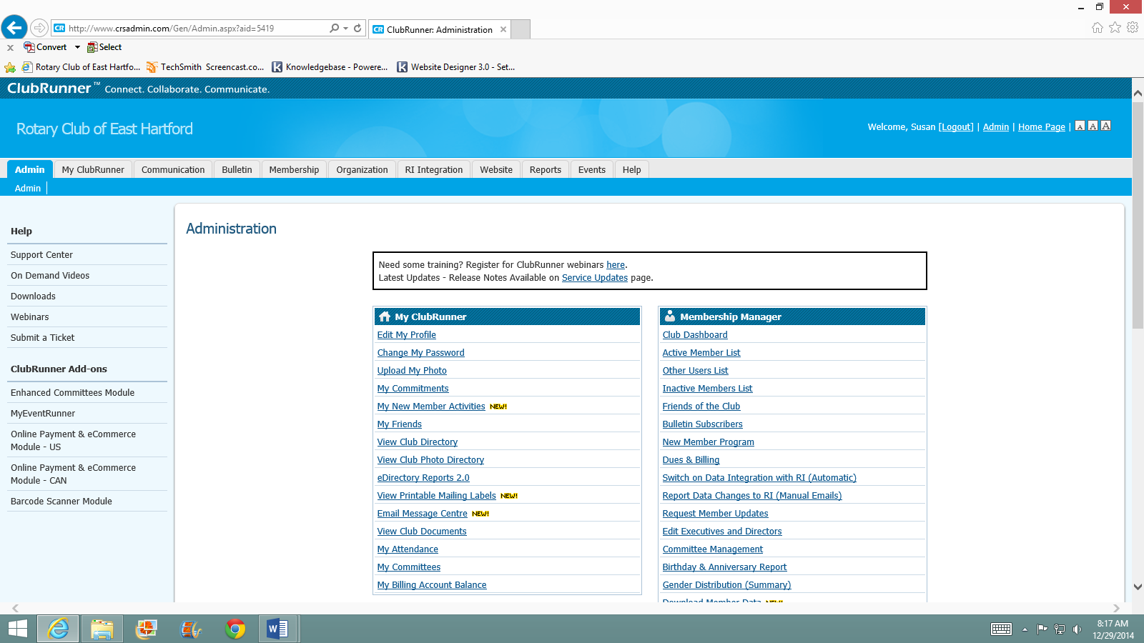
Under the “My ClubRunner” heading, your first option is to edit your profile. Click here to update your information. Once you arrive on your profile page, click “Edit” in order to change your information.
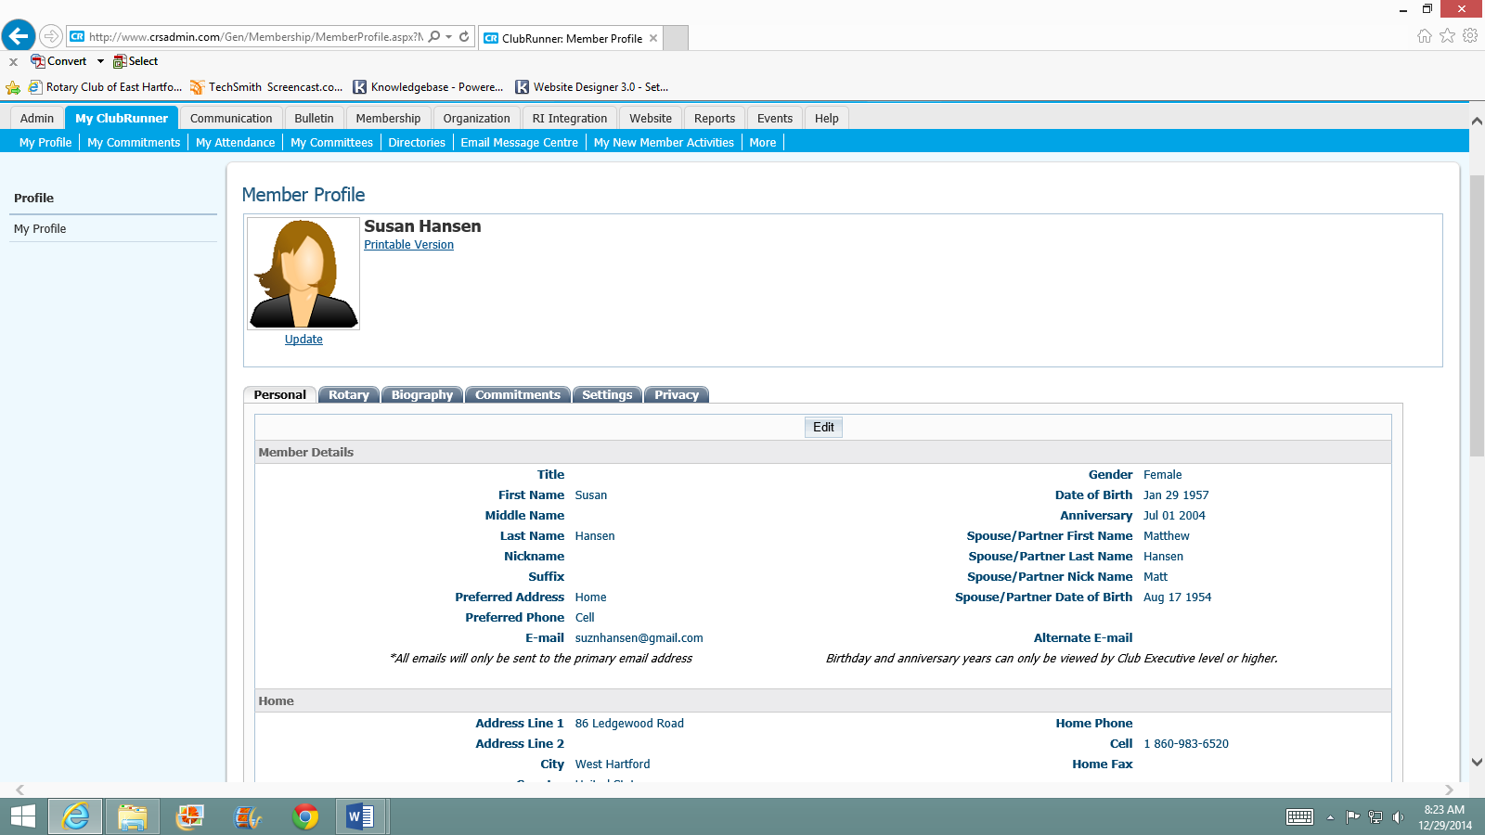

After you click edit, you’ll see that several of the fields are highlighted in red; these are required fields. Scroll down the page and make all changes necessary. When you are finished it is important to click “SAVE” or your changes will be lost.
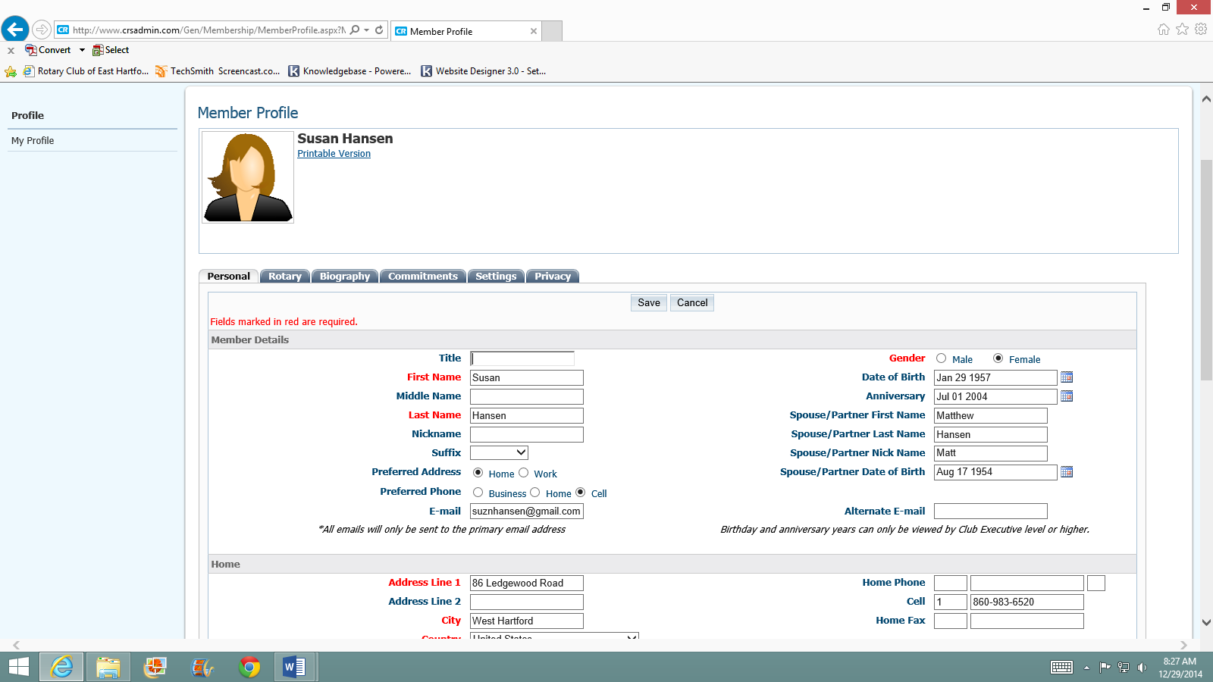
After saving your information, you will be back on your profile screen. To return to the Administration Dashboard, Click the “Admin” tab on the top left, then click the word “Admin” again that will appear below the tab.
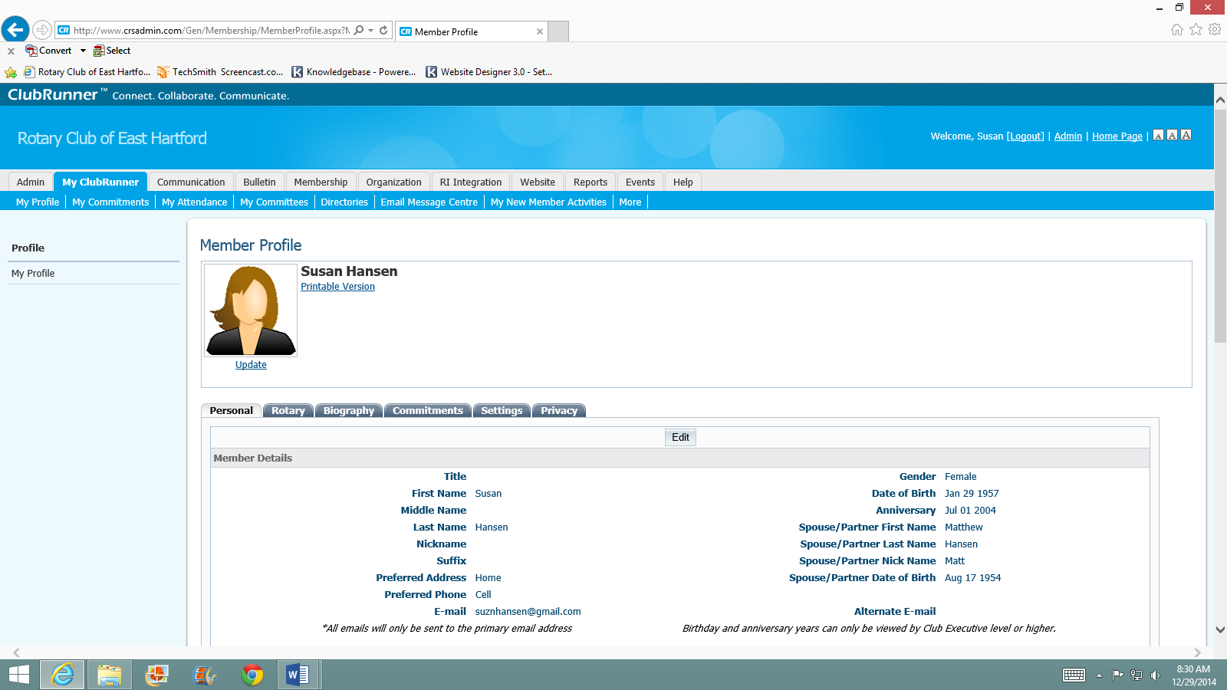
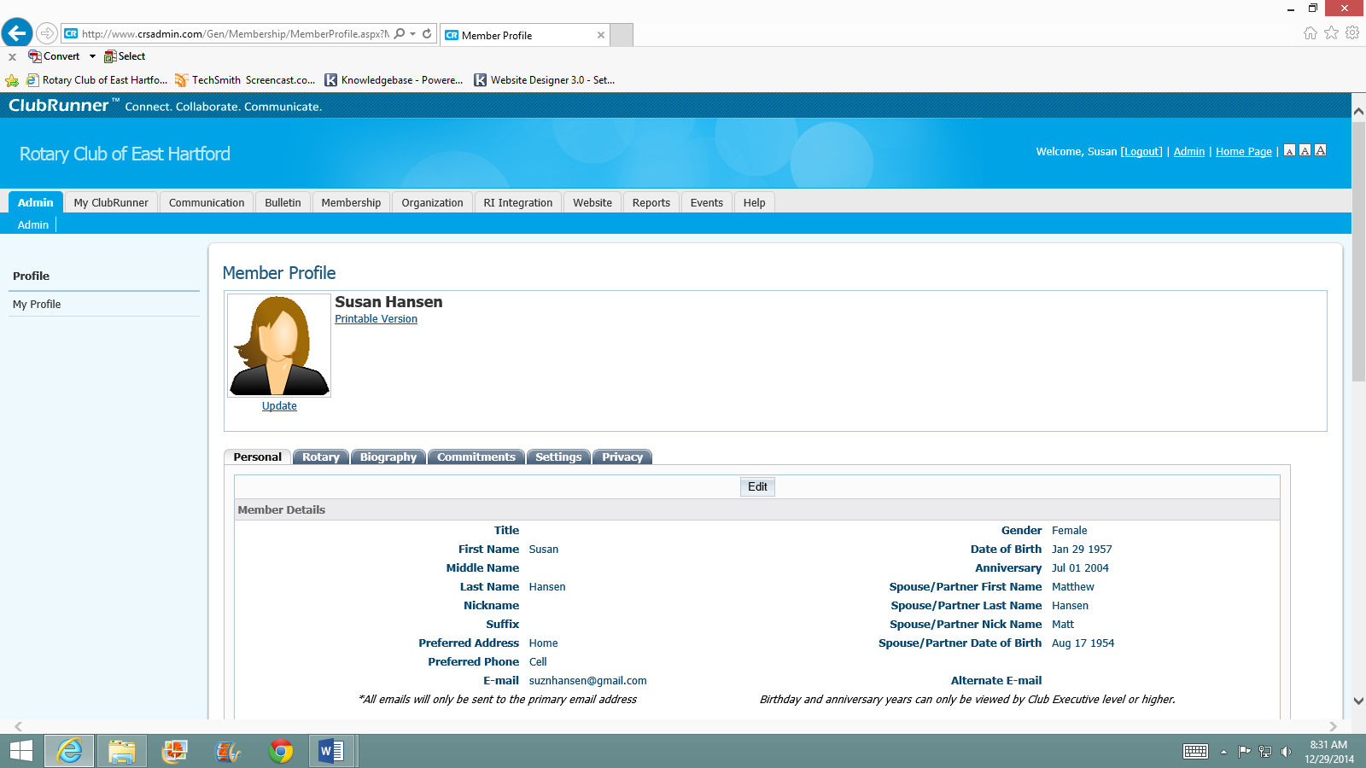
You are now back at the dashboard. You can change your password, view the club directory and photo directory, see your attendance and explore the Email message Centre. There are some options that have not yet been updated in Version 3.0. This is still a work in progress. 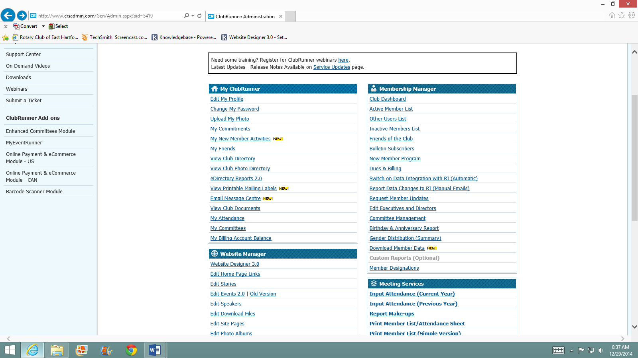
When you are finished, click the “logout” link after your name near the top right of the screen. That’s it! Feel free to login any time and get comfortable using ClubRunner.
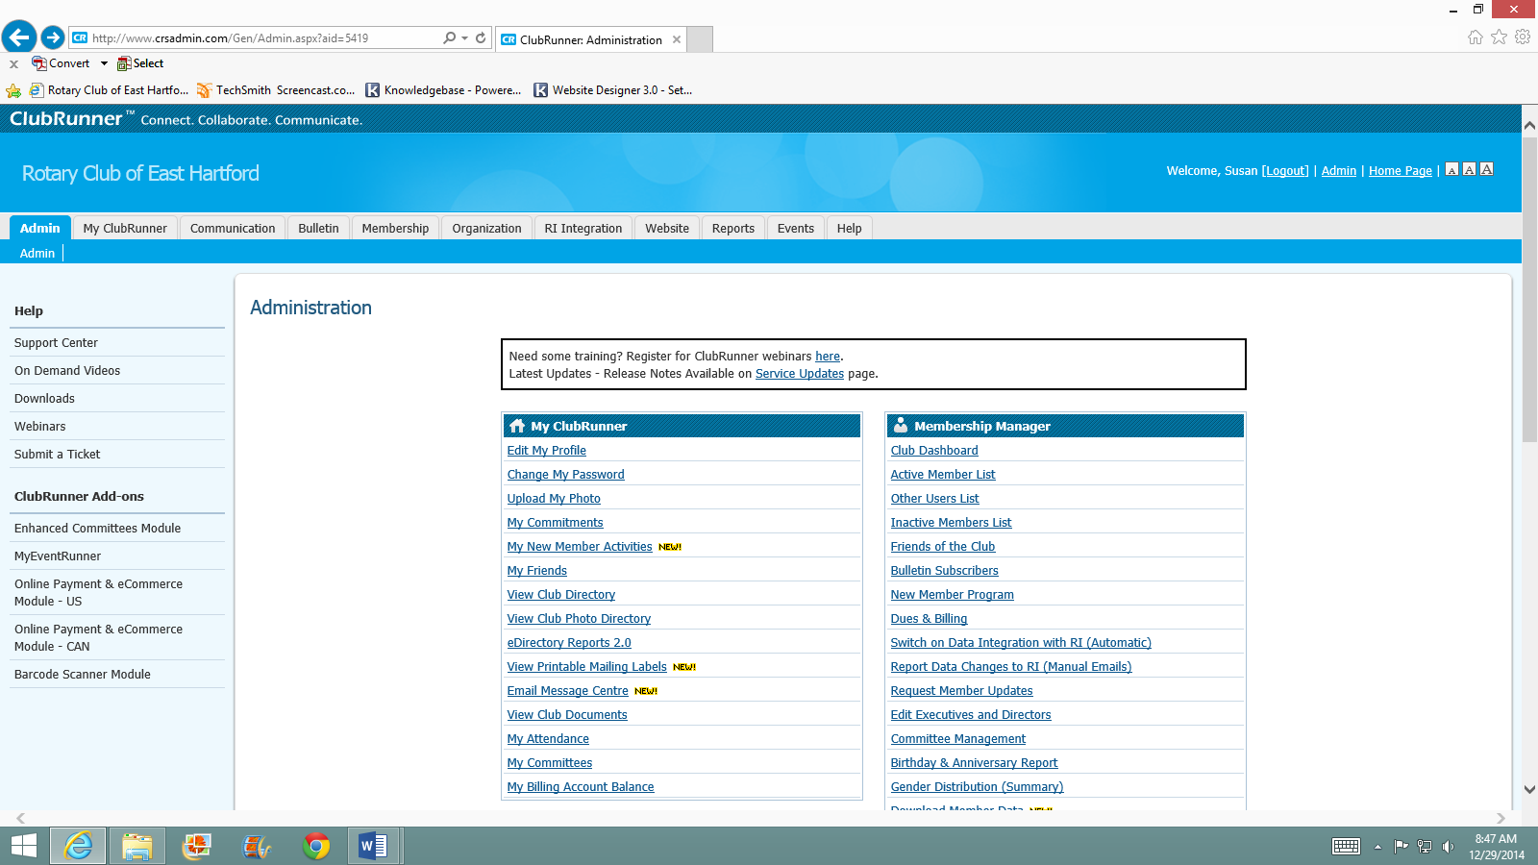
For club members who have additional access to edit or update the website, you need to do that on the Administration Dashboard under the “Website Manager” heading, using the first link to “Website Designer 3.0” ONLY!! (See red box on preceding page.) The designer shows you an outline of our site. You will only need to click on the Content Section’s “Edit Content” button to find the parts of the site you can edit. Please do not click on the Edit Banner or Edit Menu buttons. Contact Susan Hansen at suznhansen@gmail.com if you would like to discuss changes to those areas.
Use this link for editing website
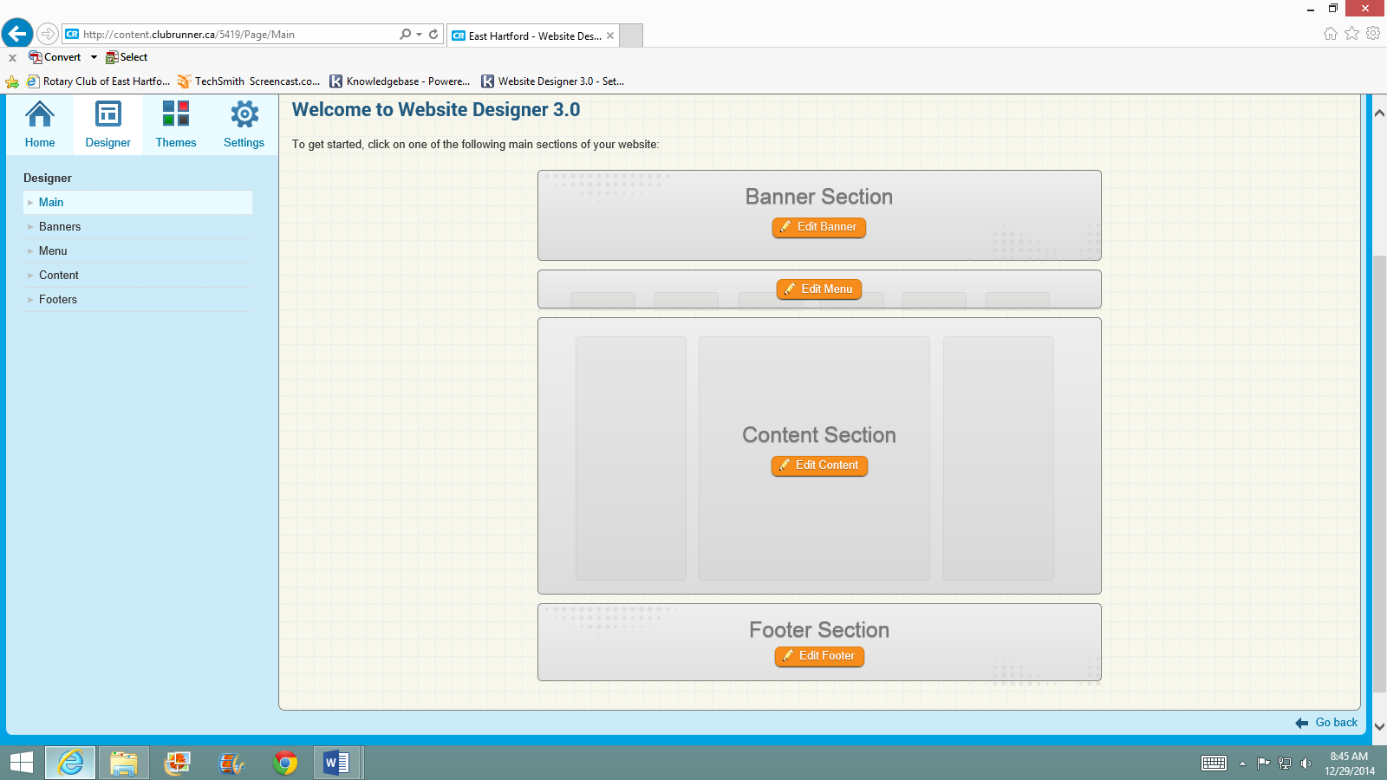
Once you enter the content section, you are able to edit the items in the center of the screen, either in the left, middle or right menu.
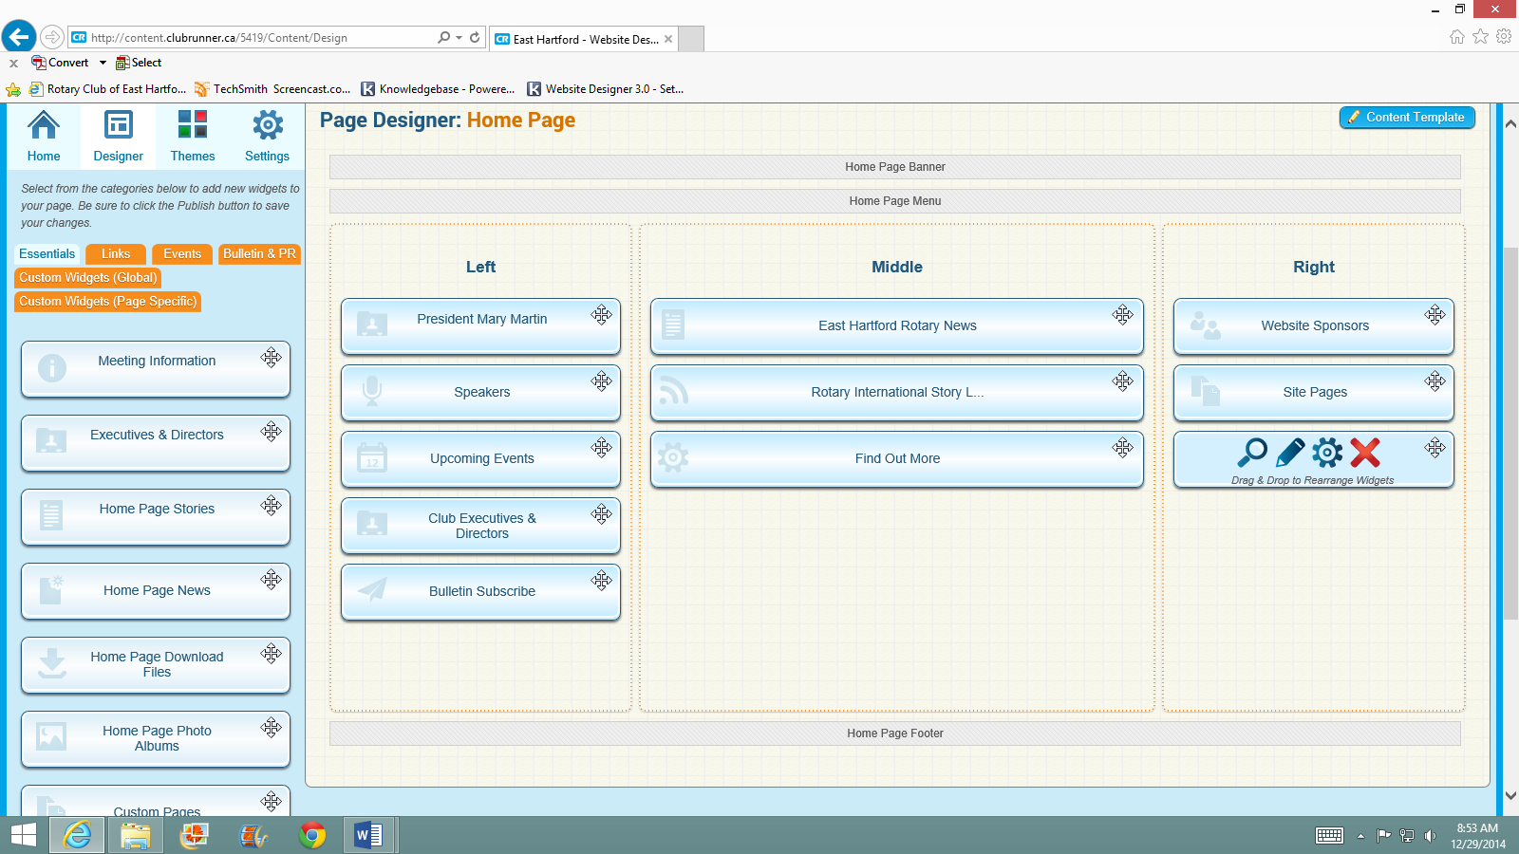
If you’ve made it this far and are fairly computer savvy, you can explore and try things on your own. If you don’t like what you’ve one, don’t click a “Publish” button and your changes will not be saved. More precise instructions might be necessary for your individual web tasks. Please contact Susan Hansen, suznhansen@gmail.com, and she will be happy to design customized instructions for you.
Hover your cursor over any item to see the editing icons; click the blue pencil to view and edit.

