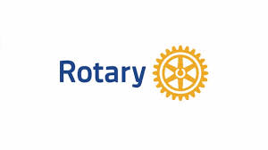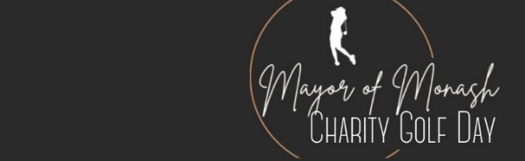

We invite you to be a sponsorship partner with the Combined Rotary Clubs of Monash in holding
THE MAYOR OF MONASH CHARITY GOLF DAY
supporting the Cerebral Palsy Education Centre (CPEC)
and
the Monash Children’s Hospital - Cancer Centre
When: MONDAY 20 OCTOBER 2025 at 11.30 AM
Where: The prestigious Riversdale Golf Club
MAJOR SPONSOR $10,000
BENEFITS INCLUDE:
- Promotion of Sponsor on a Roadside Billboard
- Company signage and displays at the golf course and clubhouse
- Golf Hole naming rights and company signage on two holes
- Company logo on billboard display in marshalling area
- Lunch, Golf Rounds, pre-dinner drinks and dinner for up to 12 participants
- Logo Display on placemats at the dinner
- Speaking time slot at the dinner
GOLD SPONSOR $4,500
BENEFITS INCLUDE:
- Golf Hole naming rights and company signage on one hole
- Lunch, Golf Rounds, pre-dinner drinks and dinner for up to 8 participants
- Logo Display on placemats at the dinner
- Company logo on billboard display in marshalling area
SILVER SPONSOR $2,250
BENEFITS INCLUDE:
- Company Logo on billboard display in marshalling area
- Lunch, Golf Rounds, pre-dinner drinks and dinner for up to 4 participants
- Logo Display on placemats at the dinner
ENQUIRIES: Peter Bramley Mob:0438316264 - Email: gerrypete@hotmail.com

