Whatever you do, don’t forget the 5th of December. This is the final C.C function of the year. Lunch at the Healesville R.A.C.V.- hosted by the assistant of all assistants, COCC’s –
Ian Symons.
RSVP by: Thursday 1st December to ilsymons@bigpond.net.au, 0428 357 741. 5964 3630
THE C.O.C.C IS EXPANDING
‘GETTIN SOME CULTURE.’
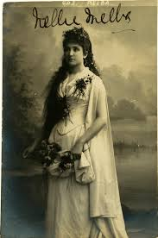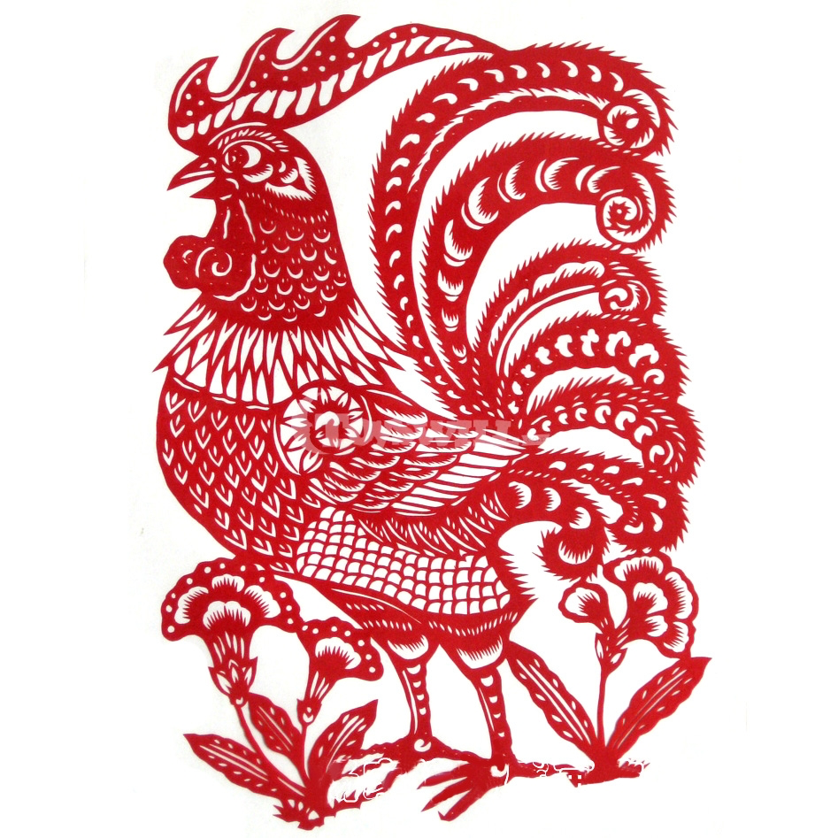
Celebrate Melba Committee.
15th of March 2017
(Sh..t I will be 65 in 2017, better think about growing up)
You must put this date in your diaries. While the COCC may choose to remind you, he may also forget.

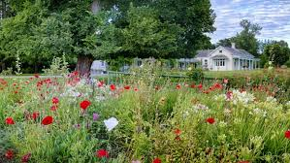
673 -675 Maroondah Hwy
Coldstream

www.coombeyarravalley.com.au
Melba Estate is "a celebration of Melba's style, elegance and sense of fun
In conjunction with others the COCC has agreed that our first lunch for 2017 will be held in support of the Red Cross. While it costs a little more than our usual fare, it will be well worth it. The savings we have made over the last couple of years can all go towards a rewarding day.

The cost includes a guided garden tour of the estate, and for all you
food buffs, a two course meal for only $70.00 per person.

Its not Darts but that is One Huuundddrreed and Fooorty for two

Festivities kick off at around 11.00, but be advised you should be there around 10.30.
The COCC needs to know if you are coming by 10th of February 2017.
MESSAGE from the Dame.
The old COCC has informed me that an opportunity has arisen for the members of COCC’s brigade to visit my home for a bit of a look see and a bite to eat. Along with many from the wonderful little group from the Red Cross I hope you all rise up and come along for a splendid day. I am sure, if I was not dead I would have really enjoyed your company.
Yours
