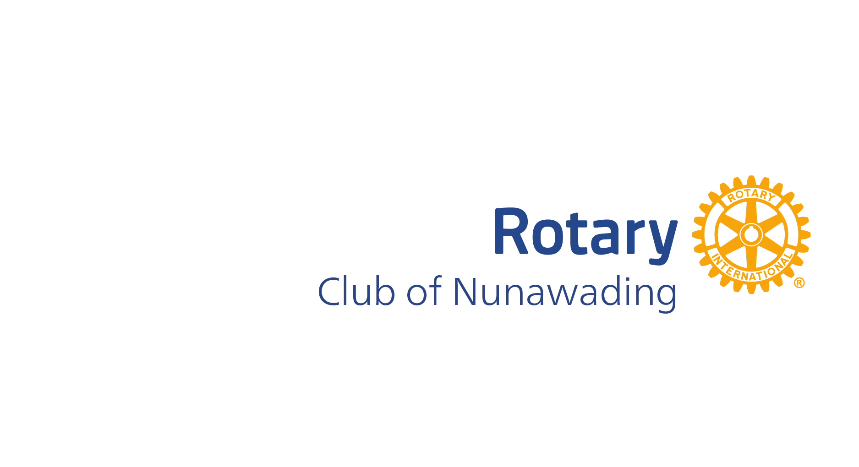

Citation – Deakin Community Awards 2026
Rotarian Harvey Lane

Harvey has been a member of the Rotary Club of Nunawading since 2008. In these 18 years Harvey has been Club President, and for many repeat terms the Fundraising Director. In 2026 Harvey is the Membership Director, a position which he has also held many times, helping to increase the Club’s number of current members to 50.
Harvey works hard to ensure that newer members have a mentor and feel actively involved in the Club. He also puts enormous effort into organising Club events which are inclusive, well-organised, and well-attended.
Harvey’s passion for Rotary, and the contribution that Rotary Nunawading can make to the local community, never wavers. He helped to facilitate the Club’s sponsorship of the Heathmont Jets Junior Football team and is currently on the Club’s Jets committee.
Harvey has superb community fundraising organisation skills and has led the club in raising tens of thousands of dollars. The fundraising then enables the Club to support local organisations such as Eastern Emergency Relief Network, the Mitcham Community Meal, Men’s Shed, local primary schools and the Ringwood Salvation Army.
Harvey also enjoys working with young people and regularly takes part in local Rotary Youth Driver Awareness (RYDA) days, which teaches year 10 and 11 students road awareness. Harvey can also be spotted volunteering at the Club’s monthly Bunnings Sausage Sizzle, which also raises significant funds for local charities.
Harvey’s caring nature not only extends to local people doing it tough. He also takes part in harvesting playgrounds from local schools and council playgrounds, through the Rotary Overseas Relocated Playgrounds (RORP) project, and which are then sent overseas to developing nations. Not only does this benefit children who would otherwise never have access to a playground, it stops the no longer wanted playgrounds going into local landfill here.
For many years Harvey was also on the District Committee supporting Interplast, a charity co-founded by Rotary which provides free surgery for people in developing nations.
Harvey is a Paul Harris Fellow, a Rotary award that recognises those who go the extra mile in support of people in need, particularly in the local Deakin community.

Nominated by Ian Evans of the Rotary club of Nunawading

