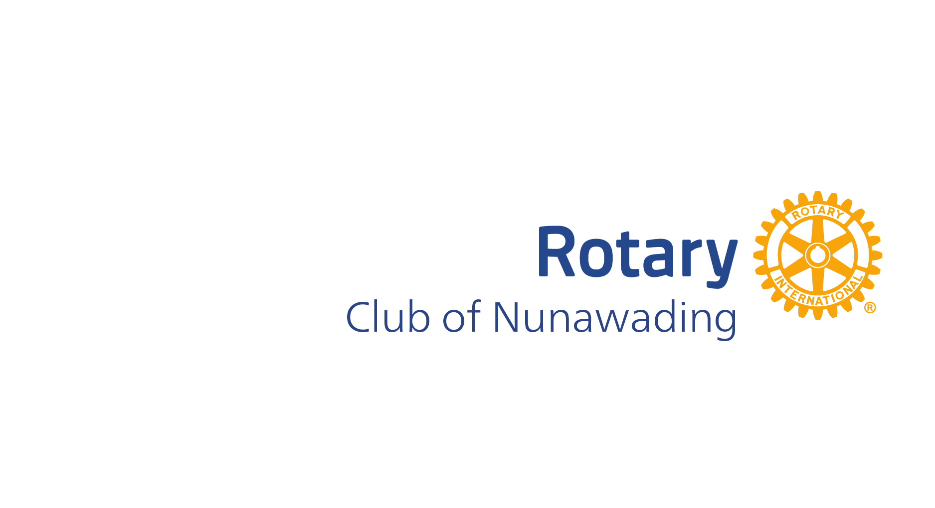

Citation – Deakin Community Awards 2026
Rotarian Russell Warmington

Russell Warmington is a man of infinite energy and enthusiasm when it comes to his local community, which he has been supporting in many different ways for over 35 years.
He coached the girls’ netball team at H.E. Parker Reserve and is a past President and coach of the former Heatherdale Junior Football Club. He is a past President of the Antonio Park Primary School council and served on the council for many years.
Russell has been a member of the Rotary Club of Nunawading for 26 years, is a past President, has been the Treasurer and a director multiple times, and has spent countless hours organising fundraising campaigns for the Club, in order to fund projects in the Deakin area.
Russell manages Nunawading Rotary’s monthly Bunnings Sausage Sizzle, with his usual passion and dedication. Over the years the club has raised tens of thousands of dollars for distribution to Whitehorse charities and entities.
In his rare moments of spare time, Russell works with the students who participate in the Rotary Youth Driver Awareness days run for secondary schools and helps out with the Rotary Overseas Relocated Playgrounds project (RORP). RORP harvests surplus playground equipment in schools and parks to send overseas to developing nations, where the children have never even seen a swing, let alone a playground. Many of these playgrounds come from the Maroondah and Whitehorse areas, and are saved from landfill, benefiting the environment as well as the children who will ultimately enjoy them.
Russell is known and respected for his enthusiasm and hard work and never lets an opportunity to raise money or to “do good in the world” pass him by.

Nominated by Ian Evans of the Rotary club of Nunawading

