[](http://www.clubrunner.ca/Data/5750/story/12471/T1112EN-rgb.jpg)

# http://www.clubrunner.ca/Data/5750/Page/pagestory/59802/ryla_c.gif

|  |  |  |  |  |  |  |  |  |  |  |  |
| --- | --- | --- | --- | --- | --- | --- | --- | --- | --- | --- | --- |
| |  |  |  |  | | --- | --- | --- | --- | | |  | | --- | | October 20  PDG Marty Postic  RYLA | |  | | October is Vocational Service month | | |  | | [**Bi-District Foundation Banquet**](http://www.clubrunner.ca/portal/Events/EventDetails.aspx?accountid=50072&eid=7301&tid=2) Sheraton Hotel Downtown  May 18, 2012 | | [**District 5750 Conference**](http://www.clubrunner.ca/portal/Events/EventDetails.aspx?accountid=50072&eid=9005&tid=2) Sheraton Hotel Downtown  May 18, 2012 at 6:00 PM - May 19, 2012 | | |  | | --- | |  | |  | | |  | |
|  |

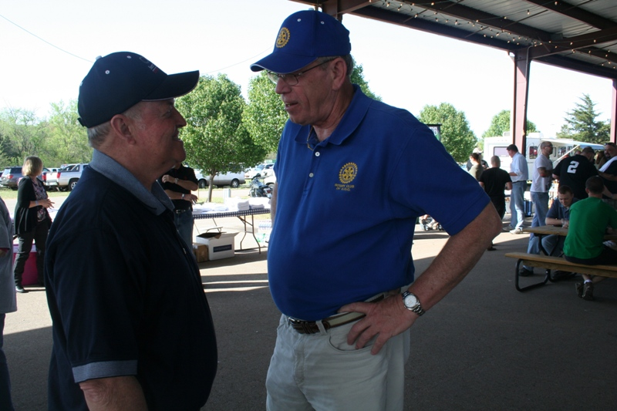

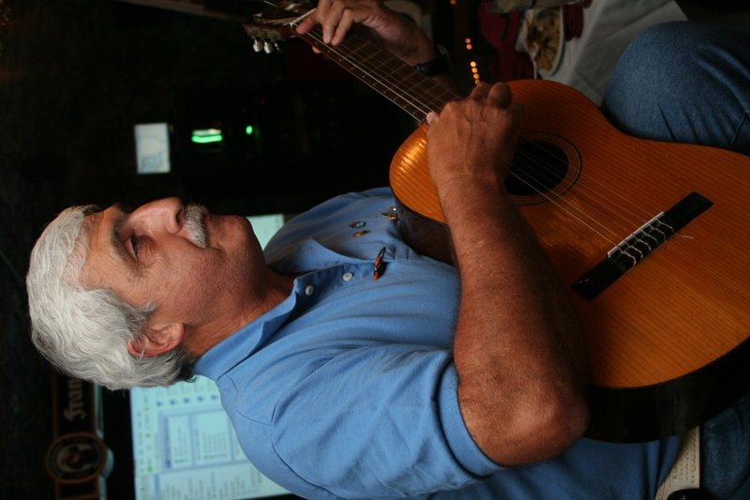

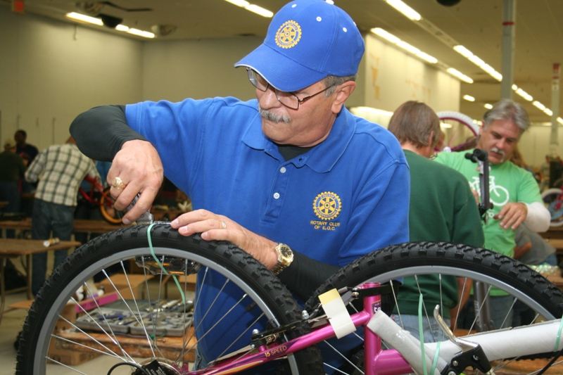



[](http://www.rotary.org/en/AboutUs/JoiningRotary/Pages/ridefault.aspx)

Rotary Club of EOC, PO Box 223, Harrah, OK 73045

[h*ttp://www.clubrunner.ca/Portal/Home.aspx?accountid=5501*](http://www.clubrunner.ca/Portal/Home.aspx?accountid=5501)

*find us at EOC Rotary Club on Facebook*

Rotary Club of EOC

October 24

Peggy Missel

October 24

Zeke Lay

Pour one-half cup vodka

And one-half cup water into a Ziploc freezer bag And freeze for a slushy, refreshing ice pack for aches,

Pain or black eyes.

|  |  |
| --- | --- |
| [Description: http://www.clubrunner.ca/Data/5750/Story/7663/tn_banerjee_kalyan.jpg](http://www.clubrunner.ca/Data/5750/Story/7663/banerjee_kalyan.jpg) | My dear brothers and sisters in Rotary,  In the pages of this month’s magazine, you will be introduced to the marvelous city of Bangkok, Thailand, which will play host to our 2012 Rotary International Convention. Please consider this my personal invitation to join me, my family, and our fellow Rotarians at what promises to be an incredible event in one of the world’s most fascinating locations.  Thailand is a spectacular destination, truly the Land... |
| ...of a Thousand Smiles. I would particularly urge Rotarians who have never visited Thailand before to consider this as your chance. You’ll be surrounded by gracious Rotarian hosts and friends, old and new, from around the world. Bangkok is a fantastic gateway for those wishing to explore Southeast Asia, and a wonderful experience on its own. For those who hail from countries closer by, take the opportunity to visit a major cultural capital, with all it has to offer – including shopping, dining, and sightseeing. Indeed, Bangkok will give you a wonderful value for your time and money.  But the very best reason to visit Bangkok, of course, will be the 2012 RI Convention itself, 6-9 May – the highlight of the Rotary calendar | |

_______________________________________________________________

|  |
| --- |
| The Capitol Rotary Club of Oklahoma City will be holding its 8th Annual Competition Skeet Shoot starting at 9:00am on Saturday, October 29, 2011, at the Oklahoma City Gun Club. The cost for participating is $50 per person, which included either 12ga or 20ga shells, donuts and coffee in the morning and a barbeque lunch, along with door prizes.Trophies will be awarded to the winning teams and the best individual shooters. You can put together your own 4 person team, or we'll be happy to assign you to one. In conjunction with the skeet shoot, Capitol Rotary is also raffling off a 12 gauge, semi-automatic shotgun.Tickets are $20 each, and the drawing will be held the morning of the shoot. Enjoy a great autumn day and help Capitol Rotary's projects for the year, including the Ready to Learn Program at Kaiser Elementary School, the Millwood Elementary School Library, support for the Oklahoma County Immunization Coalition, Law Enforcement Recognition, Polio Plus, Christmas Adopt-a-Family and more. Clark Duffe 405-760-3108 |

___________________________________________________

|  |
| --- |
|  |
|  |

.

.