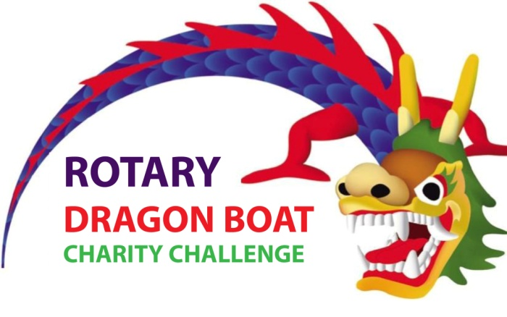
ROTARY DRAGON BOAT CHARITY CHALLENGE 2024
ROTARY CLUB PRAGUE INTERNATIONAL

Žluté lázně, Saturday 11 May, 2024

Name of sponsoring company or organization*:
Contact Person / Team Manager:
Mobile: Email address:
Dragon Boat Team Name:
Team Captain:
Mobile: Email address:
Sponsoring organization IČO:
Address for invoicing:
When your registration is received, we will confirm its reception. This confirmation will include the invoice issued by Rotary Club Prague International for 45.000 CZK, which includes the team registration fee of 20,000 CZK as well as the minimum charity donation of 25,000 CZK.
The invoice must be paid in full by April 15, 2024 to ensure your participation. Donation contract for the donation amount will be issued to the sponsor when the invoice has been paid.

Please indicate with an X in the box below, which charity or charities you would like to support. If you do not wish to choose, your charity donation will be divided equally to all charities named below:

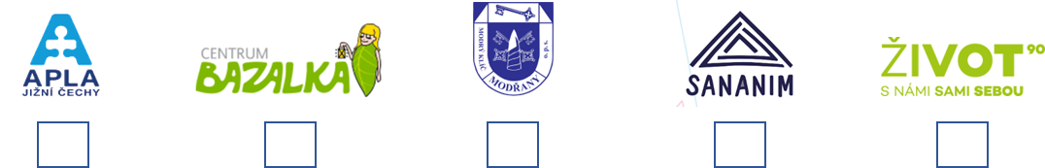
MODRÝ KLÍČ

At the venue there will be reserved for your team a space where your team will have a tent with tables and benches. Should you be interested, you can build your own tent. The amount of CZK 20,000 already includes the costs of providing place and a tent.

Should you wish to hire a tent and tables, please indicate by X: Tent & Table Hire

Rotary Club Prague International is not registered for VAT

Date / Name / Signature:
For more information, please visit www.rcpi.club or send us an email: rotarydragonboats@gmail.com

