Meetings: Mondays at Noon
DJ’S Dugout
10308 South 23rd St.
Bellevue, NE 68123

OFFICERS FOR 2022-2023

President.....................Joe Mangiamelli President-Elect..................Sharon Lier
Secretary........................Charles Adams
Treasurer.......................Denise Dolezal Sergeant-at-Arms.................Paul Reed Board Members…….Joe Mangiamelli
Bob Hovey
Herb Barelman
Paul Reed
Sharon Lier
Jeff Smith
Denise Dolezal
Charles Adams

GREETER

Sharon Lier

FROM THE PRESIDENT

What a month! March has been crazy and I’m not talking about buster basketball brackets. We’ve potentially gained two new members, Michelle Andahl, who our club selected as a Rotary Golden Wheel Award recipient, has submitted her paperwork to join us. Michelle presented last Monday noon on her new work at the Platte Institute. Welcome abroad Michelle and congratulations.

In addition the Board had a briefing from our new Edward Jones account representative, Kyle Green. We hope Kyle will join our Club as well. We’ll look to him to keep us apprised on market conditions affecting our Foundation account.

Charles attended the District conference in Lincoln over the weekend and advised us the two of our members, Jeff Smith and Rich James, were lucky winners of Paul Harris Fellow recognition. With each being long term Harris Fellows this award adds one more notch on their contribution belt – Congratulations to you both!!!

This month we will be discussing our scholarship awards – as many of you know, we’ve not had great assistance from the high schools in recommending candidates. We’ve potentially considered concentrating on Bellevue University students who are very grateful for our assistance. Please watch for email notifications for the discussions we’ll hold to move any recommendation(s) forward. We need your vital input in our considerations.

As Rich reminded us this past Monday, the golf outing is rapidly approaching and we need all of us to work toward getting players, teams and prizes to make the outing a success. Less than six months so it is never too early to start the effort. If everyone steps up it is less work for Rich, let’s make sure we’re part of the next successful outing.

Personally, I am looking for the legislative session to be over so Rick can return to his spot at our meetings and that the snow season is over so done so Bob can come back to us from the southwest and south.

Hope your Easter is spent with family and that we can enjoy an unbelievably nice spring.

FROM ROTARY INTERNATIOAL

A Peace Fellow and polio survivor focuses on accessibility
Ronald Kasule caught polio when he was 3 years old. The disease left him paralyzed. Seeing that the boy could neither walk nor feed himself, his father intended to end his son’s life before he became a burden to the family. “My parents had fierce arguments over me,” he recalls. “In the end, my mother prevailed. She made the tough decision of divorcing my father to save my life.”
The family lived in Kisubi, a village about 60 miles southwest of Uganda’s capital, Kampala. His mother sold practically everything the family owned to search for a cure. When treatment failed, she came up with many creative ways to train her son at home so he could live independently. But when Kasule reached school age, he had no means of attending the distant school. One day, he pleaded with his mother until she relented and allowed him to go.
“With a book in my hand, I went with my siblings,” Kasule says. “But they ran very fast, and I could only crawl slowly on a gravel road. Before long, a rain came down. I had to turn around and go home. The rain had damaged my book. From then on, I voluntarily gave up the idea of schooling.”
In 1986, when Kasule was 7, rebel groups waged a civil war against the new Ugandan government. His village was under frequent attacks by rebel soldiers. “One night, before soldiers raided our village, my mother had to escape with my siblings without me because I was a big boy, and she wouldn’t be able to carry me. So, I was left alone in the house, with the door wide open.” Fortunately, the soldiers never entered the house.
When soldiers terrorized the community during the day, his mother would carry him to the nearby woods and hide him behind a bush. “She would say, ‘Ronald, if I survive, I will come back to get you, but if I don’t, God will keep you,’” says Kasule. “I would lie quietly, in fear until my mother came at night.”
These traumatic experiences motivated him in later years to apply for a Rotary Peace Fellowship. “A person with a disability cannot survive without peace,” he says.
As the civil war continued, Kasule and his family deserted their home and slept in the woods. They later moved to another region and stayed with an uncle, a schoolteacher who lived on campus. The relocation enabled Kasule to fulfill his childhood dream of attending school.
Kasule studied hard and excelled in his class. The charity organization ActionAid gave him his first wheelchair and sent him to study at Kampala School for the Physically Handicapped.
For Kasule, the path to education after the war was paved with frustration. Even though he achieved the best scores in the district, he was denied access to his secondary school of choice after the school found out that he was disabled. “The school insisted that I could not manage without support, yet there was no support available for me,” he says.
Having dropped out of school, he tried to learn shoemaking. At Nkokonjeru Providence Cheshire Home, which provides vocational training to people with disabilities, staff members learned about his academic prowess and encouraged him to resume his studies, later sponsoring his college education.
“I view peace in terms of development,” says Ronald Kasule, pictured here at the Rotary Peace Center in Kampala in 2021.
“After college, I went back and tried to help people like me in my community to fight for equal access to education and jobs so we can fully participate in social, economic, and political life,” he explains.
Since people with disabilities in Uganda often lack access to reproductive health education, Kasule says that many of them are sterilized without their knowledge because some people believe that people with disabilities should not have children. So after graduation, Kasule co-founded Access for Action Uganda, an organization advocating for inclusive policies to aid people with disabilities and other marginalized groups. He later served as the honorary council representative in a district government to advocate for the rights of constituents with disabilities.
Making up for his lost educational opportunities, Kasule earned a master’s degree and completed several certificate programs, including one in sustainable development and global justice from the University of Antwerp in Belgium and another in social protection and inclusion of people with disabilities from Bonn-Rhein-Sieg University of Applied Sciences in Germany.
In 2018, Kasule was selected for a U.S. State Department-sponsored fellowship in inclusive disability employment. He traveled to Washington, D.C., to visit private and public initiatives that promote employment for people with disabilities.
“When I came back, I was supposed to implement what I had learned,” he says. “I had many ideas but did not know how to start.” While figuring out solutions, he came across news about the new Rotary Peace Center in Kampala.
In February 2021, Kasule joined the inaugural class of 15 peace fellows from 11 countries at the Rotary Peace Center at Makerere University to study peacebuilding and conflict resolution. The program strengthened his peacemaking skills, allowing him to traverse Uganda, where he met with social service providers and other peacemakers.
“During my research, I noticed that more people are now attending universities to gain various skills for supporting persons with disabilities, but after graduation there is no work for them,” he says. “Meanwhile, I have talked to many local companies, but most of them told me that they are not against employing people with disabilities. The challenge is that they do not have the resources.”
In the summer of 2021, Kasule launched an online platform, Diversity Ability Support Network System, that provides information about disability resources, connecting Ugandans with disabilities with social agencies and service providers, such as home care workers, personal aides, and sign language interpreters. At present, he and his colleagues are redesigning the Dasuns platform, incorporating additional web and mobile-based applications and features to make it accessible to more users. Kasule’s goal is to scale Dasuns across Africa.
“We often talk about peace in terms of conflicts,” he says. “But for me, I view peace in terms of development — you cannot be at peace with yourself if you are hungry, you cannot be peaceful when you have no access to the support and resources available within your community. You’ll feel sidelined.”

THE FOUR WAY TEST—of the things we think, say, or do:
Is it the TRUTH?
Is it FAIR to all concerned?
Will it build GOODWILL and BETTER FRIENDSHIPS?
Will it be BENEFICIAL to all concerned?

QUOTE OF THE MONTH

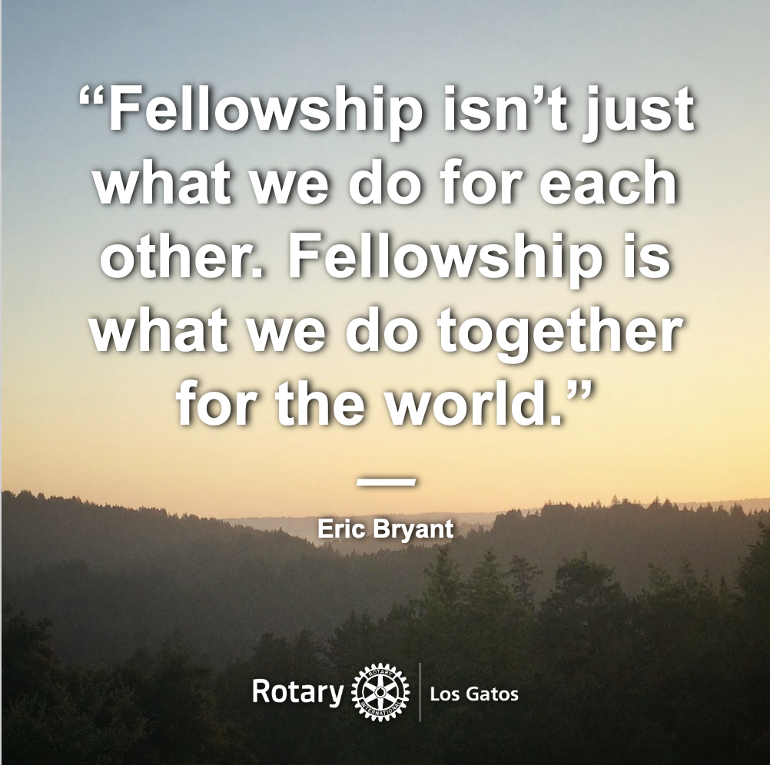

ROTARY TRIVIA
(Answer in next month’s newsletter)
What year was Polio Plus program introduced?
ROTARY TRIVIA ANSWERS FROM LAST MONTH
When was Paul Harris Fellow recognition established?
1957
AREA MEETINGS
Monday:
Omaha Millard, Noon @ German American Society
Omaha North, Noon @ Eppley Airfield Conference Center
Tuesday:
Omaha Morning, 7:00 am @ Happy Hollow Country Club
Northwest, Noon @ Champions Run
Southwest Omaha Rotary Night Club, 5:15pm @Millard Plaza Ballroom
Wednesday:
Council Bluffs Centennial, 7:00am at HyVee
Downtown, Noon @ Field Club
Plattsmouth, Noon @ Plattsmouth State Bank

Thursday:
Suburban, Noon @ Millard German American Club
Friday:
Omaha West, Noon @ Champions Run

