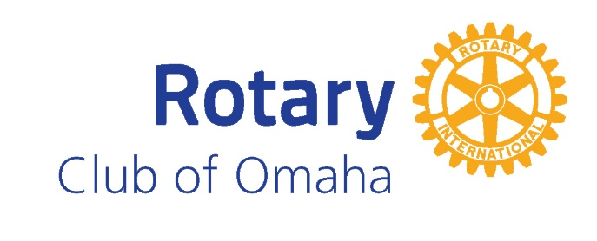

Instructions for submitting Student Names for Honor Roll:
We ask that you send us the names of your selected students at your earliest convenience, but PLEASE, NO LATER THAN MARCH 19th. The Rotary Club of Omaha takes great effort to ensure the proper spelling of each student’s name, so we appreciate your assistance in providing the correct spelling of each student honored. You may submit your names using one of these options:

- Completing the attached form and emailing it to rotary@planitomaha.com. Submit one form for each ten students if you have more than ten students to submit.
- Completing the attached form and sending it via US mail to

Honor Roll Luncheon
PO Box 964
Omaha, NE 68022

Each of these options will also allow you to submit the names of the school representatives that will be accompanying the students at the luncheon. The total number of representatives attending (if not the actual names) must also be received by March 19th.
We will be delivering to your school, no later than March 30th, a packet that contains individual letters for each student selected. We ask that you hand deliver these letters to the individual students or mail them directly to the parents/guardians. Rotary will no longer send out a printed letter directly to parents. From here, parents and guests of honored students may register for the luncheon online using the link given in the parent letter. We will also email out the link to parents, so please be sure to include email addresses in the nomination forms.

This is now a good time to check your Rotary Honor Roll plaque. If it is full and you have not already indicated that you need a supplemental one, please contact us at rotary@planitomaha.com.

As noted in our communication last week, we will be making the decision whether the event will be face-to-face or virtual on Friday, February 12th and communicating to all of you by the 15th.

As a reminder, Rotary Honor Roll recipients should be chosen on a 1-to-20 ratio of the entire 8th grade class. In schools of between 20 and 40 enrolled 8th graders, you may choose two students. In schools of under 20 enrolled 8th graders, you may only send one student. Please note: Due to the size of our event and to be fair to all, we must adhere to this selection process. Please do not submit more names than allotted.

The selection of the Rotary Honor Roll recipients should not be made on the basis of a “popularity” contest. Selected recipients should be chosen to represent your school based on the four categories listed below:

- Leadership – works well with others, respects the opinions of others, is honest, dependable and reliable
- Character – kind and courteous, responsible, demonstrates respect for others and for the environment
- Scholarship – demonstrates a thirst for knowledge, shows ownership of academic outcomes, respects teachers and the learning environment
- Presence – behaves appropriately, respects self and others in dress, speech and actions, portrays a positive self-image.

If you have any questions, please do not hesitate to reach out to us.

Sincerely,

Gary Bren and Jim Stewart
Honor Roll Co-Chairs, 2021

