Dear Community Friends,

The Buffalo Rotary Adopt a Family Program is appreciative of your past interest in making the holidays brighter for an area family in need. The need is incredibly great this year as many families struggle financially.

The Buffalo Rotary Adopt a Family Program will again provide clothing and personal items for children ages 0 to 18 this holiday season. When you adopt a family, you will purchase at least 3 gifts of clothing for each child including: pajamas, clothes, underwear, snow pants, shoes, boots, hats or mittens. These same families will then have the opportunity to participate in the Rotary Toys for Tots Program and receive several toys for each child, as well as a family game and books. You may also select from a list of items from the family's greatest needs such as paper towels, toilet paper, paper plates, laundry detergent, diapers etc. We would also ask that you consider including a $25 gift card to a grocery store and gas station for your family.

This year in an effort to offer each family an equitable Christmas, we will not accept any gifts not listed on the children’s clothing or families’ greatest needs list. Holidays can be difficult when your family is struggling financially but inequities in a Christmas gift program such as Adopt a Family can add additional stress when care is not taken to ensure each family receives an equitable Christmas. We appreciate your assistance in providing a wonderful Christmas to each of our adopted families.

There will be one drop off date for your gifts. Gifts can be dropped off to:

Buffalo United Methodist Church
609 8th Street NW, Buffalo
Sunday, December 8th from 3 pm to 8 pm.
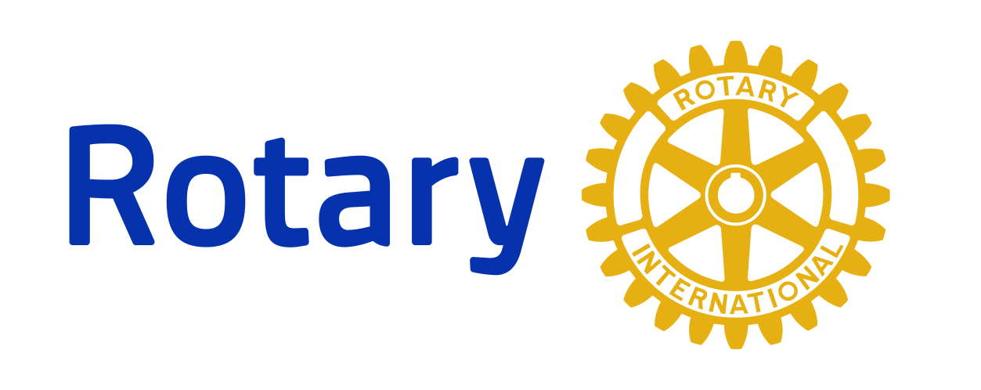
If you have any further questions, please do not hesitate to contact us at BuffaloAdoptaFamily@gmail.com. Thank you in advance for helping to make this a joyous Holiday season throughout our community!

With Gratitude,
Buffalo Rotary
_ _ _ _ _ _ _ _ _ _ _ _ _ _ _ _ _ _ _ _ _ _ _ _ _ _ _ _ _ _ _ _ _ _ _ _ _ _ _ _ _ _ _ _ _ _ _ _ _ _ _ _ _ _ _

Name: _______________________________________________ Phone: ___________________________

Address: _____________________________________________ City: __________________________

Email: ______________________________________________

Family Size you would like to sponsor: (number of children): _________________

Please mail form to: Adopt a Family, P O Box 501, Buffalo MN 55313 or email information to above email.

