Adding a File to a Page 8/17/17

To add a file to a custom page, such as a board meeting notes:
- Login at http://www.stillwatersunriserotary.org/

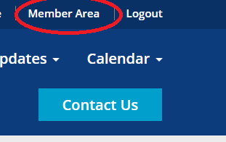
- Click on Member Area:

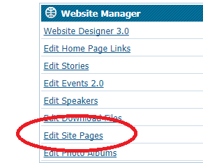
- Click on Edit Site Pages

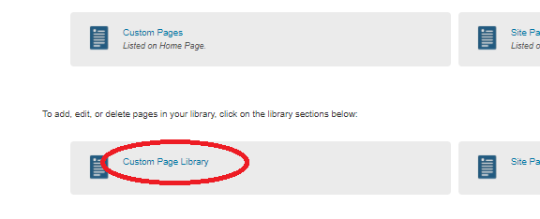
- Click On Custom Page Library

- Select Your Page
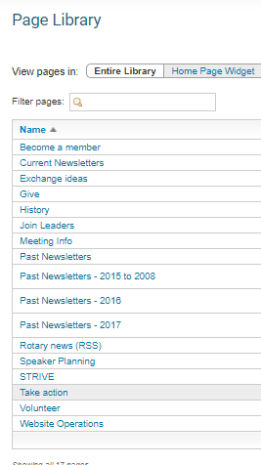

- You’ll see the page designer screen. Point to the Page Download Files area, then click the pencil icon:
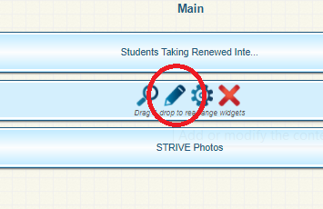

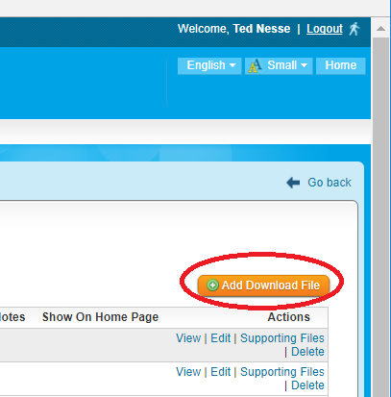
- Click on Add Download File:

- Choose the file, enter a title for it, and click Save:

