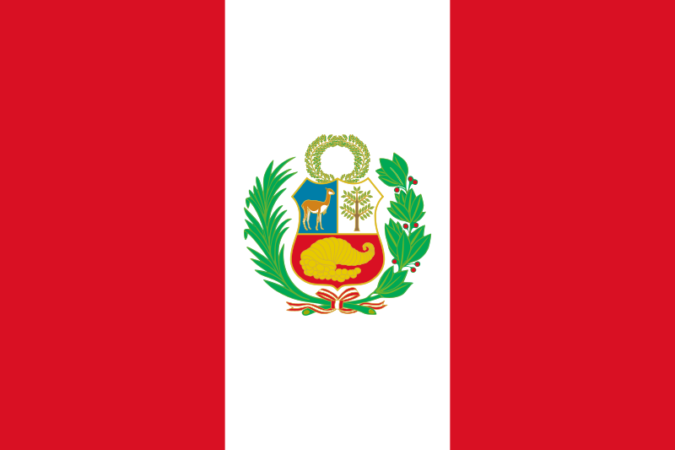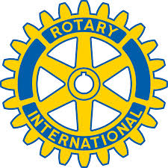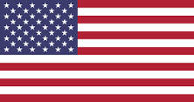

Whereas: The Oshkosh Rotary Club and Rotary Club La Molina became sister clubs in 1998 and have since enjoyed fellowship and a mutual commitment to service.

Whereas: Project Peru was created between Rotary Club La Molina Vieja and the Oshkosh Rotary Club and has grown to include: Oshkosh Rotary Southwest, Fond du Lac Morning Rotary, Municipality of Ate, and Municipality of La Molina, and thus become an international Rotary model of cooperation.

Whereas: Carlos Rioja has served as a member of both clubs and has been instrumental in our club’s cooperation, fellowship and ongoing service projects.

Whereas: the impoverished of Peru have benefited from our mutual dedication to service that includes medical, educational, nutritional, orphanage support and sow cow and baking operations.

Whereas: as a direct result of our twenty years of cooperation on various project hundreds of American students, travelers and Rotarians have visited Peru, enjoyed your culture, embraced your people and worked to build lasting goodwill and friendships that help make Peru and the world a better place.

Now therefore: on behalf of the Oshkosh Rotary Club we extend to Rotary Club LaMolina our congratulations on your 25th anniversary as a Rotary Club and look forward to our continued relationship and mutual commitment to “Service Above Self.”

Signed This 30th day of January 2018

John Fuller
President
The Rotary Club of Oshkosh

