Newsletter: Winter/Spring 2022
In collaboration with Believe in Belize, RCI just completed two missions to Belize. One mission was to Stann Creek District and the second, sponsored by the Rotary Club of Sylvania, was to the Toledo District. The Toledo District mission was funded by a District 6600 Grant. In the past year RCI has been very active and forward looking, receiving many significant donations, both financial and material.
This Newsletter will summarize our recently completed missions and also include an article from Nabil Bedewi, founder of Believe in Belize.

Missions to Stann Creek & Toledo Districts

This Stann Creek mission was scheduled for fall 2021. The team was ready to go in early December when Belize closed down due to COVID. All the educational equipment and supplies were stored at the Citrus Growers Association in Pomona, Belize, waiting for the Mission Team from District 6600 to come down. The Toledo Mission was scheduled for April 2022 and came off as planned.

In order to efficiently use our resources we conducted both missions during the same trip. We did Toledo first and then moved north to conduct the Stann Creek/Cayo District mission. In all we provided over 45 schools with equipment and supplies. The list of schools served follows this article.

Future plans are to conduct two missions to Belize in fiscal year 2022/2023. If you would like to be part of this project contact: Mel Honig, Project Coordinator, at melhonig.rci@gmail.com.
The mission team from the US was composed of:
- Kent Iler, Elyria Rotarian
- Will Mosby, E Club Rotarian (Texas)
- Mel Honig, Sylvania Rotarian
- Samantha Iler, Educator/Technician
- Nate Stroempl, Videographer
Included in the team were the following Belizeans:
- Judy Williams, Dangriga Rotarian
- Jo Audinette, Punta Gorda Rotarian
- Indira Williams, Dangriga Rotarian
- Mario Bull, Dangriga School Teacher
- Jill Cotter, Punta Gorda Rotarian

THE MISSION IN PICTURES
The mission teams arrive on site on Friday. The first priority for any mission is to set up the equipment for distribution to the schools. All the schools are contacted and they pick up that weekend. Next the team goes to the schools to meet with administrators and teachers and then set up the donated equipment.

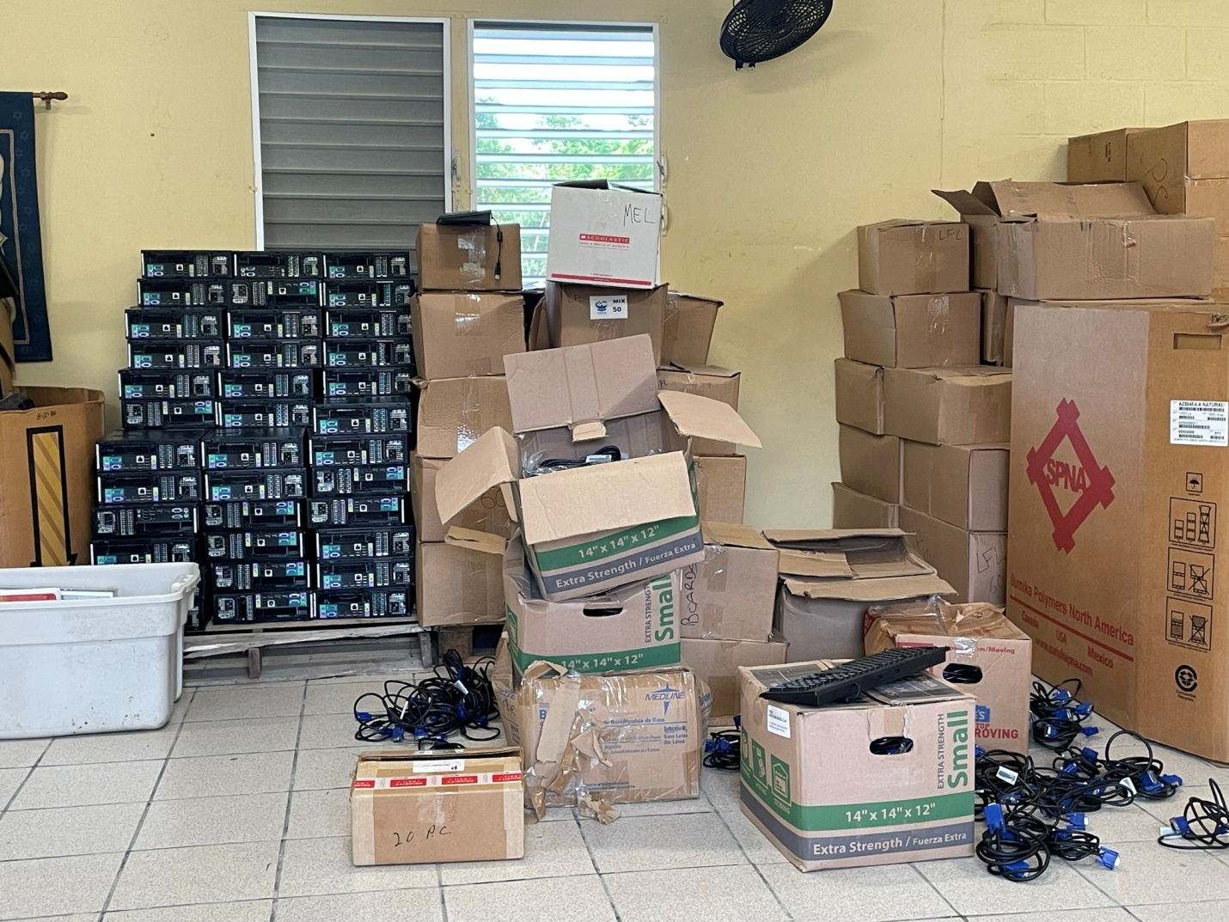
Computers, books and anything electronic stayed inside.
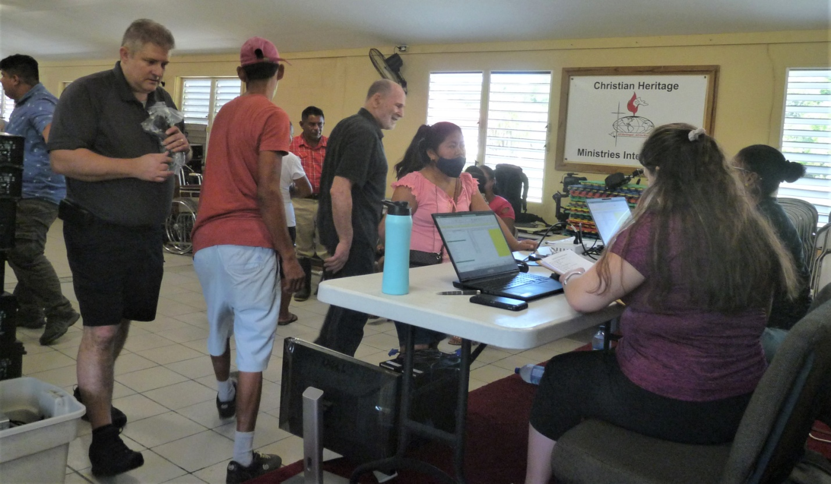
Tables were set up and Sam and Indira logged all the schools in… one at a time. At the desk the school representative fills out an application and an inventory form is developed. After the school gets their allotment they sign for everything they receive. In the Stann Creek District pickup, one principal drove over 100 miles to pick up the educational equipment and supplies for her school in the Cayo District.

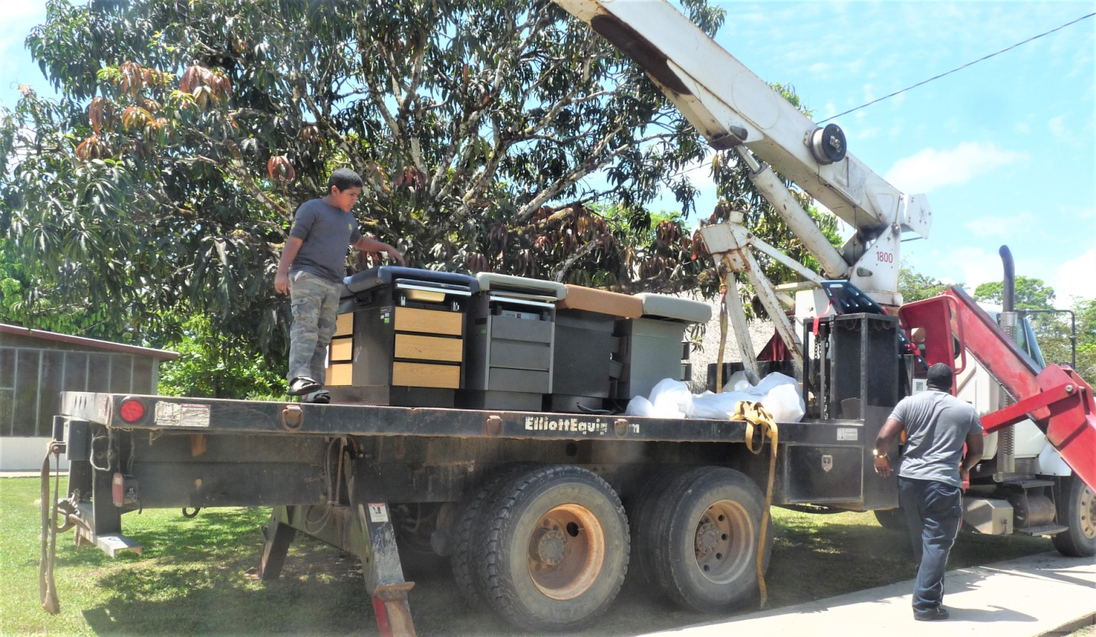
As part of our partnership with Believe in Belize, medical supplies for local clinics were also placed on the container as well as school supplies and computers for their educational projects.
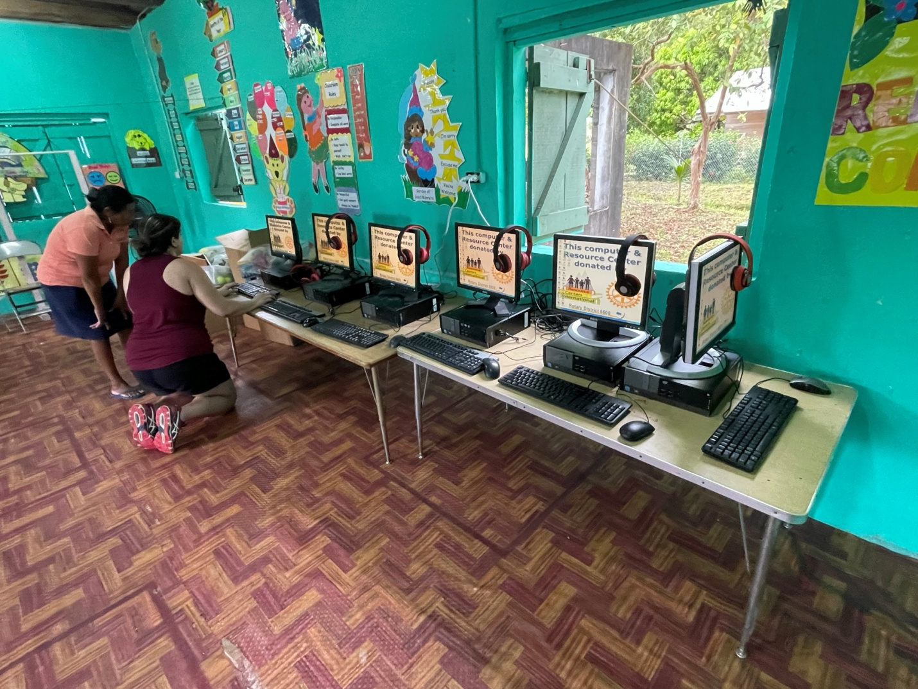
At each school we set up their computers, each one loaded with educational software for children 3 to 12 years of age. Here Sam is giving a tutorial to one of the teachers.
On first arriving at a school we meet with the Principal. First question is: where do you want to put the computers? Many times they are all in one place but they can also be spread out among different classrooms.
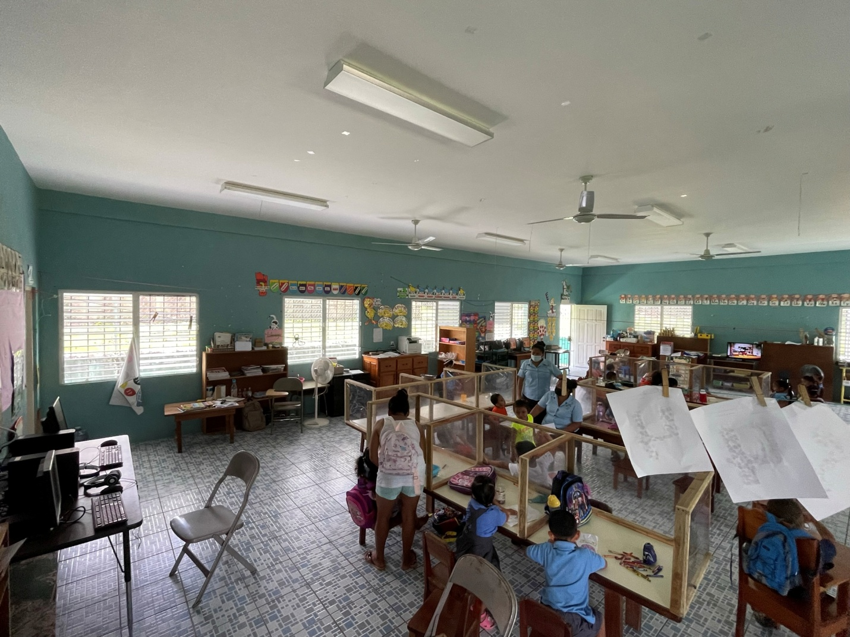
During COVID many precautions are being taken to make sure children and teachers are safe. Access to schools is restricted to appointments only, everyone wears a mask and there are washing stations at all school and classroom entrances.

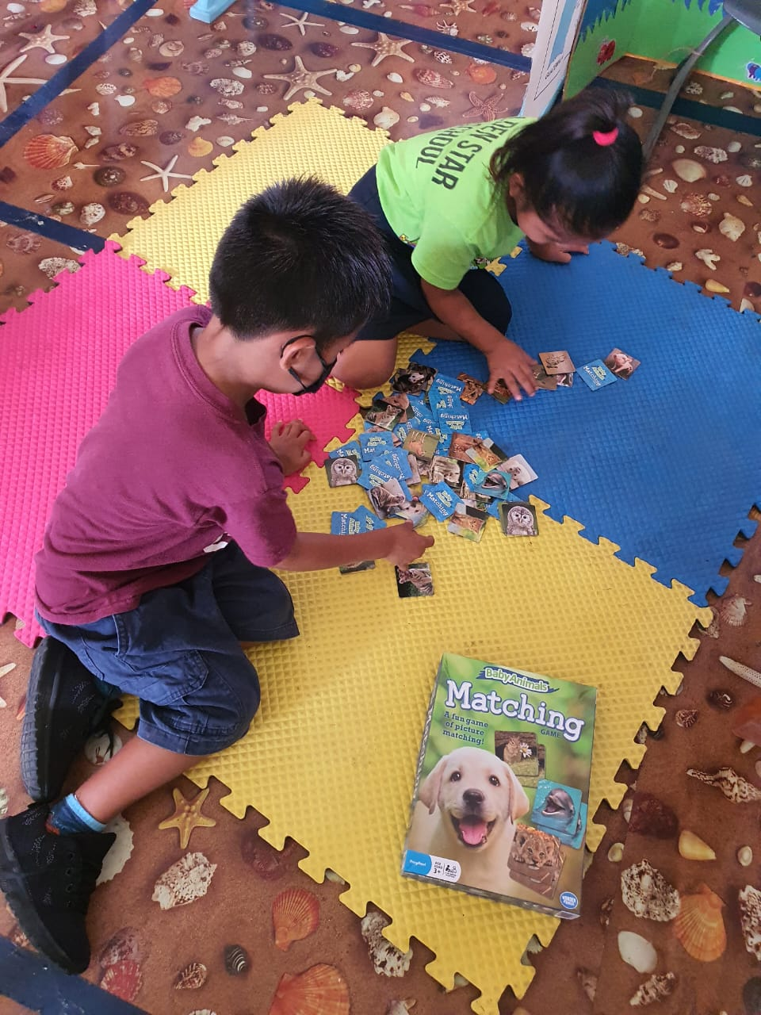
Best games that we send down are those that challenge memory and hand eye coordination. Children usually always work in pairs or small groups, thus increasing their social skills. The exercise mats are also provided by RCI.
The rewards of our missions is working with the children and seeing the joy in their faces.

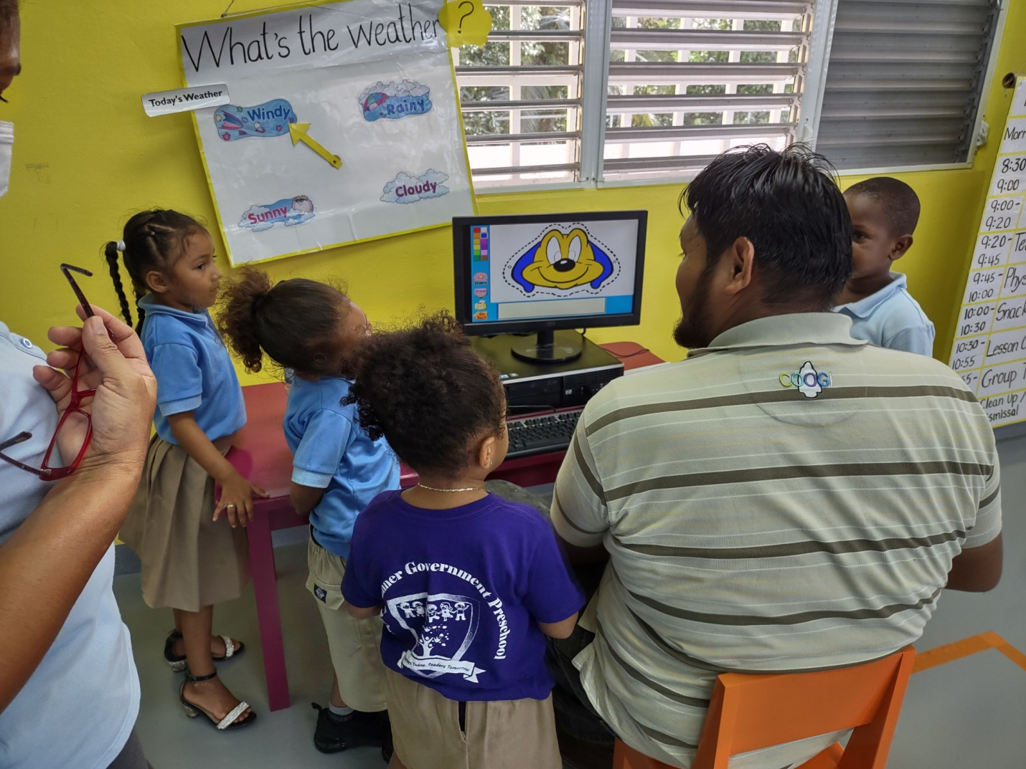
Mario is demonstrating how the children can use the software programs that Kent installs on each computer. After the mission is over Mario continues to work with the schools to solve problems they may have with the equipment the school has.

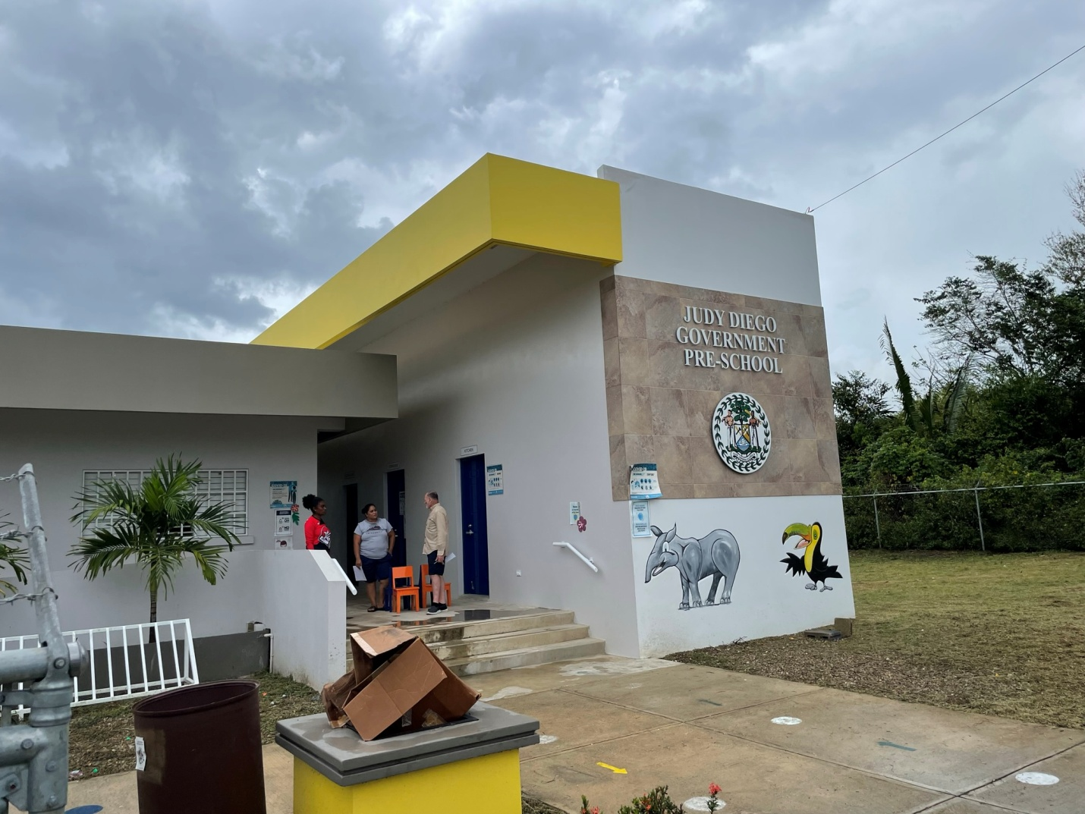
This is one of the many new preschools that the government is building. There is universal preschool education, and in many ways Belize is ahead of many developed countries in their emphasis for early childhood education.
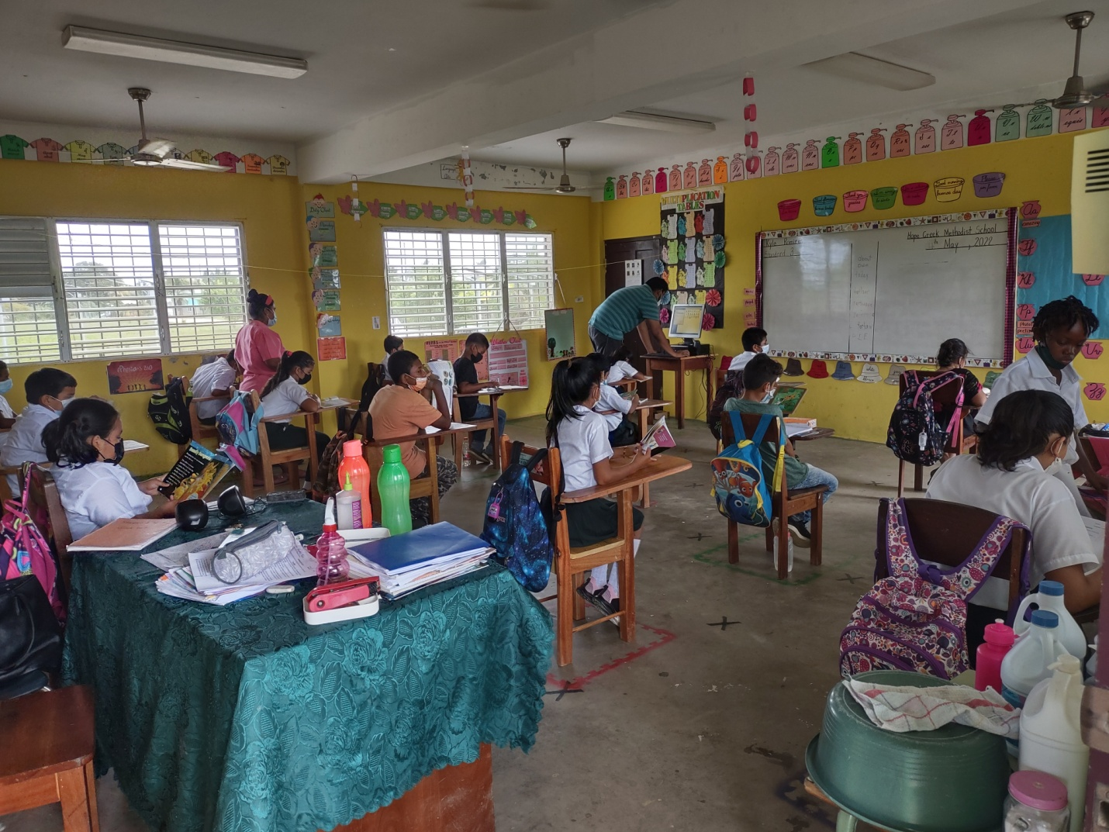
In this school the Principal requested that we place one computer in each classroom. Mario, in the background, is setting up their classroom computer. All the classrooms not only practice social distancing, but are clean.

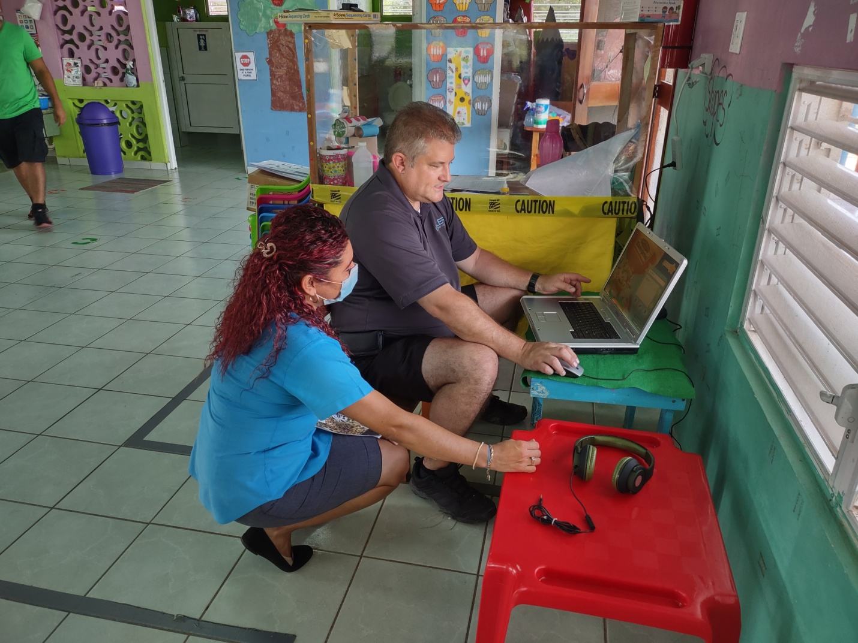
Kent is going over the educational software with one of the preschool teachers. Most of our computers are not laptops. If would be a lot more convenient if they all were… but we take what is offered. We always are in need of more computers.
Each year, as we return to Belize, we find that the quality of education and the facilities provided have improved. This is because there are many government sponsored programs: to insure that each teacher and administrator is properly qualified for the job they do: and new schools and upgrades to infrastructure are constantly being made.
I invite you to check out the Ministry of Education, Culture, Science and Technology website to find out more about the education system of Belize. Their website is: https://www.moecst.gov.bz/.

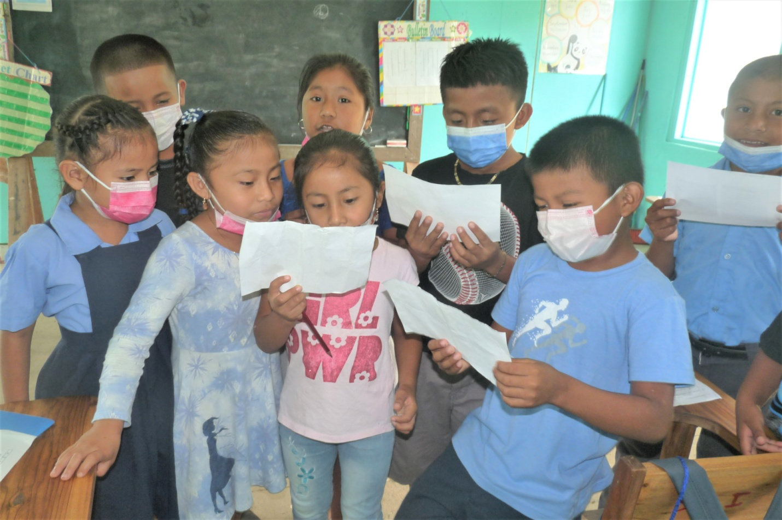
Singing is a part of school life. Each day they sing the National Anthem prior to class… and if there is a school song, they sing that also. Here they are serenading the mission team.
The joy of bringing children opportunities to improve their lives makes everything we do worthwhile. These children are fantastic, as are their teachers and administrators who work for the betterment of their country.

LISTS OF SCHOOL SERVED

TOLEDO DISTRICT SCHOOLS (Week 1)
Happy Home Preschool
Progressive Early Learning Center
Little Paradise
St. Peter Claver Preschool
San Jose Preschool
Bright Star
Sunshine Preschool
Sacred Heart Preschool
Midway Preschool
Golden Star Preschool
San Pedro Columbia
St. Joseph Anglican Preschool
Silver Creek Preschool
San Benito Poite Preschool
San Antonio Christian Preschool
Big Falls Preschool
San Miguel Preschool
Toledo Christian Academy Preschool
Twinkle Star Preschool
Little Haven Preschool
Blue Creek Preschool
Santa Teresa Preschool
Tiny Tots SDA Preschool
Sunrise Preschool
Pueblo Viejo Preschool
Our Lady of Sorrows Preschool
Laguna Government School
Santa Cruz RC School
Hopewell Bus Library (books only)

STANN CREEK DISTRICT SCHOOLS (Week 2)
Hope Creek Methodist School
St Mathews Anglican School
Holy Angels RC School
St Augustine RC School
Light of the Valley Baptist School
Epworth Methodist Pre School
Hope Pre School
Holy Family RC School
Guilisi Community Primary

CAYO DISTRICT SCHOOLS (Week 2)
Armenia Government Pre School
St Michael RC Pre School
Judy Diego Government School
Myrtle Banner Government School
A to Z Preschool
St Mathews Government Pre School
Kuxlin Ha Government Pre School
Belmopan Community Pre School
Miracle Angels Nazarene
Belmopan Baptist High School
Garden City Government Preschool
United Evergreen Primary
St Margaret’s RC

BELIEVE IN BELIZE
Believe in Belize was founded by Nabil, Kareen, and Lucy Bedewi (husband, wife, and daughter). It is an all-volunteer, U.S. based 501c3 non-profit organization launched in January 2018 (incorporated in Maryland), with the sole purpose of helping with the development of Belize, by implementing projects and providing services. To learn more about our organization, please see this link https://believeinbelize.org/sitepage/our-organization.

We operate six different programs: Education, Health, Community Development, Common Resources, Partnerships and Operations. These programs are implemented through a set of projects or services grouped by initiatives. The projects/services are either initiated or managed by Believe in Belize or provide visibility to efforts being done by other organizations or individuals. To learn more about what we do, please see this link https://believeinbelize.org/sitepage/our-current-programs.
Since our inception we have completed seven projects related to computers for schools, COVID-19 relief, and bringing a couple of fire trucks to Belize. We also launched seven services addressing student educational needs, bicycle safety and animal welfare. For a complete list of our impact to date, please see this link https://believeinbelize.org/sitepage/our-current-programs/our-impact.

If you would like to learn more about Believe in Belize or inquire about volunteer opportunities or options for supporting us financially please contact us at Board@believeinbelize.org or check out these two links https://believeinbelize.org/stories/why-join-believe-in-belize, https://believeinbelize.org/sitepage/donation-options.

By Nabil Bedewi

Editor’s note: Believe in Belize has been a valuable supporter of RCI for the last 3 missions. We look forward to continued collaboration in an effort to help the citizens of Belize.

DONATIONS

Over the past year we have had many donations. The most significant are:

School Equipment and Supplies:

Shelving and furniture from the University of Toledo
Computers from St Luke’s Hospital
Computers from Blanchard Valley Health System
Books from the Rotary Club of Oberlin
Books from the Cleveland Kids’ Book Bank
Games and Toys from Gail Odneal
Tables and chairs from the Findlay school system

Financial:

Believe in Belize
District 6600 Grant
The Juarez Family
The Heinrich Foundation
Interact Club of Wynford High School

PRESENTATIONS

Interact Club of Wynford High School and the Rotary Club of Sylvania

