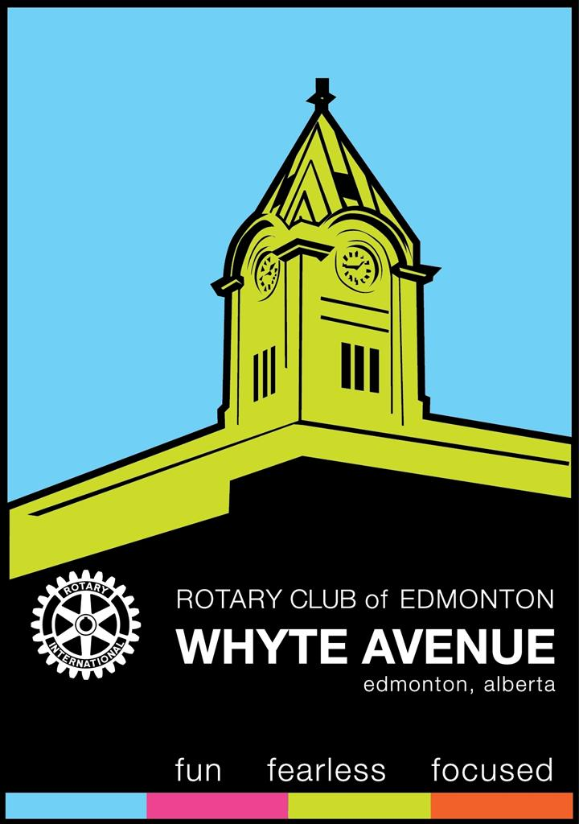
Rotary Club of Edmonton Whyte Avenue
Meeting Date:
Name | Paid | Cash / Cheque
Beddoes, Colin
Bissell, Stan
Brown, Alicia
Ceccherini-Nelli, Alfonso
Davison, Murray
den Heyer, Kent
den Heyer, Meltem
Fashan, Idris
Goralski, Shannon
Jaffer, Saiyed
Lamoureux, Nicole
Mucha, Marilyn
Onciul, Tim
Rabin, Kelsey
Strobl, Kathy
Sysak, Kelly
Waldin, Sophie

