Rotary Youth Exchange &

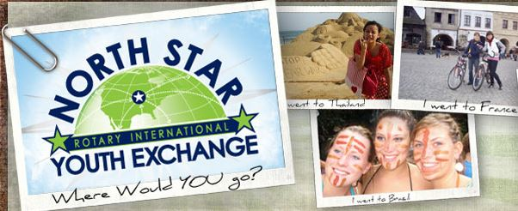
Host Family Information Night

Thurs., Nov. 2, 2017 6:30-7:30 p.m.

Chanhassen Recreation Center

2310 Coulter Blvd, Chanhassen

Join us to hear from current exchange students and host families!

Enjoy the International food shared by our current exchange students!

Long & Short Term Exchanges!
- 2 month summer family exchange (1 month abroad with host sibling, 1 month in MN with same host sibling)

- 1 year cultural exchange with 3 host families and
1 unforgettable, amazing life-changing year

- 30+ countries, 70 selected students, and a $14,000 Rotary scholarship available for youth ages 15-19

Deadline to apply: Nov. 27, 2017
For more info... check out http:/northstaryouthexchange.com
Sponsored by Chanhassen, Chaska, and
Eden Prairie AM Rotary Clubs

